WALT; identify different types of sentences Date……………………………………………………………………….. Name..................................................................
questions  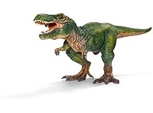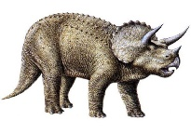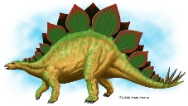  …………………………………………………………………………………………………………………………………………………………………………………………………………………………………..  ………………………………………………………………………………………………………………………………………………………………………………………………………………………………….  ………………………………………………………………………………………………………………………………………………………………………………………………………………………………….  ………………………………………………………………………………………………………………………………………………………………………………………………………………………………….  …………………………………………………………………………………………………………………………………………………………………………………………………………………………………..  ………………………………………………………………………………………………………………………………………………………………………………………………………………………………….  …………………………………………………………………………………………………………………………………………………………………………………………………………………………………. | statements  …………………………………………………………………………………………………………………………………………………………………………………………………………………………………..  ………………………………………………………………………………………………………………………………………………………………………………………………………………………………….  ………………………………………………………………………………………………………………………………………………………………………………………………………………………………….  ………………………………………………………………………………………………………………………………………………………………………………………………………………………………….  …………………………………………………………………………………………………………………………………………………………………………………………………………………………………..  ………………………………………………………………………………………………………………………………………………………………………………………………………………………………….  ………………………………………………………………………………………………………………………………………………………………………………………………………………………………….
exclamation sentences  …………………………………………………………………………………………………………………………………………………………………………………………………………………………………..  ………………………………………………………………………………………………………………………………………………………………………………………………………………………………….  ………………………………………………………………………………………………………………………………………………………………………………………………………………………………….  ………………………………………………………………………………………………………………………………………………………………………………………………………………………………….  …………………………………………………………………………………………………………………………………………………………………………………………………………………………………..  ………………………………………………………………………………………………………………………………………………………………………………………………………………………………….  ………………………………………………………………………………………………………………………………………………………………………………………………………………………………… | commands  …………………………………………………………………………………………………………………………………………………………………………………………………………………………………..  ………………………………………………………………………………………………………………………………………………………………………………………………………………………………….  ………………………………………………………………………………………………………………………………………………………………………………………………………………………………….  ………………………………………………………………………………………………………………………………………………………………………………………………………………………………….  …………………………………………………………………………………………………………………………………………………………………………………………………………………………………..  ………………………………………………………………………………………………………………………………………………………………………………………………………………………………….  ………………………………………………………………………………………………………………………………………………………………………………………………………………………………….

