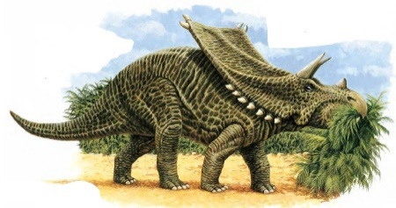
Chasmosaurus
King of the Dinosaurs

What do I look like?
I stand higher than an elephant
What a huge, jagged frill I have!
Get out of my way!

How do I move?
I stomp slowly across the land.
How the ground shakes under me!
Run away now!

By Mrs Joyce

