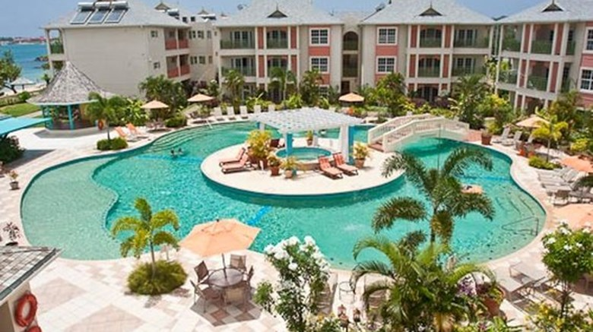

Bay Gardens Resort St. Lucia

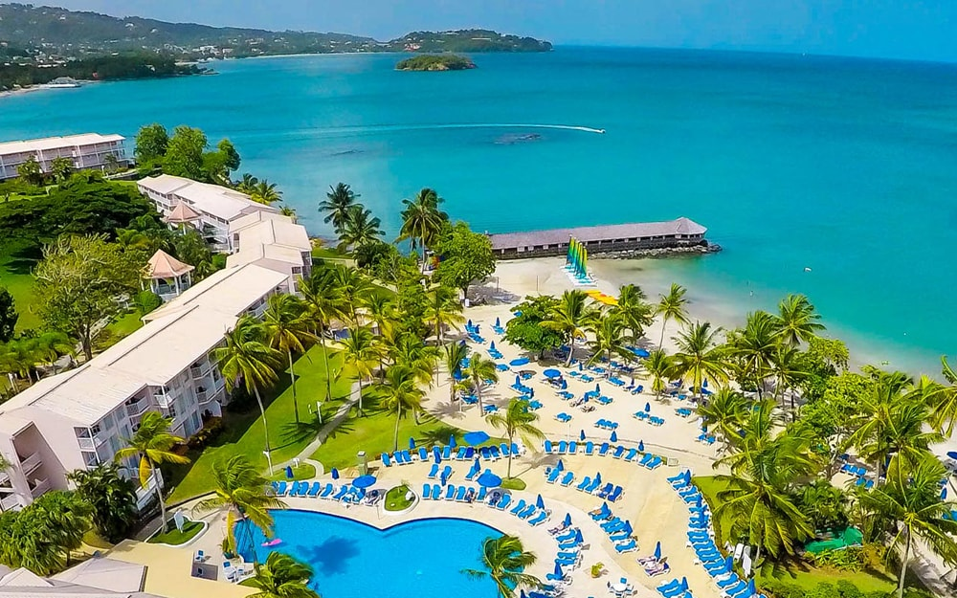

St. James’s Club Morgan Bay