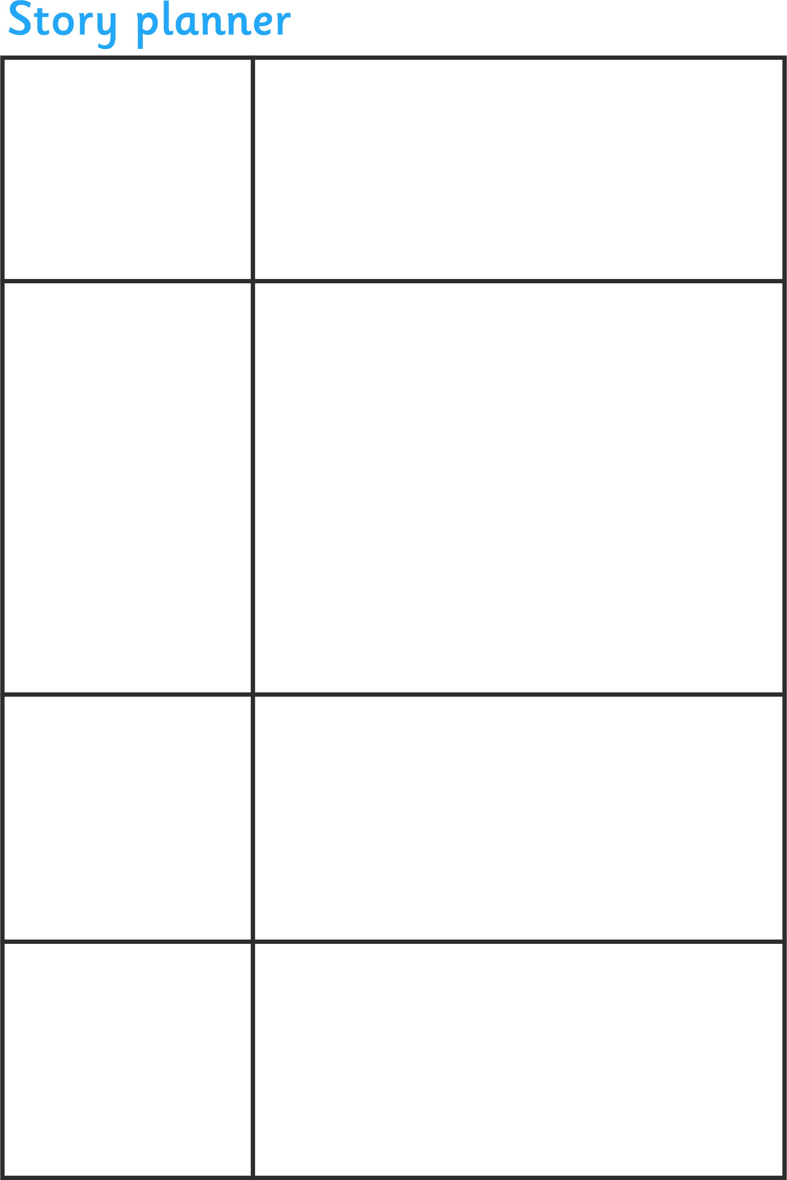

Introduction
- Introduce the main
characters.
-Introduce the story
setting.
Build-up
-Develop the characters and the setting.
-The points that lead up to the problem in the middle

The problem in the middle
-The conflict or climax in the story.
-How do the characters react?
Resolution
-How the problem is solved and the ending of the story.

