Thursday 26th March 2020

WALT draft a travel brochure for India’s Taj Mahal
This is The Macmillan Encyclopedia entry about India.
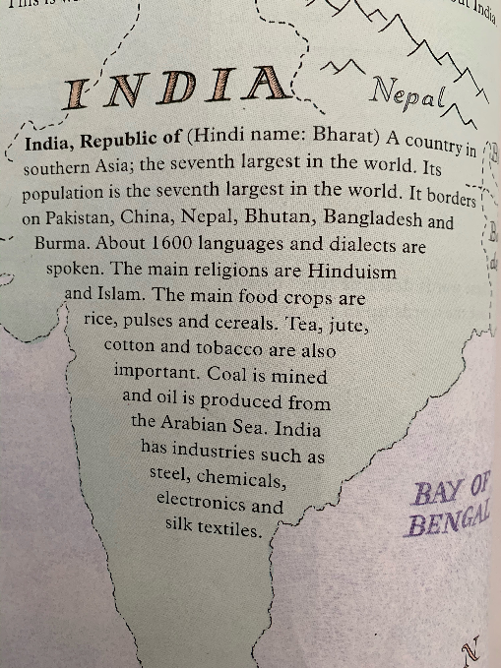
Task 1: Answer the following questions in your book:
- What is the Hindi name for India?
- What is a dialect?
- What are India’s main food crops?
- What are the main religions in India?
- Which continent is India in?

If you were writing to persuade someone to visit India, you would not list all the facts like the encyclopedia entry above. Instead, you would make it as exciting as you possibly could. You would also be as descriptive as you could possibly be. Here are some examples below:

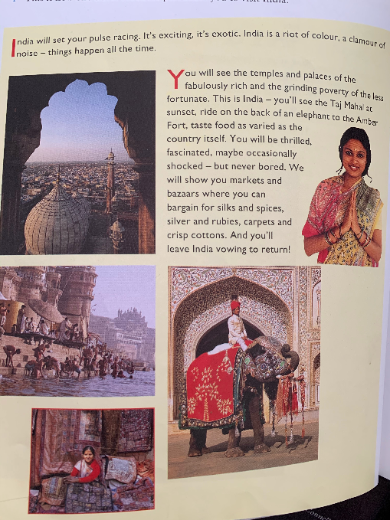

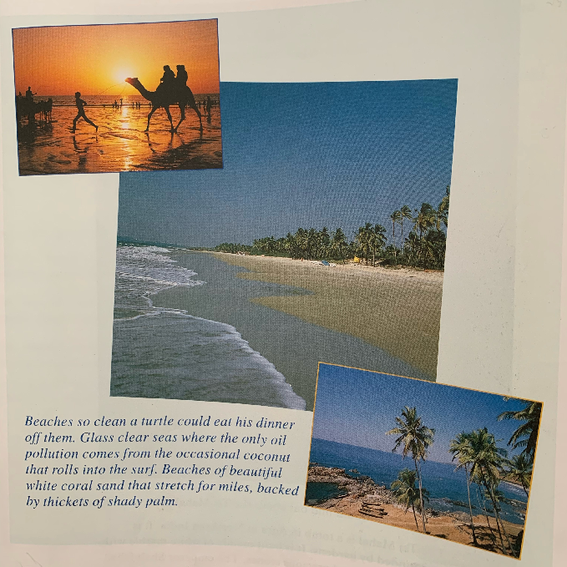

Task 2: List all of the words and phrases in the brochures that would make you want to visit India. Think about:
- What you would see
- How you would feel
- What you could do

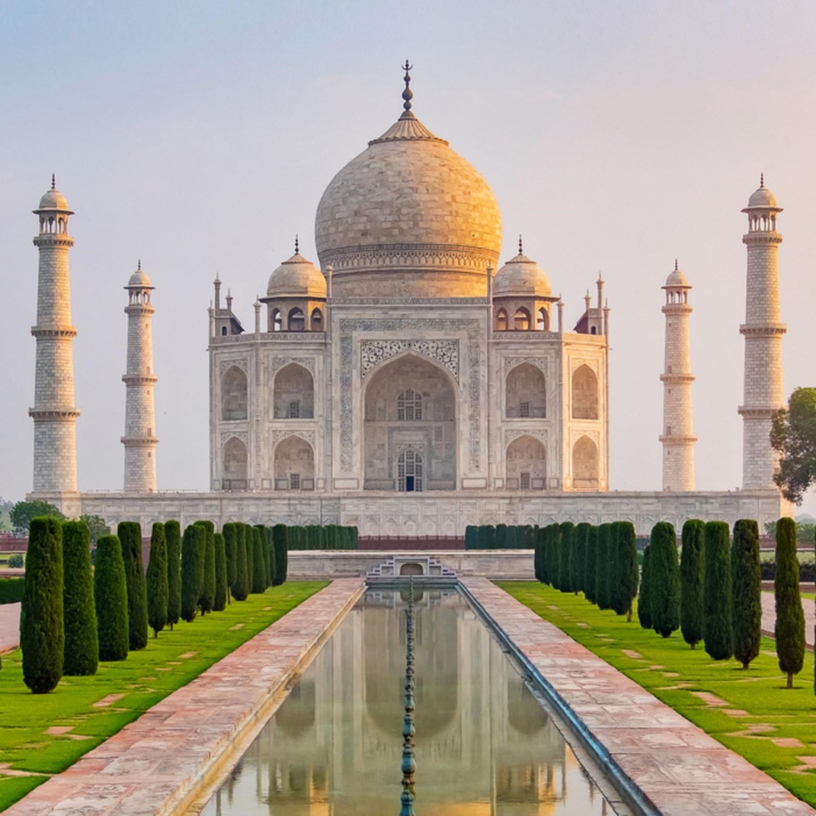
Encyclopedia for Taj Mahal:
The Taj Mahal is a tomb in Agra in Northern India. It is surrounded by gardens. It is built mainly of white marble with lots of carvings and precious stones. The emperor Shah Jahan built it in memoryof his wife Mumtaz Mahal who died in 1631.

Task 3: Read the encyclopedia entry for the Taj Mahal and create your own draft for a travel brochure to try to persuade people to visit.
WILF:
- Persuasive language
- Descriptive vocabulary
- Facts embedded in your persuasive writing
- Try to make your reader imagine themselves being there

Why not challenge yourself? Find out more information about the Taj Mahal and embed some of your findings into your draft.

