Practical Maths Challenges – Capacity

Capacity is how much fluid (liquid) a container can hold when it is full. It is the word we use when we are measuring liquids. e.g. we might say: 'What is the capacity of the liquid in that cup?'

You need some empty containers like these (if you have them):
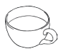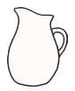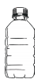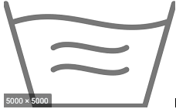
a cup a can a jug a small plastic bottle a large plastic bottle a washing-up bowl

Fill containers with water, measuring out to complete each of the challenges:

 | How much does it hold?
the cup | _____ cans of water | _____ small bottles of water
the jug | _____ cups of water | _____ cans of water
the large bottle | _____ cups of water | _____ small bottles of water
the washing up bowl | _____ jugs of water | _____ large bottles of water

- The ________________________ holds the least.

- The ________________________holds the most.

- Do any containers hold the same (equal) amounts? _______

