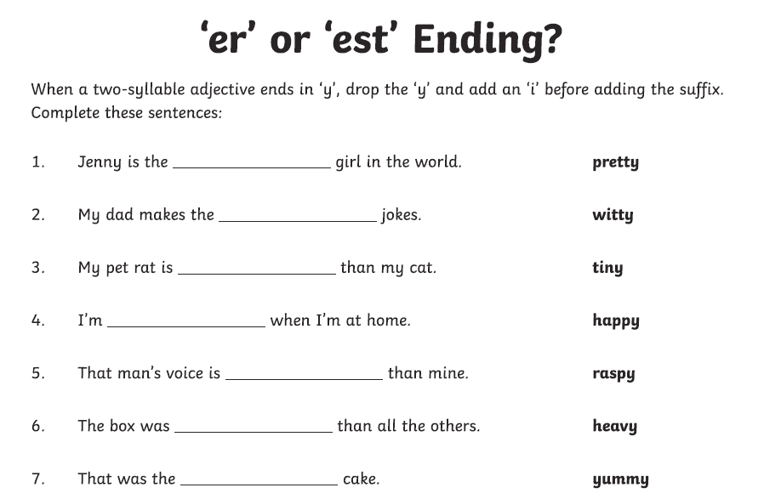

Task 2

Choose 8 of the words (preferably ones that you didn’t spell correctly last time) from your Common Exception Spellings list and write each one into a sentence.

Make sure that your sentence makes sense, that you used the spelling word correctly and that you include an exciting conjunction in each one. Also try to use fronted adverbials to start them.

Conjunctions you could choose:

because also
as well as
whilst in order to

