WALT: solve 1 and 2 step word problems involving capacity. Date………………………..
Write down the calculation required to solve each one
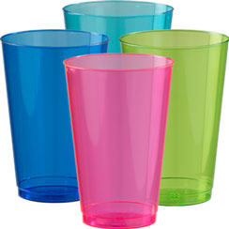
1. Amy had a 600ml bottle of water. She drank 200ml of it at playtime. How much is left?

2. Laila has to take three 5ml spoons of medicine a day. How much medicine is this?

3. If Ben drinks 2 litres of water in one day. how much will he drink in a week?

4. A cup of tea is 50ml and a mug of tea is 70ml. Louis drinks one of each. How much tea does he drink?

5. There are 5 litres of water in a fish tank. How many litres are in 7 tanks?

6. A bath holds 73 litres of water. There is a leak and the bath loses 21 litres of water. How much water is left? The next day it loses another 21 litres. How much water is left now? (Use column subtraction here to help you.)
Step 1

Step 2

7. I have 80ml milk to share between my 10 kittens. How many ml can they drink each? How much milk will 2 kittens drink?
Step 1_______________________________________________________
Step 2_______________________________________________________

