Hundredths as Decimals:
Complete this table (If you can’t print it, just write how many squares you would colour. You don’t need to draw four hundred squares!)
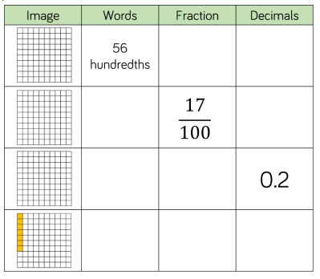

Try this reasoning question:
