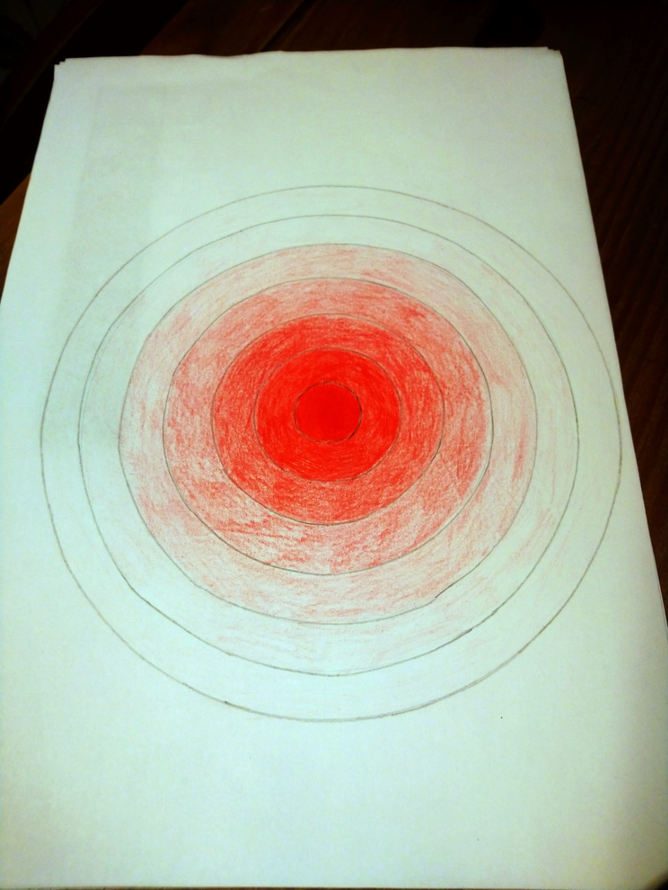

Mrs Joyce’s example of shades of one colour