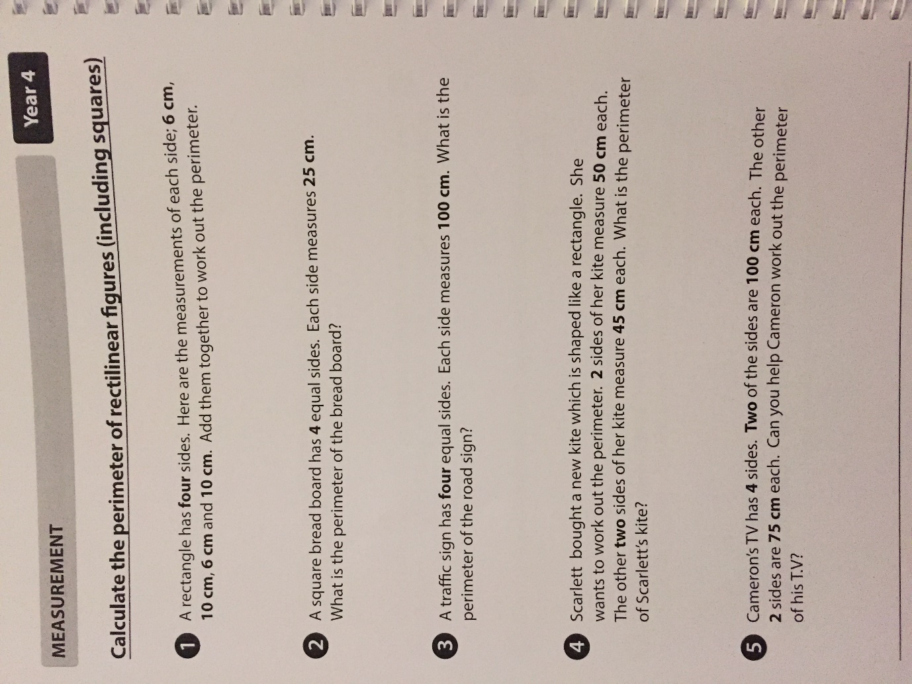

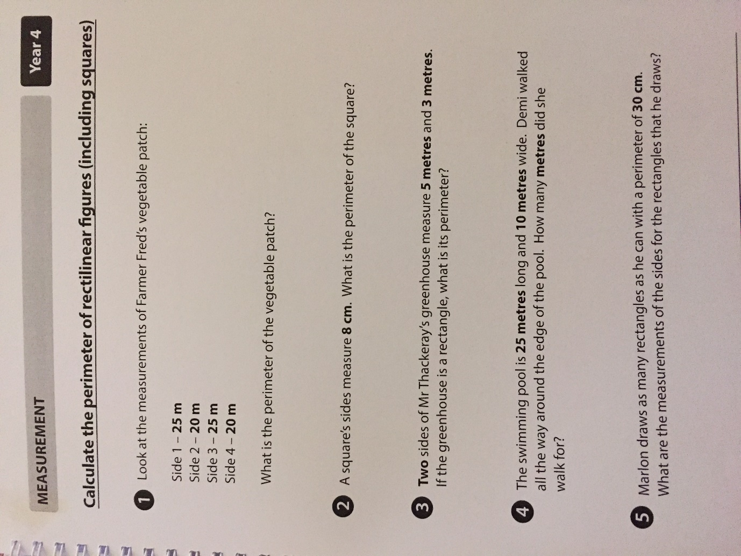

Extension: Write a word problem of your own about calculating perimeter.

Answers Page 1
- 32cm
- 100cm
- 400cm
- 190cm
- 350cm
Answers Page 2

- 90m
- 32cm
- 16m
- 70m
- Any of the following combinations:
7cm x 8cm
6cm x 9cm
5cm x 10cm
4cm x 11cm
3cm x 12cm
1cm x 14cm
2cm x 13cm

