WALT: add amounts in ml to 100ml. Date………………………………
Task: Imagine these are the amounts of water in the miniature cups. By adding them together, how many different ways can you make the total of 100ml? Record your answers on the chart underneath this page.
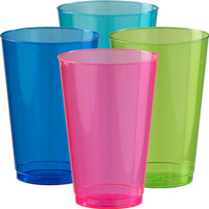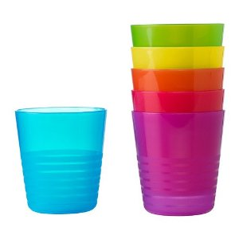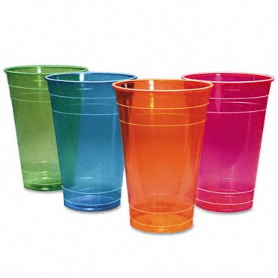
60ml 15ml 10ml

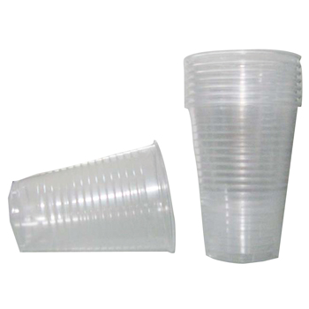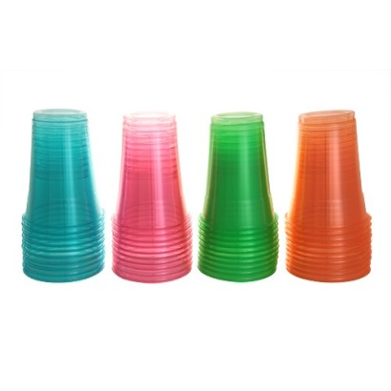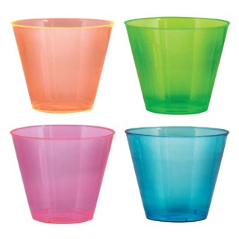
80ml 70ml 20ml

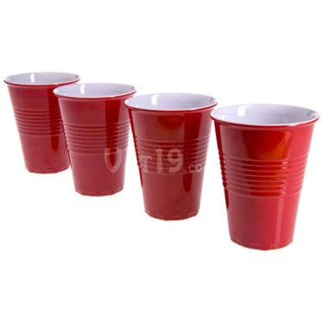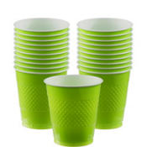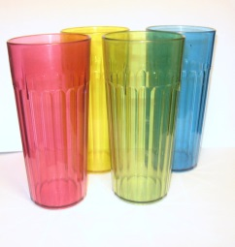

25ml 40ml 30ml

I have started you off. Really try and challenge yourself!
1. 40ml + 30ml +20ml +10ml= 100ml
2. 60ml + 25ml + 15ml = 100ml
3.

4.

5.

6.

7.

8.

9.

10.

11

12.

13.

14.

15.

16.

