WILF in a story re-tell 24/4/20  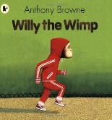 | What do I think?
Have I used and, or, but?

Have I used when, if, that, because?

Have I used expanded noun phrases?

Have I used a simile?

Have I used apostrophes for contraction?

