Willy the Wimp
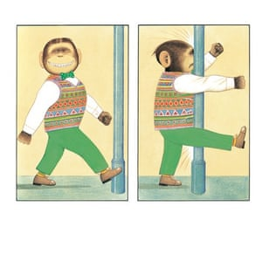
Willy was a small, weak monkey who everyone called a wimp. He wore green trousers and on top of a smart, white shirt he wore a multi-coloured jumper. Willy’s ears were quite large but his beady, brown eyes were very small. He walked quietly around town in his shiny, leather shoes making sure he didn’t stand on any small insects like ants, spiders, beetles or ladybirds. Willy was afraid of everything. He even apologised to the lamppost when he bumped into it!
Willy hated being called Willy the Wimp. What a horrid name that was! I don’t want to be a wimp anymore he thought. He was so fed up that he decided to do something about it. This quiet, little chimp sent off for a book on how to become much stronger.
Firstly, Willy had to go running because he needed to build his strength up. He wore a bright, red tracksuit and ran for miles and miles. Willy was hungry all the time so he gobbled down piles and piles of bananas or any other fruit he thought would be healthy. He realised he’d have to go to dance classes if he was to improve his level of fitness. Poor Willy! He looked so silly in his leggings, headband, vest top and belt.
Willy started to change…………He grew and grew. Willy’s little wimpy body became tall, strong and full of muscles. What an amazing body he had now! Willy even stood up to the suburban gorillas when they tried to attack Millie. Willy was as powerful as a lion and as fast as a cheetah. You wouldn’t call him a wimp now would you?

