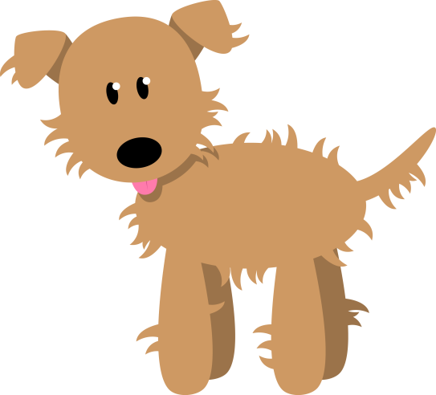

|  |  |
| --- | --- |
| Speech verbs | |
| yelled  screamed  howled  boasted  asked  replied  snapped  whispered  shouted  screamed | inquired  shivered |