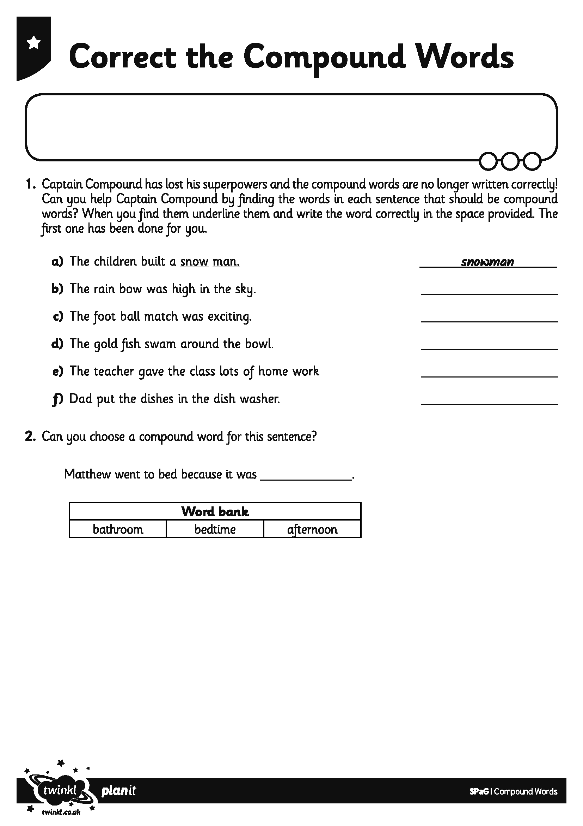

I can read compound words by splitting them into two shorter words.
I can write compound words by splitting them into two shorter words.

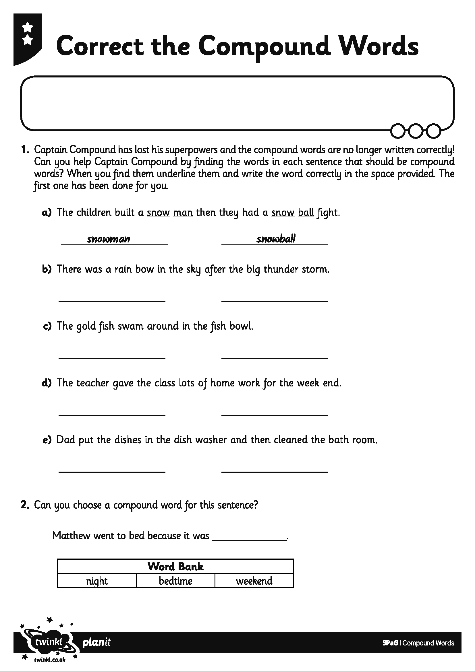

I can read compound words by splitting them into two shorter words.
I can write compound words by splitting them into two shorter words.

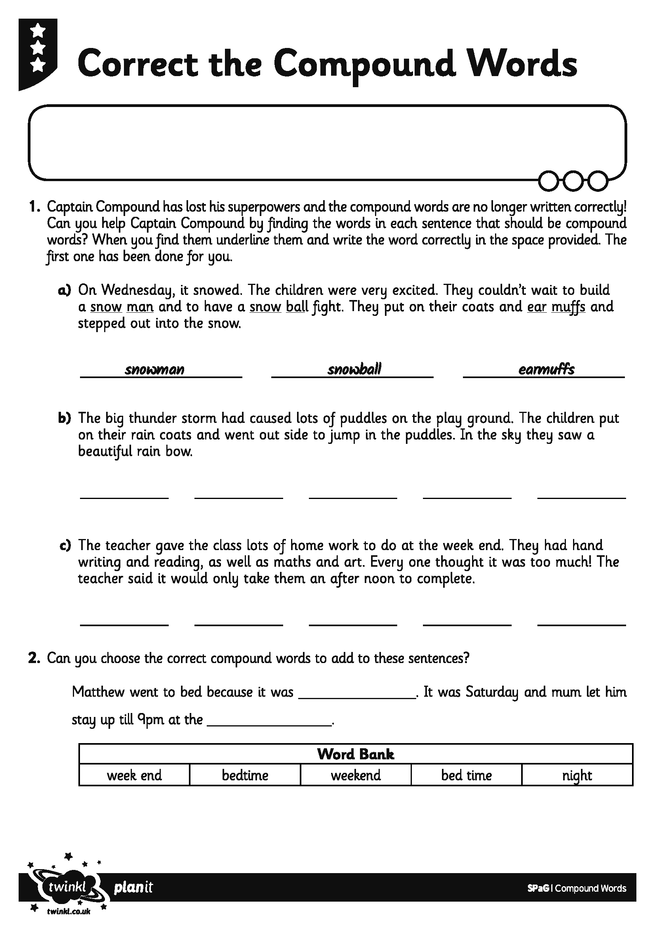

I can read compound words by splitting them into two shorter words.
I can write compound words by splitting them into two shorter words.

