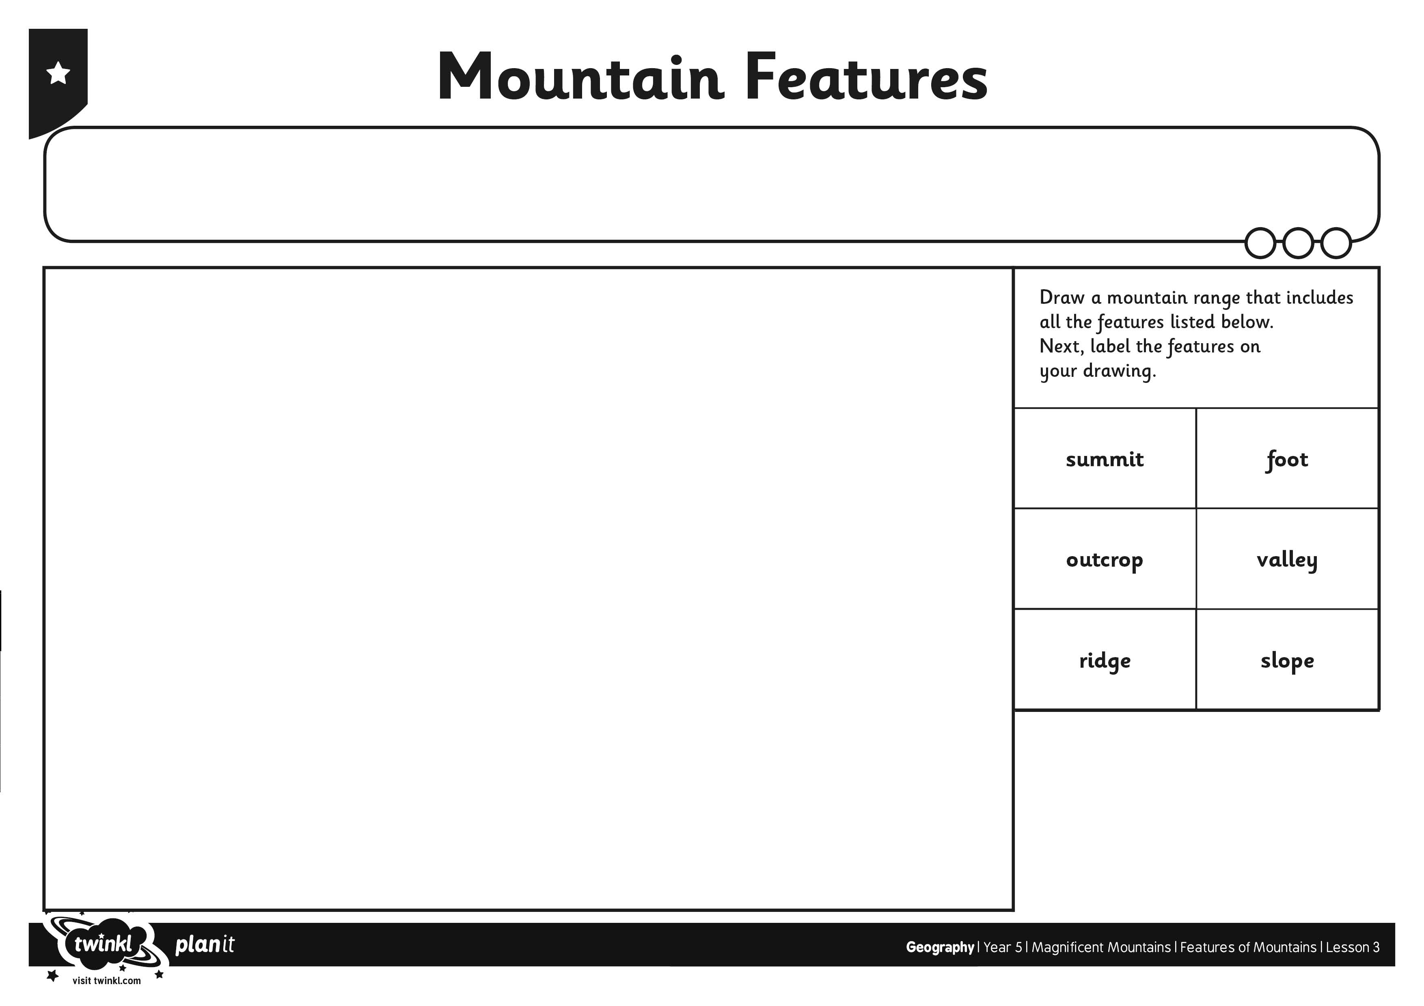
I can describe the key features of a mountain range.
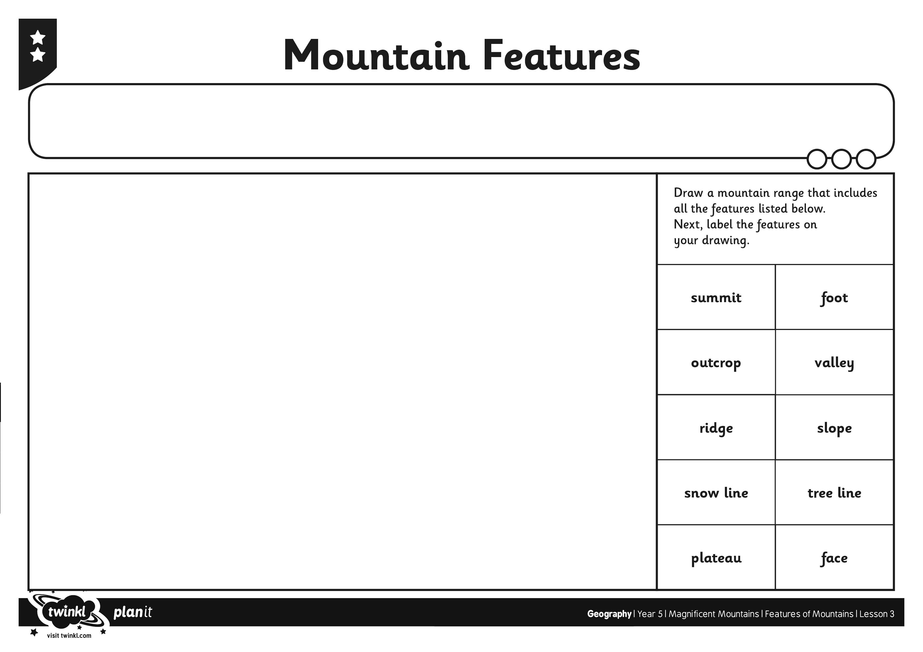
I can describe the key features of a mountain range.
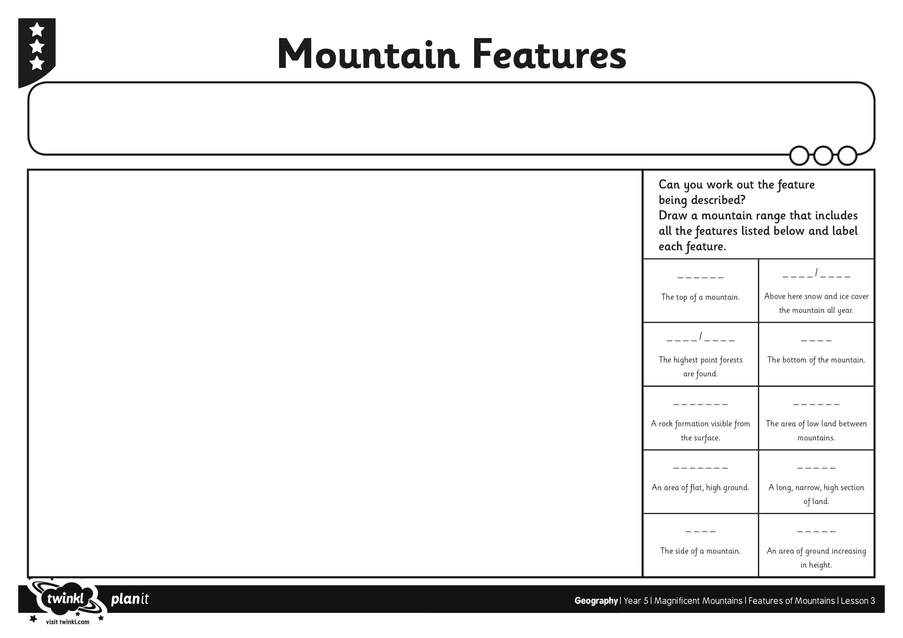
I can describe the key features of a mountain range.
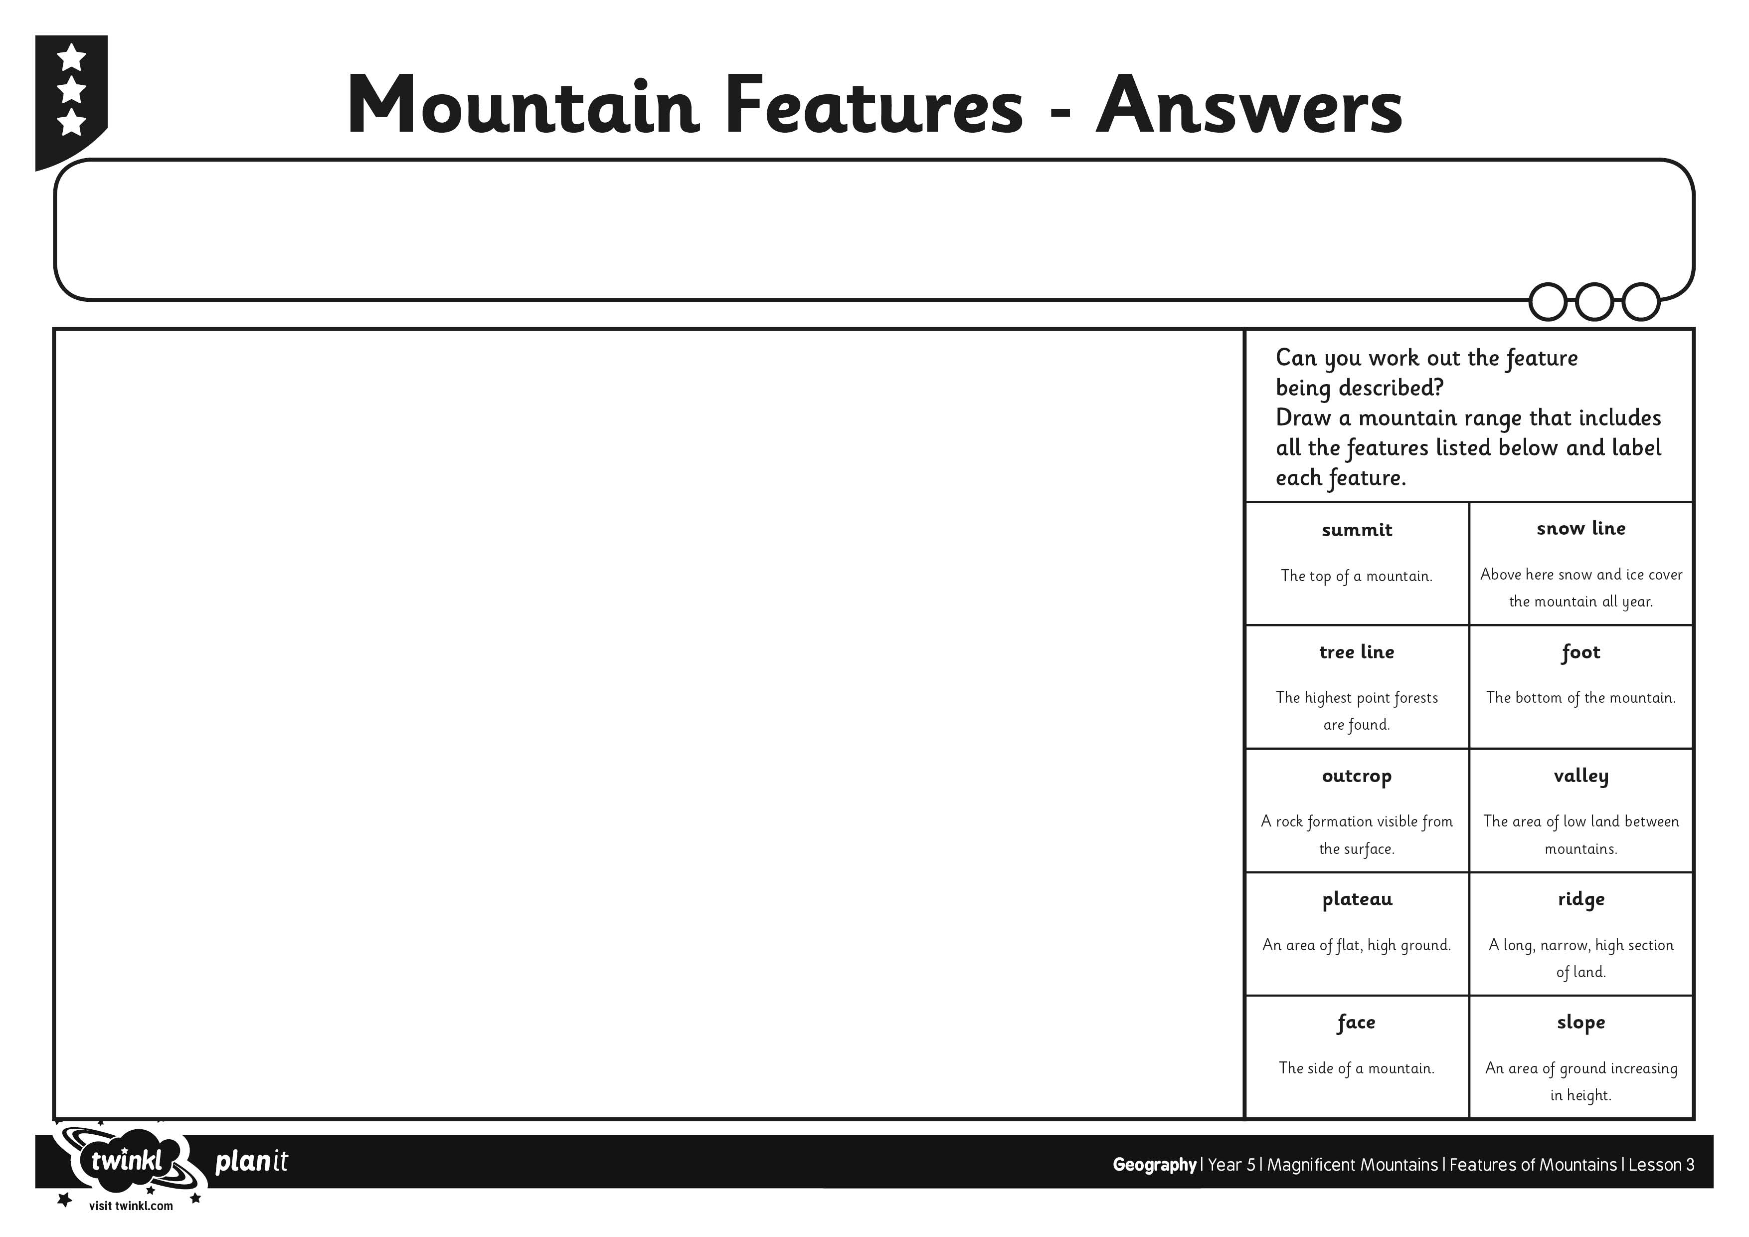
I can describe the key features of a mountain range.

