WALT paint Durdle Door using watercolours.

Durdle Door is a natural limestone arch on the Jurassic Coast near Lulworth in Dorset, England.
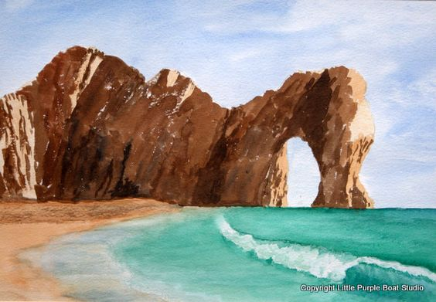
Task: try to copy the image below using pencil and watercolours. Try to mix different shades, tints, tones and hues to get the right look. If you don’t have watercolours, perhaps you could use something else e.g. pencil crayons, watercolour pencil crayons, pastels etc.

