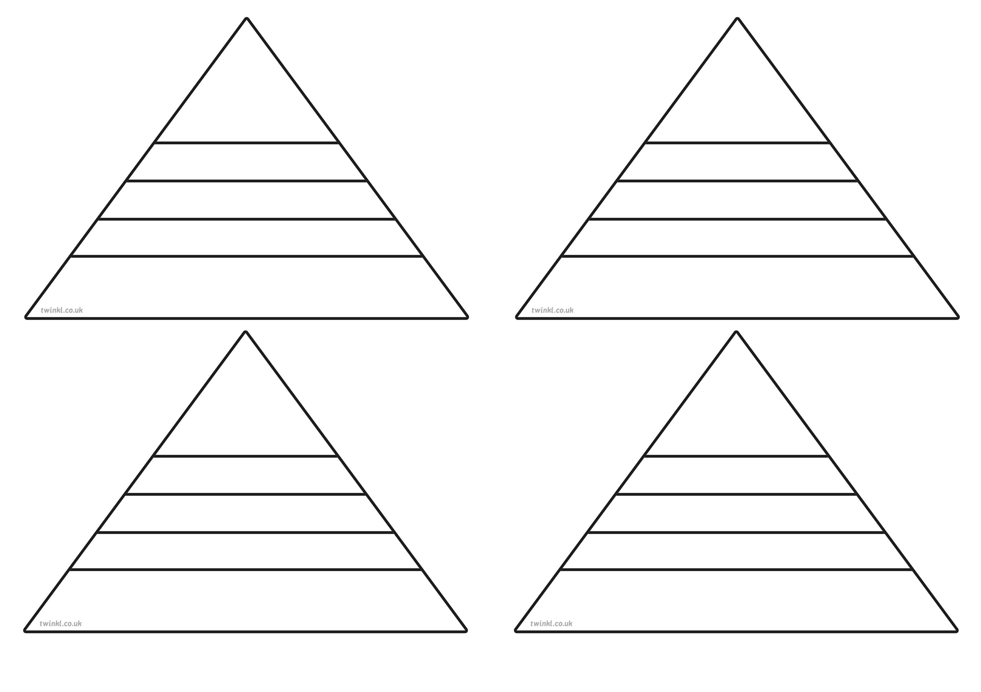
Height:
Country:
Continent:
Mount Olympus
Height:
Country:
Continent:
Mount Taibai
Height:
Country:
Continent:
Hekla
Height:
Country:
Continent:
Jungfrau
Height:
Country:
Continent:
Mont Blanc
Height:
Country:
Continent:
Matterhorn
Height:
Country:
Continent:
Mount Snowdon
Height:
Country:
Continent:
Vesuvius
Height:
Country:
Continent:
Mount Kilimanjaro
Height:
Country:
Continent:
Ben Nevis
Height:
Country:
Continent:
Popocatépetl
Height:
Country:
Continent:
Mount Rainier
Height:
Country:
Continent:
Scafell Pike
Height:
Country:
Continent:
Aoraki
Height:
Country:
Continent:
Aconcagua
Height:
Country:
Continent:
Snaefell
Height:
Country:
Continent:
Slieve Donard
Height:
Country:
Continent:
Denali
Height:
Country:
Continent:
Zugspitze
Height:
Country:
Continent:

