WALT : write questions Date………………………………………………………………………
Queen Elizabeth II

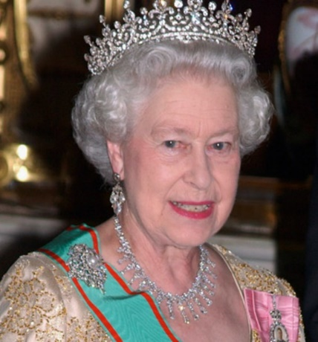
Write 3 things that you already know about Queen Elizabeth
1…………………………………………………………………………………………………………………………
…………………………………………………………………………………………………………………………….
2……………………………………………………………………………………………………………………………
……………………………………………………………………………………………………………………………..
3……………………………………………………………………………………………………………………………
….…………………………………………………………………………………………………………………………

What would you like to know? (Ask at least 4 sensible questions)

.............................................................................................................................................................................................
…………………………………………………………………………………………………………………………………………………………………………………………………………………………………………………………………………….
…………………………………………………………………………………………………………………………………………………………………………………………………………………………………………………………………………..
…………………………………………………………………………………………………………………………………………………………………………………………………………………………………………………………………………….
.............................................................................................................................................................................................
…………………………………………………………………………………………………………………………………………………………………………………………………………………………………………………………………………….
…………………………………………………………………………………………………………………………………………………………………………………………………………………………………………………………………………..
…………………………………………………………………………………………………………………………………………………………………………………………………………………………………………………………………………….
.............................................................................................................................................................................................



