11.05.20
WALT represent the position of a shape following a reflection

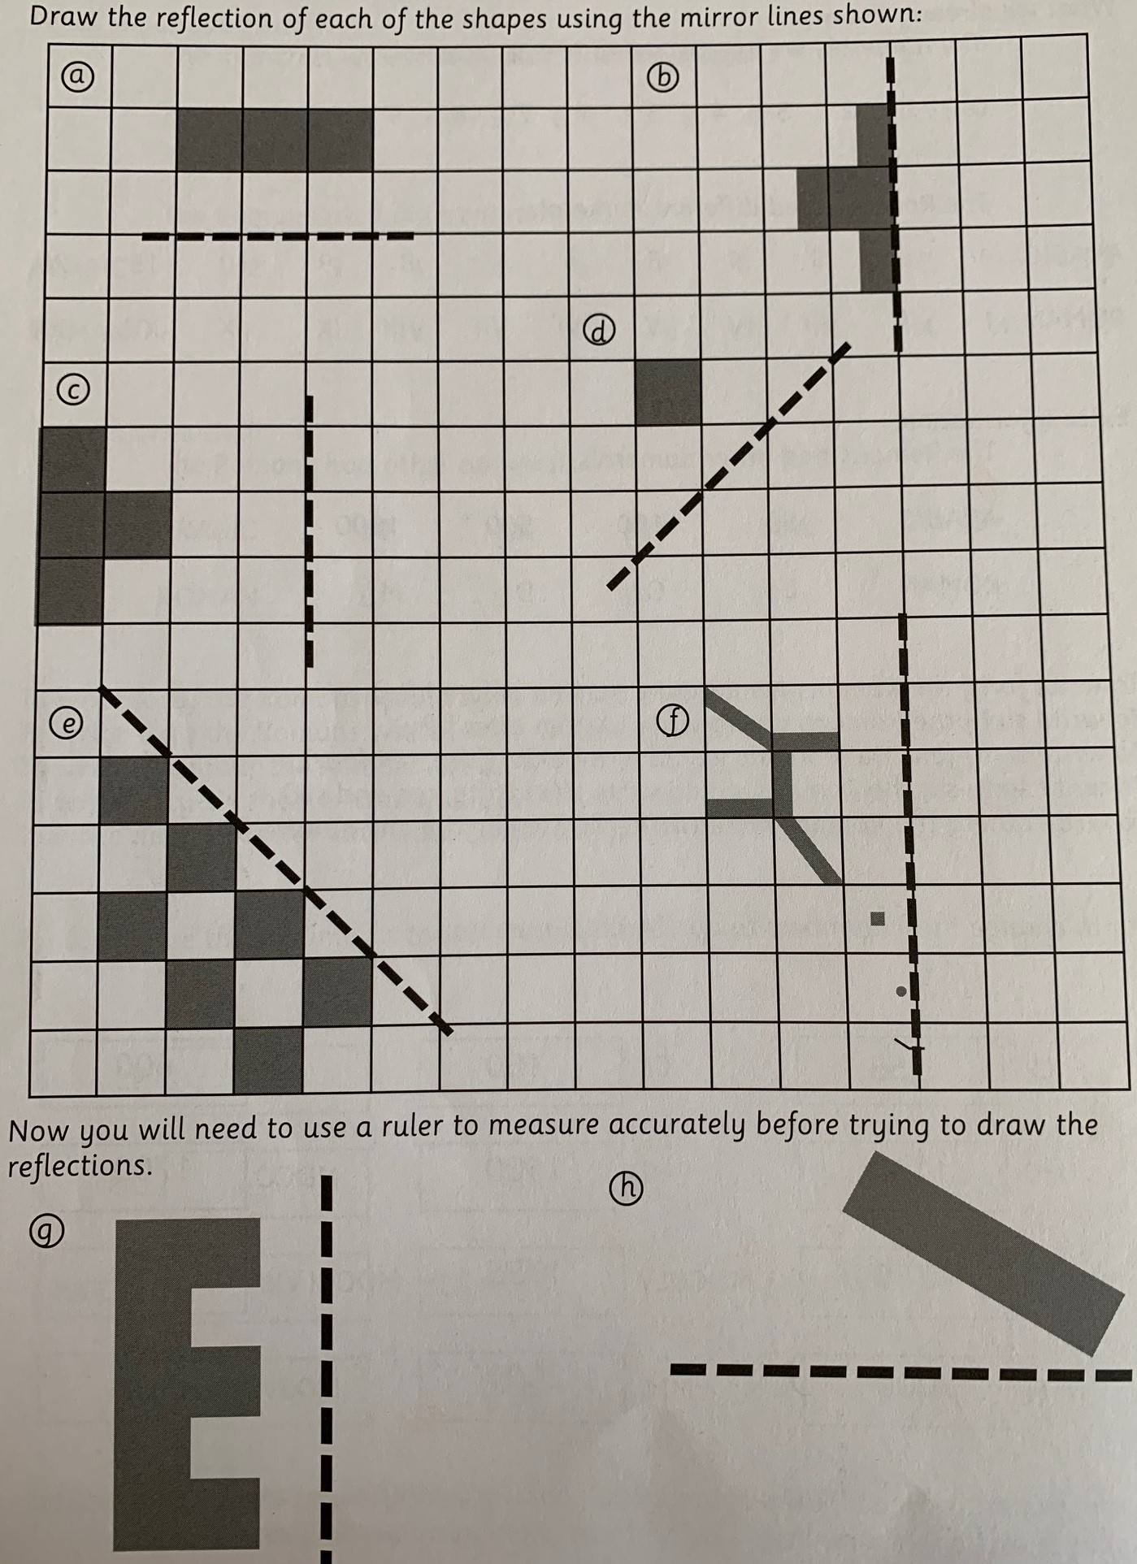
Task: reflect the shapes below as carefully as you can. Feel free to draw them into your books rather than print. Use the squares very carefully to help you and you can tilt your page too.

Answers
