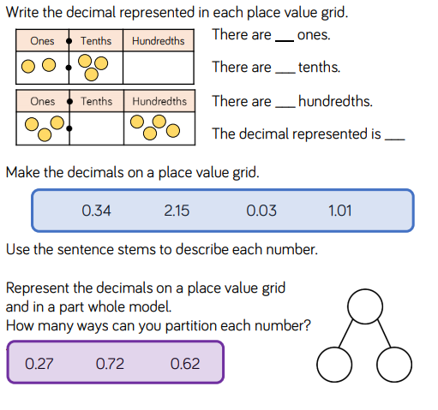
3.
2.
1.
These are the sentence stems
4.
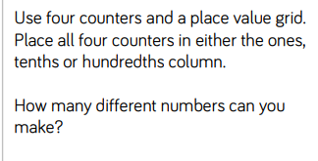
Note: The wording is a bit funny. You can put the counters in different columns but you can only use 4 counters altogether.

If you can’t manage every single question on the sheet, don’t worry. Just do whatever you can
If you are really struggling, just have a go at drawing some place value grids and putting these numbers into them:

3.45 2.34 5.67 3.05 4.32 1.23 0.07

Answers:

- There are 2 ones
There are 3 tenths

There are 4 hundredths
The decimal represented is 3.04

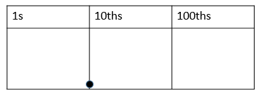

- This question has a lot of possible answers

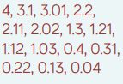
- These are the possibilities you could make with 4 counters:

