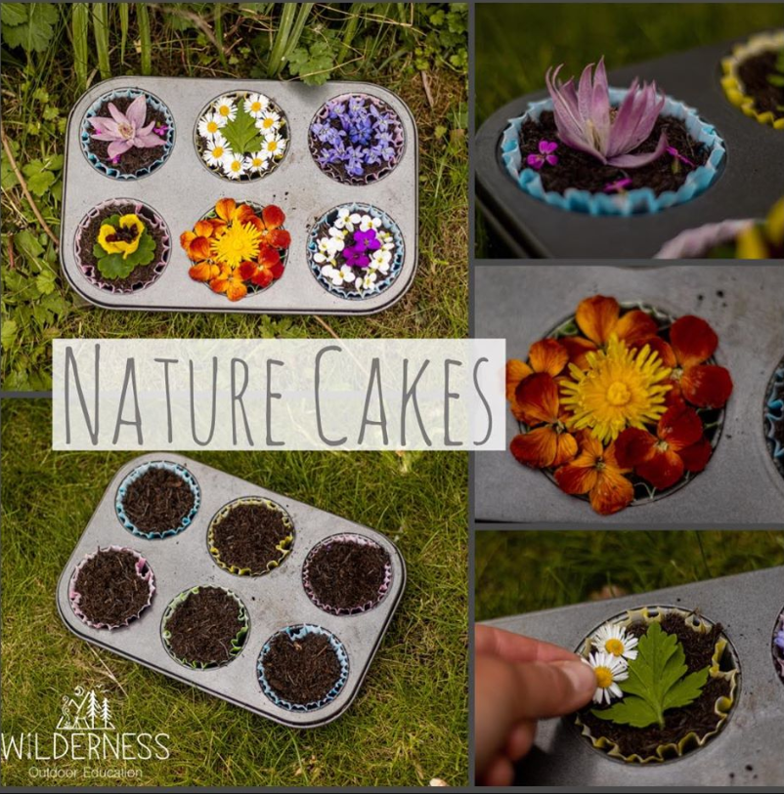
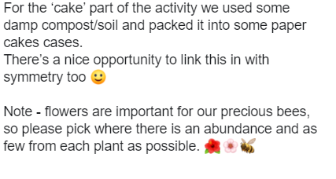
Above is an example of a natural cake recipe using plants from our own gardens. Can you make your own cakes this week or plant some seeds and watch them grow? Can you remember the name of any of the plants you have used?

