The Life of Christopher Columbus

In August 1492 he and his 3 ships (The Niña, The Pinta & The Santa Maria) set sail. | Christopher Columbus died in Spain in May 1506. | Christopher Columbus was born in Genoa (Italy) in 1451. | He wanted to go to India in search of herbs and spices. | He reached an island off the coast of America in October 1492. It became known as ‘The New World’. | He moved to Spain and asked the King and Queen for money to fund his trips.
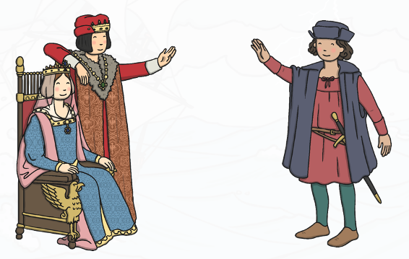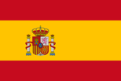 |  | 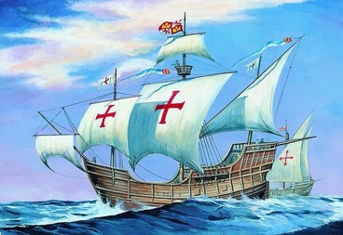 | 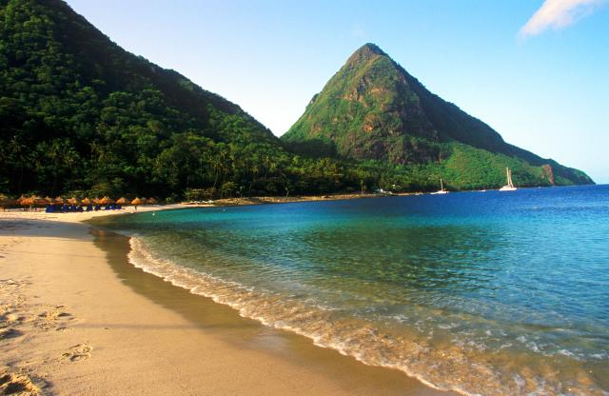 | 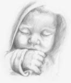  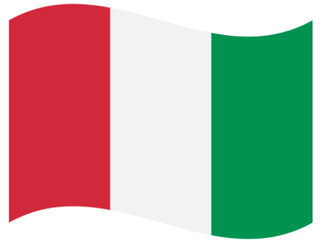 | 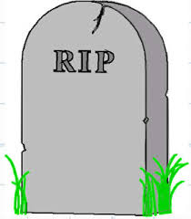

The Life of Christopher Columbus
Put the sentences in order along the top, then put the matching pictures along the bottom:
1 | 2 | 3 | 4 | 5 | 6

