WALT create a piece of artwork of our favourite biome

As the biomes topic is coming to an end, I would like you to pick your favourite biome and create a piece of artwork based on it. Use your imagination. Here are some ideas below:

* Silhouettes
* Collages
* ICT
* Pencil drawings
* Painting
* [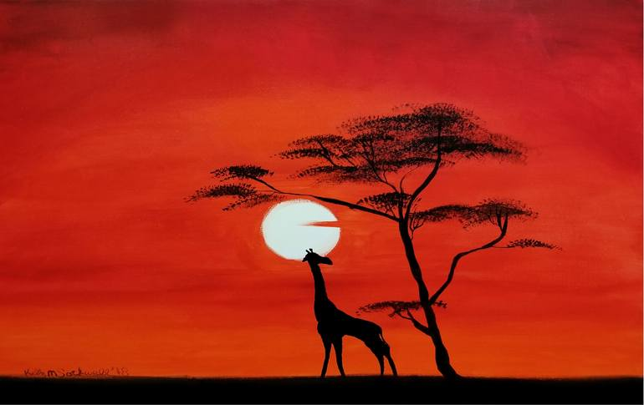](https://www.google.co.uk/url?sa=i&url=https%3A%2F%2Fwww.saatchiart.com%2Fart%2FPainting-Savanna-Evening%2F1076559%2F4163631%2Fview&psig=AOvVaw2LSV8YZ1jfPgAA8uWScaAE&ust=1589029356495000&source=images&cd=vfe&ved=0CAIQjRxqFwoTCMjIxOqppOkCFQAAAAAdAAAAABAD)Canvas
* Mixed medium
* Recycled materials/rubbish

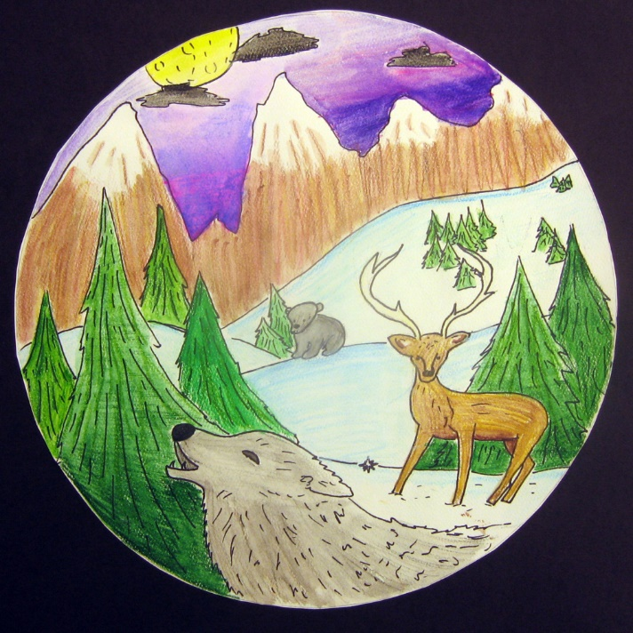 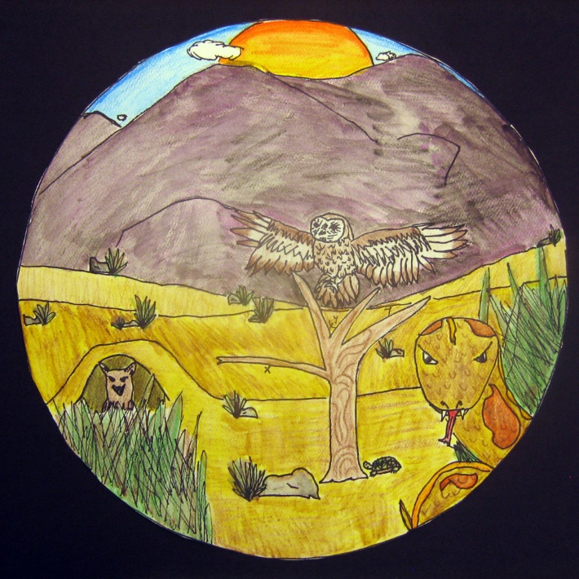

[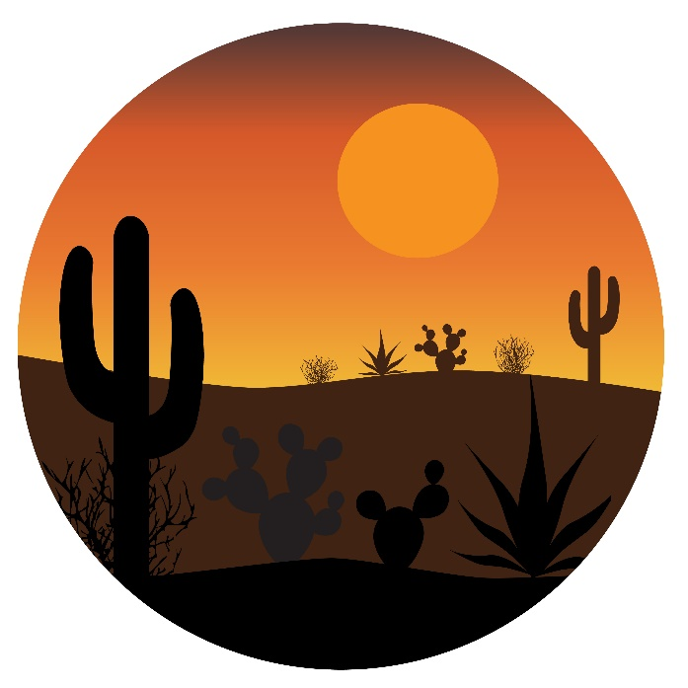](https://www.google.co.uk/url?sa=i&url=https%3A%2F%2Fwww.vecteezy.com%2Fvector-art%2F517894-desert-cactus-scene-in-circle&psig=AOvVaw3kjA-CwpV6s6O3jMoAsn_B&ust=1589029415426000&source=images&cd=vfe&ved=0CAIQjRxqFwoTCKjf1YiqpOkCFQAAAAAdAAAAABAF)[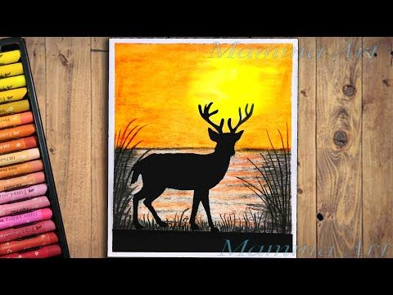](https://www.google.co.uk/url?sa=i&url=https%3A%2F%2Fwww.pinterest.com%2Fpin%2F856246947885374973%2F%3Famp_client_id%3DCLIENT_ID(_)%26mweb_unauth_id%3D%7B%7Bdefault.session%7D%7D%26from_amp_pin_page%3Dtrue&psig=AOvVaw0UI1O6BgPwOH-P2NpfEmzA&ust=1589029835163000&source=images&cd=vfe&ved=0CAIQjRxqFwoTCMDDvNWrpOkCFQAAAAAdAAAAABAI) [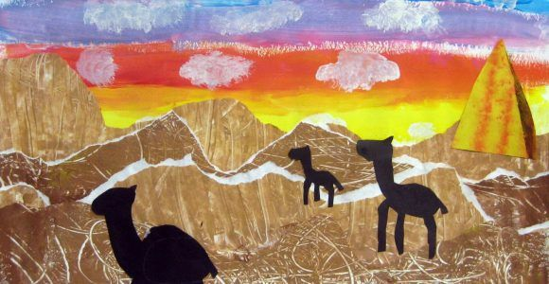](https://www.google.co.uk/url?sa=i&url=https%3A%2F%2Fwww.pinterest.com%2Fpin%2F451063718923034000%2F&psig=AOvVaw1-_SMYwppTplJ1QXKxLJlp&ust=1589029935279000&source=images&cd=vfe&ved=0CAIQjRxqFwoTCND104ispOkCFQAAAAAdAAAAABAE)

[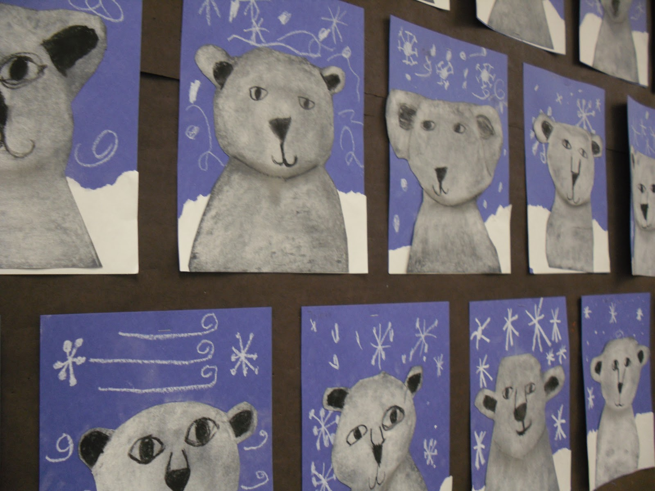](https://www.google.co.uk/url?sa=i&url=https%3A%2F%2Ffuncraftskids.com%2Fpolar-bear-ideas-art%2F&psig=AOvVaw1nHFTJdt8HKeH1F1hmXQJN&ust=1589029642550000&source=images&cd=vfe&ved=0CAIQjRxqFwoTCLjOkO-qpOkCFQAAAAAdAAAAABAM)

[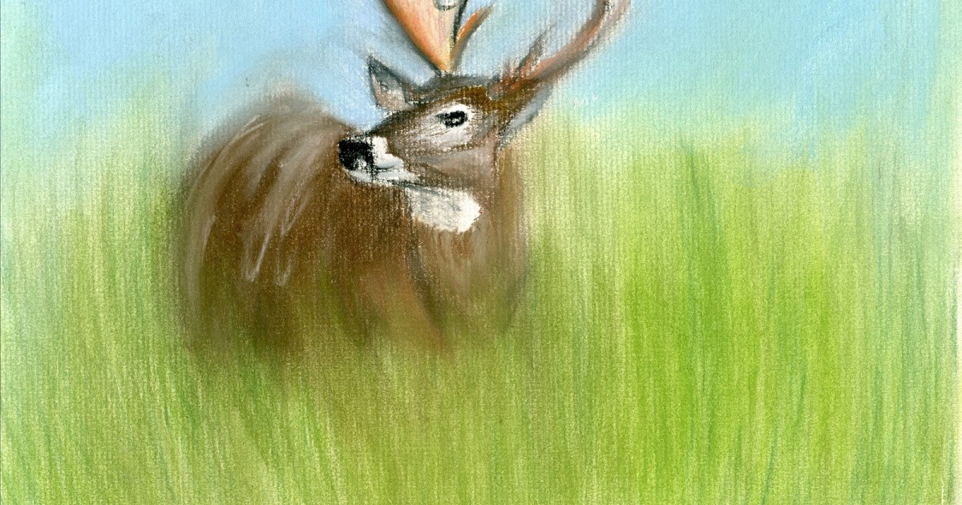](https://www.google.co.uk/url?sa=i&url=http%3A%2F%2Fblogofdrawings.blogspot.com%2F2011%2F08%2Fpastel-deer.html&psig=AOvVaw0UI1O6BgPwOH-P2NpfEmzA&ust=1589029835163000&source=images&cd=vfe&ved=0CAIQjRxqFwoTCMDDvNWrpOkCFQAAAAAdAAAAABAD) [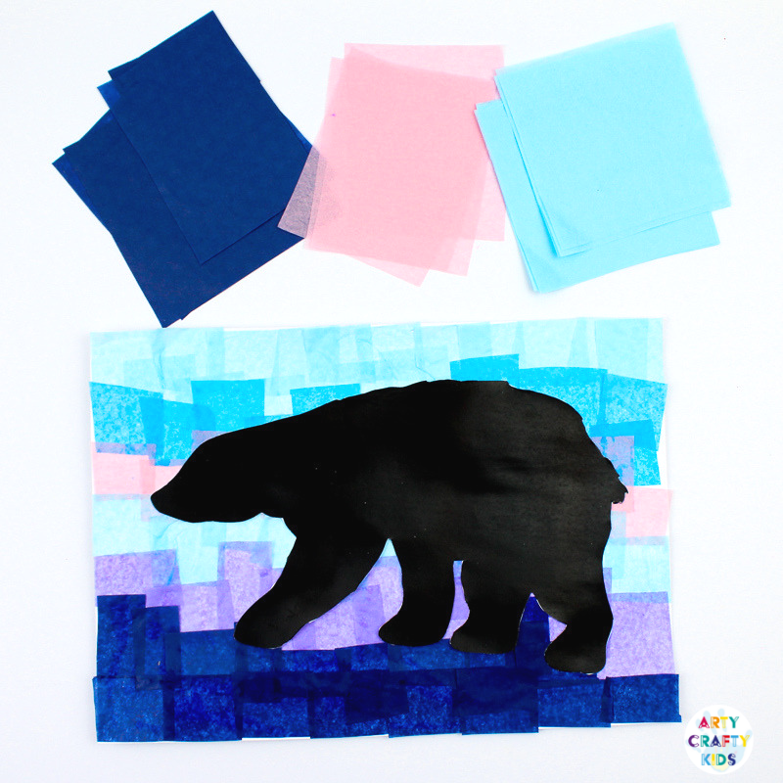](https://www.google.co.uk/url?sa=i&url=https%3A%2F%2Fwww.artycraftykids.com%2Fart%2Fpolar-bear-winter-art%2F&psig=AOvVaw1nHFTJdt8HKeH1F1hmXQJN&ust=1589029642550000&source=images&cd=vfe&ved=0CAIQjRxqFwoTCLjOkO-qpOkCFQAAAAAdAAAAABAG)