Thursday 14th May 2020
WALT plan a story

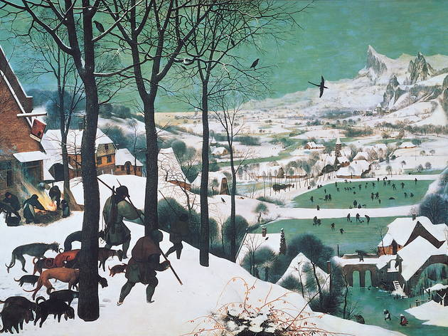

- Write two senteneces to describe what you see in the picture.
- Make a list of adjectives to describe the people, landscape and weather.
- If you were one of the hunters in the picture, how would you feel about being outside on a cold day?
- Make a plan for a story in your book using the structures below:

