Week Beginning 11.5.20 Reception Home Learning
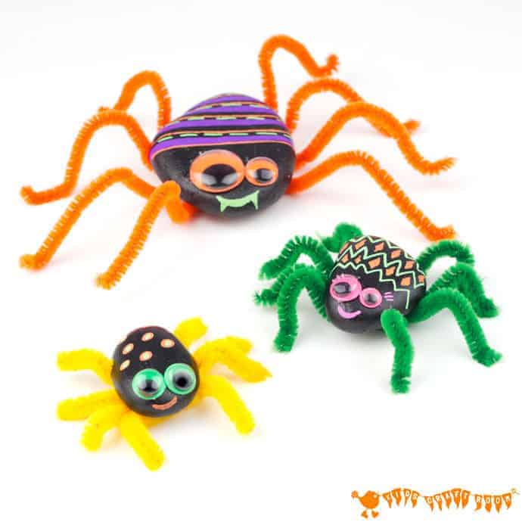
This week our minibeasts of the week are spiders! Some people are afraid of spiders but you don't need to be. You'll be spider experts by the end of the week!

Monday
English
Our special story of the week is Spinderella by Julia Donaldson. Read or watch the story (this video version can be stopped just after 9 mins, as it then repeats again!). Discuss the story, have you heard it before? Next use your neatest colouring skills to colour the Spinderella Colouring Sheet or you can draw your own picture of Spinderella and then colour it in. Remember the focus is on pencil control and correct grip as well as making the picture look beautiful!
Phonics
First try and read all of the phase 3 sounds on the Polly's Phonics path (Espresso) watching any videos along the way if your child is unsure. Then play the Phonics Pop game from last week. Here you can choose which phonemes (sounds) to practise, so please pick the set of sounds that you feel your individual child needs to practise the most. You can repeat this game with different sounds to practise each time.
Maths
Start by singing and dancing to our favourite numbers to 20 song. Spinderella loves numbers. Do you remember in the story she loved counting to 20? We are going to do some counting to 20 work today too! First carefully count the number of spiders on each of the webs on the Spider Counting sheet and then add the right number of spiders to the webs on the Spider Counting 2 sheet.
Topic
Start by singing the Minibeasts Song. Then watch the Spider minibeasts adventure video to find out lots of interesting spider facts. Did you know that all spiders have 8 legs and they can also have up to 8 eyes?! After you've watched the video you could do your own spider and harvestmen search of your garden (or out on a walk). Can you find any? Are you brave enough to hold one?

Tuesday
English
Re-read or watch Spinderella by Julia Donaldson. Then have a think about what you already know about spiders. Use the Spider Describing sheet (or just a piece of paper) to make a list of words associated with spiders - e.g. web, 8 legs, fast etc. We're going to use this list for our writing tomorrow so make sure you keep it safe! When you've finished your list you can give your spider a nice friendly face :)
Phonics
Watch the Phase 3 sounds video, reading the sounds as they appear on the screen. Then play any of the phase 3 games on Phonics Play.
Maths
Spinderella has learned all about sharing things fairly or equally. Today we are also going to practise sharing things equally into two groups. This is called halving or finding half - it's the opposite of what we were doing last week when we were doubling!
First watch the Pedros Pizza Parlour Halving powerpoint (Remember to click on 'slide show' and then 'from beginning' to make it work properly). Then the children can have a go at drawing their own pizza and cutting it into two equal halves. Make it as yummy as you like and make sure both halves are the same!
Topic
Tuesday afternoon is our computing afternoon. Go to the Spider activity on Purple Mash (Art, Animals, Spider). Create your own spider, remember it needs 8 legs! Then you can try the other spider activity, Spider on a Web - I can't wait to see what you come up with! Remember to save your work in our Reception folder - I do love to see all the lovely things you've done at home. Here are ones I did for you to have a look at...
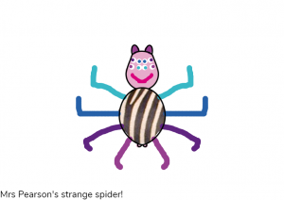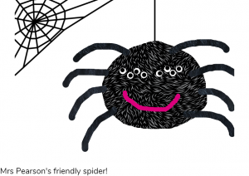

Wednesday
English
Re-read or watch Spinderella by Julia Donaldson. Next we're going to use the list of spider words that you came up with yesterday to help us write some spider sentences! You can use the Spider Writing sheet, or just a piece of paper. All you need to do is choose one of the items on your list from yesterday, e.g. 8 legs and put it in to a sentence, e.g. Spiders have got 8 legs. We always practise saying the sentence out loud before we write it down and don't forget to use a space between every word! Can you write another spider sentence when you've finished? Add your own spider picture when you've finished your writing.
Phonics
Watch the Tricky Words song and then try copying each of the tricky words in the first column of the Phase 3 Tricky Words List 3 sheet (the second column is for tomorrow).
Maths
Start with a counting to 20 song (please point out that this song is American and we need to pronounce the t in twenty!)
Re-cap what sharing equally and halving mean. This sharing game will help you practise sharing into two equal groups, or halves, that we learnt about yesterday. You've got to try and make sure that both dogs get exactly the same number of dog treats, half each!
Topic
First listen to and sing the Incy Wincy Spider Song on espresso. We used to sing along to these nursery rhymes a lot with our year 6 buddies at the start of the year, so we should know them very well! :) Then it's creative time! Use anything you like: paper, play-dough, stones, bottle lids, egg boxes, cardboard boxes, tubes etc. that you have lying around the house to create your own model spider. Here are some spider ideas to help inspire you.
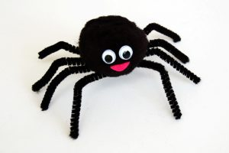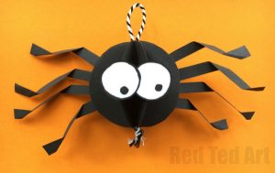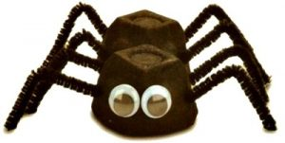
(If you are struggling for resources and would prefer to use an activity sheet instead then you can use 2D Shape Spider Picture Activity Sheets). Please send us a photo so we can see your creations!

Thursday
English
Today we're going to look at a different spider story. This one is called Aaaarrgghh, Spider! by Lydia Monks. It's about a family who end up having a spider as a pet, imagine that! Your activity is to first discuss - would you like to have a spider as a pet? Then fill in the Pet Spider sheet (or create your own simple version).
Phonics
Watch the Tricky Words song again and then try writing each of the tricky words in the second column of the Phase 3 Tricky Words List 3 sheet, remember to cover up the original words first - no peeping!
Maths
Start with a different counting to 20 song (this is another American song, please make sure they pronounce the t in twenty!)
Re-cap what halving means - to share something into two equal groups. Last week ladybirds helped us with our doubling skills, this week they're back to help us with our having skills! Today you need to share the number of spots equally between the two halves of the ladybirds body on the Ladybird Halving To 20 sheet - make sure they're the same on both sides before you write the answer down!
Topic
First watch The Very Busy Spider. There are lots of great spider stories but I thought you might like to see this one as it's by the same author who wrote The Very Hungry Caterpillar! Spider webs are so beautiful. Have a go at making your own spider web picture. You can use paint, chalk, glitter, paper, string, wool, spaghetti - or anything else you can think of! Please send us photographs, we love to see your creations!
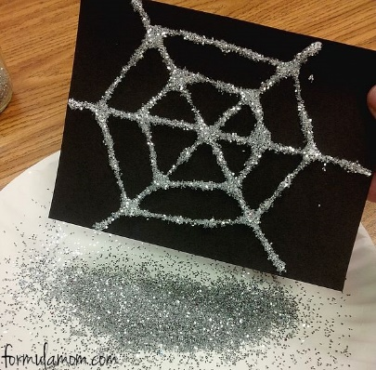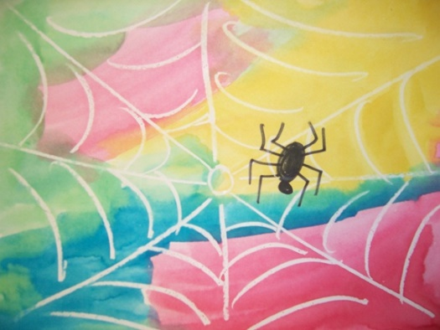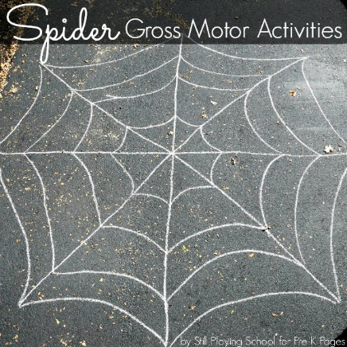

Friday
Physical Activity
Today warm up with some of the actions from the Minibeast Action Cards and then try the Cosmic Yoga Spider activity.
Phonics
Recap the phase 3 phonemes along Polly's Phonics path (Espresso), watching any videos along the way that you need extra practise with. Then have a go at using your phase 3 phonics to read the words on the Phase 3 Sound Buttons Powerpoint (remember to click on 'slide show' and then 'from beginning' to make it work properly).
Forest School
Collect some natural resources from your garden or on your walk and use them to create your own spider and/or web. Please take a photograph so that we can see your wonderful creations!
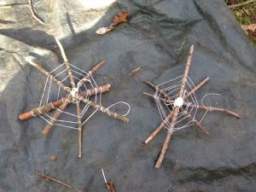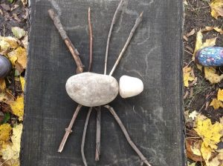
Topic
Listen to The Minibeasts Song again, join in if you can!
Friday afternoon is our finishing off/ intervention time. Go over any activities that your child needs to complete or has found tricky this week. Remember number and letter formation is always a priority – especially writing their own name perfectly!

Have a lovely weekend! 🙂

