Week Beginning 18.5.20 Reception Home Learning
This week is our final minibeasts week! Because it’s our last week there isn’t one special minibeast of the week- we’re going to think about ALL minibeasts and have lots of fun! *** Please look ahead to the special activity we have planned on Thursday afternoon – more details will follow on Tapestry too 😊🦋🐌🐛🦟🦗🐜🐝🐞🕷🕸***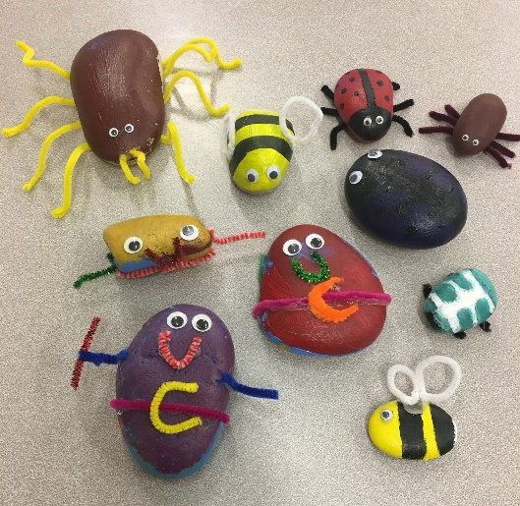

Monday
English
Our final minibeasts book is one about lots of different minibeasts. It’s called Mad About Minibeasts! by Giles Andreae. Read or watch the story together and discuss the different minibeasts. Choose one of the Mad About Minibeasts Colouring Sheets to colour carefully – colour the name of the minibeast in carefully too.
Phonics
We are going to re-cap all of the phase 3 phonics this week. But first let’s go back and check we’re super confident with phase 2. First look at the Scraps Phonics path on Espresso. Read all the sounds along the path and press to watch the video of any that you’re unsure of (*make a list of these sounds to practise afterwards throughout the day).
Next go on Scrap’s phonics Activities. Here you can choose an activity (or activities) best suited to the individual needs of your child – if they are fully confident with all of the sounds, go right down to the activities at the bottom; if they need to practise certain sounds then choose an activity linked to that sound from the list.
Maths
This week we are going to re-cap numbers to 20, so that we’re really confident with those teen numbers. We’re also going to practise some basic addition and subtraction skills.
Start with our numbers to 20 song. Then we’re going to do an adding activity. Re-cap what adding means, look at the + sign. Then try the Minibeast Addition sheet.
Topic
Start by singing the Minibeast song. Then we’re going to be minibeast detectives! Watch the Minibeast Detectives PP (remember to click ‘slide show’ and ‘from beginning’ to make it work properly). We are all minibeast experts now – look/listen to the clues very carefully and see if you can guess what each of the mystery minibeasts is?

Tuesday
English
Re-read or watch Mad About Minibeasts! by Giles Andreae. Discuss all the different minibeasts and which ones you like/dislike. Listen to the ‘If I were a minibeast‘ song. If you could be any minibeast, which one would you be? Use the If I Was A Minibeast planning sheet to draw and carefully colour your chosen minibeast. * the writing part is for tomorrow*
Phonics
Start by quickly reading through all the sounds on the Phase 2 Mat to practise these sounds again (*please make a note of any that your child doesn’t know confidently and write them down to practise throughout the day). Then play the phase 2 Dragon’s Den game (revise all phase 2) on Phonics Play to make sure they are using these sounds well to blend and read words.
Maths
Start with a counting to 20 song Then we are going to focus on taking away – which is basically just the opposite of adding. We know that when we add the numbers always get bigger, but when we take away the numbers always get smaller.
Watch the Minibeast Subtraction Powerpoint (remember to click on ‘slide show’ and ‘from beginning’). Please explain that take away and subtract mean the same thing! Then try some practical maths: Give your child 5 objects to start with (anything you have lying around the house – pencils, sweets, anything!) and ask them to take away 2. How many do they have left? Try again with different amounts, moving up to 10 if they are confident subtracting within 5.
Topic
Tuesday afternoon is our computing afternoon. Today your child can choose from any of the minibeast activities on Purple Mash; either one which they’ve particularly enjoyed or one which they’ve not had chance to do yet: Purple Mash, Art, Animals, then either:
Butterfly Butterfly Life Cycle Minibeast Spider or Spider on a Web.
Here are some examples of fabulous minibeasts that have been created by members of our class over the last two weeks:
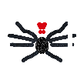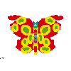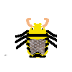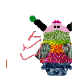

Wednesday
English
Re-read or watch Mad About Minibeasts! by Giles Andreae. Look back at the picture of a minibeast that you chose yesterday. Why would you choose to be that particular minibeast? Explain your answer before writing it down on the sheet underneath your picture. Remember a finger space between each word!
Phonics
Now we’re going to focus on all the phase 3 sounds. First look at Polly’s Phonics path on Espresso. Read all the sounds along the path and press to watch the video of any that you’re unsure of (*make a list of these sounds to practise afterwards throughout the day).
Next go on Polly’s phonics Activities Here you can choose an activity (or activities) best suited to the individual needs of your child – if they are fully confident with all of the sounds, go right down to the activities at the bottom; if they need to practise certain sounds then choose an activity linked to that sound from the list.
Maths
Start with a different counting to 20 song. Then watch and play the Number stories: Take away game on Espresso to practise the subtraction skills that we learned yesterday (this game introduces how to write a subtraction problem as a number sentence).
Topic
We have had lots of fun over the last half term learning about different minibeasts. This afternoon we are going to get creative and make a home for minibeasts – a bug hotel! Your bug hotels do not need to be anything ‘fancy’; minibeasts just love having lots of different places to hide – rolled up newspaper or natural resources you can collect (such as sticks and leaves) are perfect! Here are some ideas for you to have a look at:
* There will be more time to finish these on Friday so do not feel that they have to be completed today! *

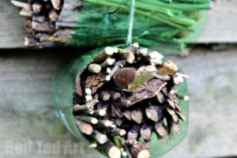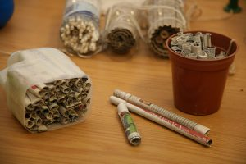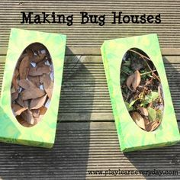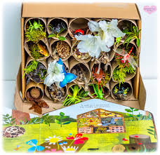

Thursday
Topic
If we were all in school today, it would be our end of topic celebration day – I was hoping we’d all come dressed up as different minibeasts! 🦋🐌🐛🦟🦗🐜🐝🐞🕷 So, to make sure that we don’t miss out on this opportunity we have a ‘mini’ minibeast party planned for this afternoon! Your job this morning is to decide whether you’d like to come to the party dressed up as a minibeast – and if so what can you find at home to do just that? Here are some Minibeast Masks Templates To Decorate, which are just fun to make- and also gives you something to wear this afternoon if you would like to!
Phonics
Start by quickly reading through all the sounds on the Phase 3 Mat to practise these sounds again (*please make a note of any that your child doesn’t know instantly and write them down to practise throughout the day). Then play the phase 3 version of the Dragon’s Den game (whichever sounds your child needs to practise) on Phonics Play to make sure they are using these sounds well to blend and read words.
Maths
Start with our numbers to 20 song. Then re-cap what ‘subtraction’ or ‘take away’ means. Have a go at the Minibeast Subtraction Sheets. There are three different levels of worksheet here – choose whichever one you think your child needs. * In school I would teach them to actually cross out the number of minibeasts that they are subtracting, in order to find the answer.
Topic
1.30pm is minibeast party time! 🕷🐞🐝🐜🦗🦟🐛🐌🦋
There is obviously no obligation to do so, but if you would like to join our minibeast party then please log in to Zoom and use the codes that I sent you on Tapestry on Monday. This is a meeting set up purely for the children (and families!) in our Reception class, just to give them the opportunity to see each other again. The children who are in school will be able to join from our classroom with Mrs Leavy. Mrs Hall and I will both be joining from our own homes. 😀
If you are unable to join our class party, please do have your own little minibeast party at home with your own families, get them to have a silly dance along to The Ugly Bug Ball song and do the Bug Dance!

Friday
Physical Activity
Warm up by doing the Bug Dance then it’s cosmic yoga time again: Stella the Stick Insect!
Phonics
Revision of Phase 3. Watch the Phase 3 video (don’t worry about the technical terms – ‘phoneme’ is just the sound, ‘grapheme’ is how it’s written down – i.e. the letters. The children are used to hearing these words in school). Then play any of the phase 3 games on Phonics Play.
Forest School
First use this session to finish off your bug hotels from Wednesday. Then try and find a good place for it to go – it needs to be outside, but where is up to you! Please send us a picture of your finished bug hotel when it’s in place – I wonder how many visitors you will get in your hotel!
Topic
Listen to The Minibeasts Song and the Creepy Crawly and Itchy Things! songs.
Friday afternoon is as always, our finishing off/ intervention time. Go over any activities that your child needs to complete or has found tricky this week. Remember number and letter formation is always a priority – especially writing their own name perfectly!

***Have a lovely half term break! 🙂***

