Week Beginning 27.4.20 Reception Home Learning

Monday
English
Our story this week is The Very Hungry Caterpillar by Eric Carle. Read or watch the story together and then try the TVHC Sequencing Activity – first cut out and mixing up the pictures, then ask your child to carefully sequence them in the correct order – taking about the story as they go. If you don’t have access to a printer simply ask them to retell the story, using the pictures or book to support.
Phonics
Re-cap all of Polly’s Phonics (Espresso) and focus on any sound/s that your child doesn’t know confidently. Then have fun playing any of the Phase 3 games on Phonics Play.
Maths
Our focus for this week is the days of the week. First ask your child to sing the days of the week song that we sing frequently in class (there is no online video for this, but remind them it’s to the tune of The Addams family!). They can also watch The days of the week song and then complete the Days Of The Week Caterplillar activity (just page 1). For this they need to cut out the days and stick them in the correct order, starting with Monday. * Tuesday is the day that they might find tricky as it sounds like a ‘ch’ at the start, the others they should be able to work out themselves from looking at the start letters* They can then colour their caterpillar when they have finished.
Topic
This afternoon we are going to look at the life cycle of a butterfly. First look at the Butterfly Life Cycle on Espresso. Then they can create their own butterfly life cycle, using either the Butterfly Life Cycle Activity sheet or using any other resources that you may have at home – here are some ideas: Butterfly Life Cycle Ideas – be as creative as you like!

Tuesday
English
Re-read or watch the The Very Hungry Caterpillar together and discuss all the different foods that the hungry caterpillar eats along the way. Which of the foods do you like/dislike? Ask your child to make a list of all the foods they can remember that the caterpillar eats along the way, adding a small picture to go with each item on their list. Use the The VHC Food List sheet or simply make the list on a blank piece of paper.
Phonics
First re-cap all of the phase 3 sounds on the Polly’s Phonics path (Espresso), then click on the Tricky words video at the bottom. Try the Reading Tricky words game to finish.
Maths
First ask your child to sing the days of the week song that we sing in class. They can also watch The days of the week song and then try today’s activity: TVHC Days Of The Week Writing If you don’t have access to a printer the children can simply practise writing the days of the week in the correct order.
Topic
Tuesday afternoon is our computing afternoon. Go to the fruit bowl activity on Purple Mash (Art, Food, Fruit bowl). Fill the bowl with lots of delicious fruit – it could be fruit from our story of the week or it could just be full of fruits that you like!

Wednesday
English
This video is of Eric Carle himself reading the The Very Hungry Caterpillar, watch the video together and discuss. Think about all the food that the very hungry caterpillar ate and then talk about which food you really like to eat. Use the Foods I Like sheet or just a blank piece of paper to create two lists – including at least three foods that your child likes and three that they don’t like – add a little picture to go with each item in the list.
Phonics
Watch the Tricky Words song and then try copying each of the tricky words in the first column of the Phase 3 Tricky Words List 1 sheet (the second column is for tomorrow).
Maths
Re-cap days of the week by watching The days of the week song again and then we are going to revise last week’s work on addition by completing the TVHC Addition activity Remember to focus on number formation (all start at the top) as well as the actual addition process.
Topic
This afternoon we are going to consolidate our learning of the story and of the days of the week. We are going to make our own ‘lift the flap’ days of the week hungry caterpillar. For this you can basically be as creative as you like -all you really need is some paper! Simply make 7 different ‘flaps’ each with one of the days of the week written on the top and a picture of the food eaten that day on the underneath. Then stick the ‘flaps’ down onto a long caterpillar shape and add a face!
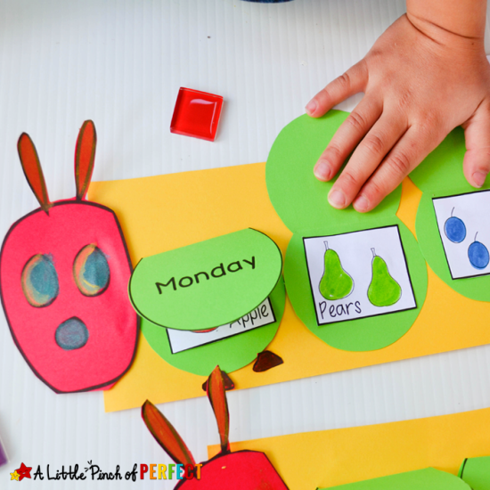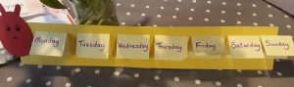
Please do send us any photographs of your completed lift the flap caterpillars

Thursday
English
Choose either the Eric Carle version of the The Very Hungry Caterpillar or the The Very Hungry Caterpillar video from the start of the week. Think about all the food that your child wrote on their list yesterday and ask them to choose from it which one food is their absolute favourite. Ask them then to write (at least) one sentence about this food using the My Favourite Food Writing Frame sheet or just on a plain piece of paper. Remind them about finger spaces and careful letter formation. Finish by adding a picture of their favourite food.
Phonics
Watch the Tricky Words song again and then try writing each of the tricky words in the second column of the Phase 3 Tricky Words List 1 sheet, remember to cover up the original words first – no peeping!
Maths
Watch The days of the week song and then try today’s activity: TVHC Pattern Sheet
Remind the children that to be a pattern the colours need to repeat. Can they complete the colour patterns?
Topic
Junk modelling time! Use any old cardboard boxes, cardboard tubes and other bits and bobs that you have lying around the house to create your own model – choose from a caterpillar or butterfly, which one will you make? Please send us a photo so we can see your creations!

Friday
Physical Activity
First use the Minibeast Action Cards to have fun pretending to be lots of different minibeasts! Can you come up with any new ideas of your own? Then finish with Cosmic Yoga: The Very Hungry Caterpillar activity
Phonics
Today ask your child to read through the words on their individual key words list that they brought home from school. Let us know on Tapestry how they did- if you can upload a video of your child reading their words that would be even better! If they now know all the words then we will send you the next word list to work on at home
Forest School
Whenever possible use your walk to collect some leaves of different shapes and sizes. When you get home pretend to be the very hungry caterpillar and ‘munch’ through each leaf once (a grown up needs to help with this unless you have a hole punch at home), then thread the leaves together using string, wool or anything else you have. You could even make a leaf necklace! Look at the Leaf Threading picture to give you an idea of what to do.
Also of course, see if you can spot any real caterpillars or
butterflies whilst you are outside
Topic
Listen to The Minibeasts Song again, join in if you can!
Friday afternoon is our finishing off/ intervention time. Go over any activities that your child needs to complete or has found tricky this week. Remember number and letter formation is always a priority – especially writing their own name perfectly!

Please keep on sending any photographs in via Tapestry (rather than via email to the school office), it is so lovely to see the work that the children are doing at home – and we can add them to the Home Learning Experiences Page so that the children can all see each other too!

