Week Beginning 4.5.20 Reception Home Learning
This week our minibeasts of the week are bees and ladybirds! The bees will be featuring mostly in our English lessons and the ladybirds mostly in our maths lessons :)
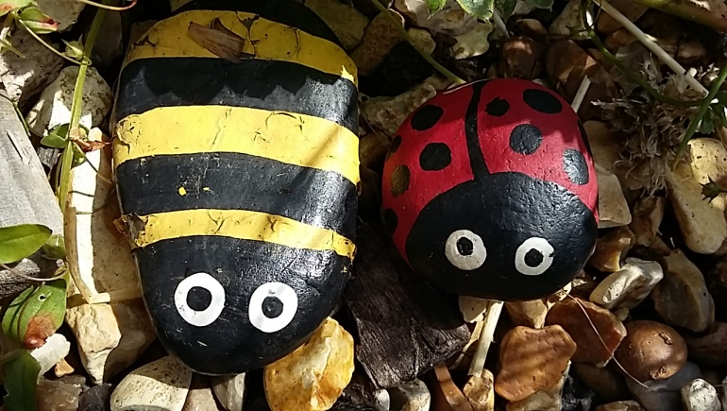

Monday
English
Our story of the week is The Very Greedy Bee by Steve Smallman. Read or watch the story and discuss, did they enjoy the story? Then we're going to practise our pencil control and letter formation by using our very neatest writing to complete the letter formation sheet (you should have some of these in your pack from school, or you can download it here: Letter Formation Alphabet Handwriting Sheet) Please make sure that every letter starts in the right place (indicated by the dot), also encourage your child to name each letter and sound as they write it. Any letters that your child struggles to form correctly please practise on the back of the sheet several times.
Phonics
First try and read all of the phase 3 sounds on the Polly's Phonics path (Espresso) watching any videos along the way if your child is unsure. Then click on the Tricky words video at the bottom. Try the Reading Tricky words game to finish.
Maths
Start by singing and dancing to our favourite numbers to 20 song. Then play the Topmarks ladybird game to practise careful counting, with 1:1 correspondence: First click on 'Matching' and then '1-10'. If your child needs more of a challenge choose the 'Ordering' (instead of Matching) and then 'Smallest to Largest' and '1-10'.
Topic
Start by singing the Minibeasts Song . Then watch the Minibeast Adventures with Jess' Bee video and Ladybird video to find out a little more about each of these minibeasts.
Next we are going to do a ladybird symmetry hunt! Use the Ladybird Hunt sheet or simply draw a few small ladybirds of your own (some with the same number of spots on each side and some with different amounts of spots).
The idea is to cut these ladybirds out and hide them around your home/garden for your child to find. Once they find them they can sort them into two groups: ladybirds that are symmetrical (have the same number of spots on each side) and ladybirds that are not symmetrical. This activity will lead us nicely into tomorrow's maths activity on doubling.

Tuesday
English
Watch a different video of The Very Greedy Bee story. This one is read by 'Uncle Wally', who is a very animated story teller! In the story the bee is very greedy. Ask your child to think of some words to describe themself: e.g. clever, kind, smiley, cheeky, gorgeous... Use the Bee Writing Frame - On the top line write 'I am' and then on the following lines of the bee's body make a list of the words to describe themselves (four words). They can then colour the bees wings to finish :)
Phonics
Watch the Tricky Words song and then try copying each of the tricky words in the first column of the Phase 3 Tricky Words List 2 sheet (the second column is for tomorrow).
Maths
To start, sing the numbers to 20 song then we are going to learn about doubles. First watch the Doubling Machine PP to explain what doubles are (Press on slide show and then from beginning to watch it).
Double just means two of the same thing, so if we're adding doubles it's just a special addition where we add the same number twice! Try the Double The Number Of Spots On The Ladybirds To 12 sheet (or draw a simple version of your own).
Topic
Tuesday afternoon is our computing afternoon. Go to the Minibeast activity on Purple Mash (Art, Animals, Minibeast). First try and create your own bee or ladybird and then you can create your own brand new minibeast creation - I can't wait to see what you come up with! Remember to save your work in our Reception folder - I do love to see all the lovely things you've done at home. Here are ones I did for you to have a look at...
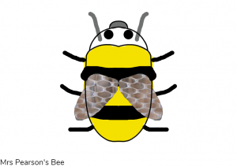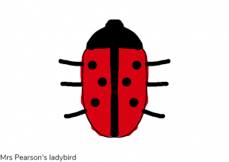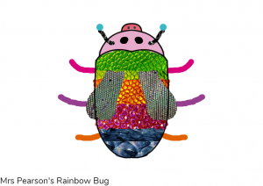

Wednesday
English
Watch either Monday's video of The Very Greedy Bee or Tuesday's The Very Greedy Bee by Uncle Wally - whichever version your child prefers. There is a very important message behind this story, about sharing and being kind to others. Ask your child to think of something they have done to be kind or to share with somebody else (e.g.sharing something of theirs with a friend/sibling). Ask them to draw a picture of this and write a sentence to explain what it is, don't forget a finger space between every word!
Phonics
Watch the Tricky Words song again and then try writing each of the tricky words in the second column of the Phase 3 Tricky Words List 2 sheet, remember to cover up the original words first - no peeping!
Maths
Sing the numbers to 20 song. Then re-cap what double means and how we find the double of a number. Try the harder Double The Number Of Spots On The Ladybirds sheet (or create your own version).
Topic
First watch The Bee song and The Bees go buzzing song. Then it's creative time, activity one! Use anything you like: paper, play-dough, stones, bottle lids, bun cases, cardboard boxes, tubes etc. that you have lying around the house to create your own model bee. Here are some bee ideas to help inspire you. (If you are struggling for resources and would prefer to use an activity sheet instead then you can use 2D Shape Bee Picture Activity Sheet).
Please send us a photo so we can see your creations!
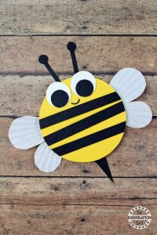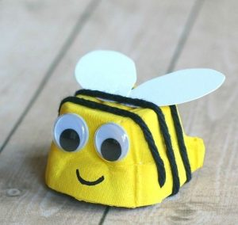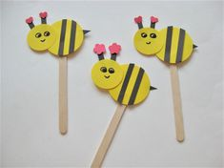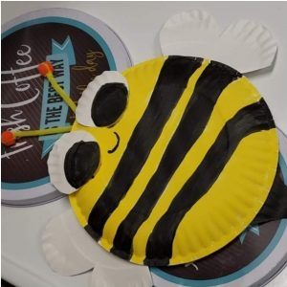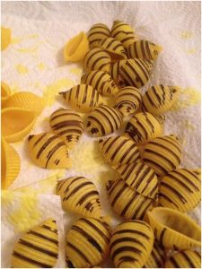

Thursday
English
Watch the Bees video. Bees are very busy minibeasts who work very hard! Use the Bee Poem Sheet to write a poem about bees. All they need to do is choose one word to complete each of the first three lines and then think of their own sentence for the last line. There is a word bank to help them at the bottom but they can use words of their own too.
Phonics
Revision of different phase 3 phonemes: Try the Phonics Pop game. Here you can choose which phonemes (sounds) to practise, so please pick the set of sounds that you feel your individual child needs to practise the most. You can repeat this game with different sounds to practise each time.
Maths
Sing the numbers to 20 song. Review what doubling a number means. Today we're going to do the Blank Ladybird Sheet Ask your child to come up with their own ladybird doubles sums, remembering to write the number sentence underneath each ladybird!
Topic
First listen to and join in with the Ladybird Song, (remember to click on slide show and from beginning to make it work). Can you add actions too?
Then it's creative time, activity two! Use anything you like: paper, play-dough, stones, bottle lids, bun cases, cardboard boxes, tubes etc. that you have lying around the house to create your own model ladybird. Here are some ladybird ideas to help inspire you. (If you are struggling for resources and would prefer to use an activity sheet instead then you can use 2D Shape Ladybird Picture Activity Sheet).
Please send us a photo so we can see your creations!
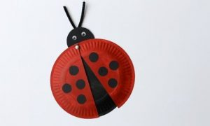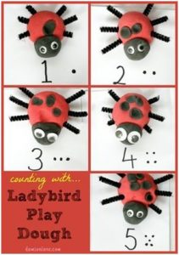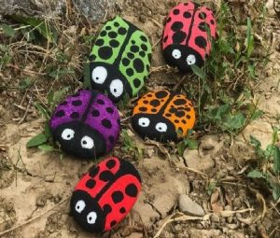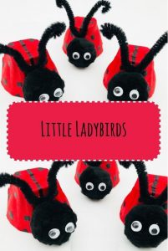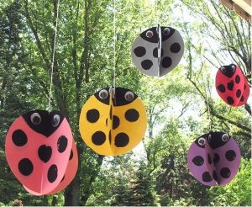

Bank Holiday Friday
Enjoy a day off with your family today! There are different VE day activities on Twinkl and Espresso if you would like to do any activities at home, or you could try one of these:
Flag Colouring Union Flag Bunting
If you manage to get out for a walk or play in the garden then please do keep an eye out for minibeasts - especially bees and ladybirds! Also if you want to try a new cosmic yoga activity there's a nice one called Enzo the Bee :)

Have a lovely weekend! 🙂

