WALT label coastal resorts on a UK map.
http://www.british-coast-maps.com/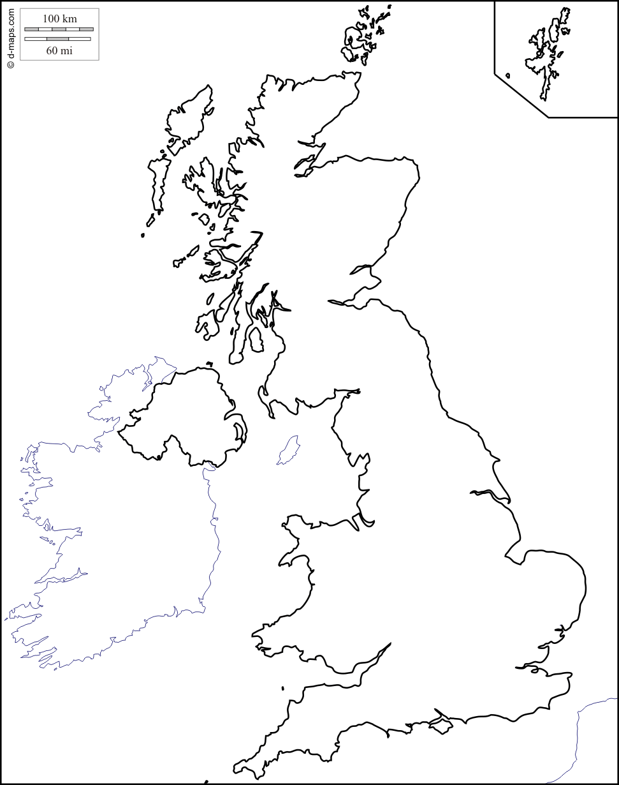
- Shade the coastal areas on the UK map.
- Draw lines to show the borders of the countries in the UK and label them.
- Pick 5 well-known coastal resorts and label them using a key below:
Blackpool

