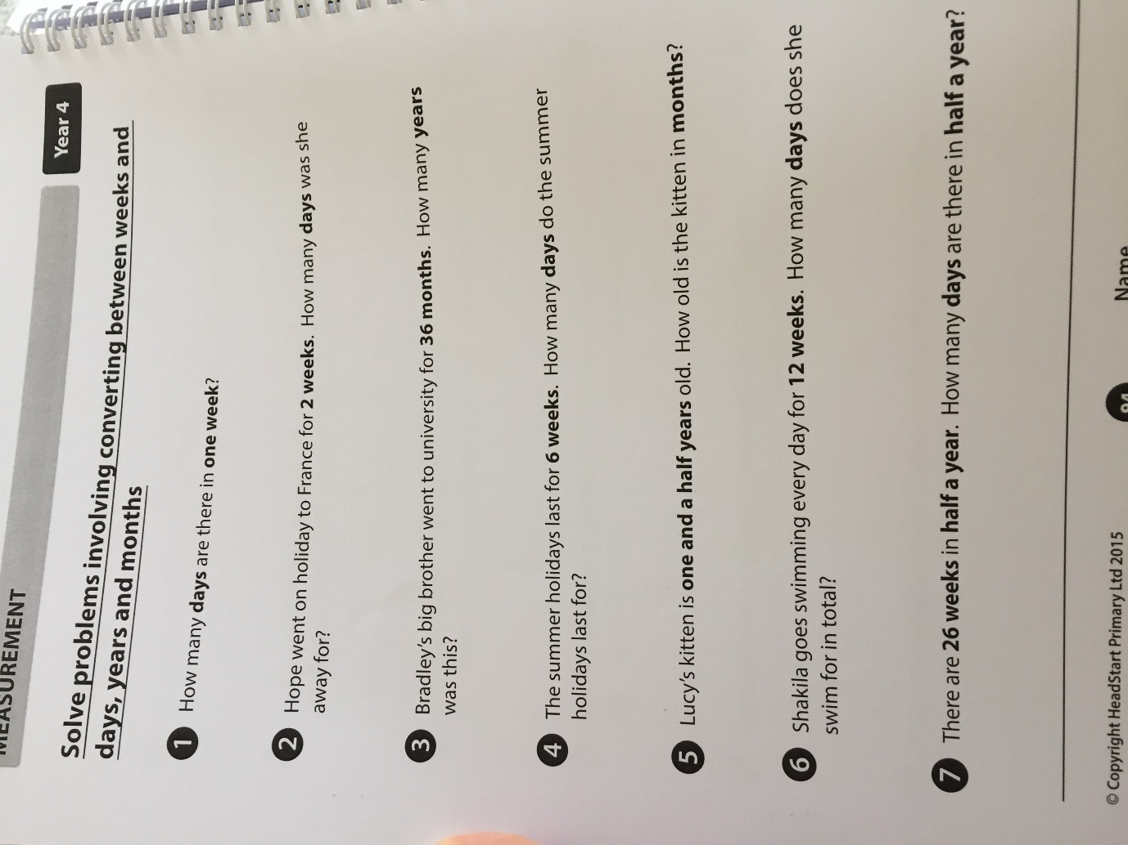

Extension: Write 5 questions of your own which involve converting between days, weeks, months and years

Answers:
- 7 days
- 14 days
- 3 years
- 42 days
- 18 months
- 84 days
- 182 days (or 182.5 days)

