WALT: think about what we are good at and what we find difficult. Date……………………………………..

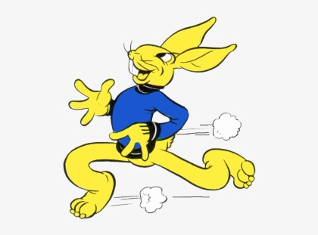  Things I am good at  ……………………………………………………………………………………………………………………………………………………………………………………………………………………………………………………..  ……………………………………………………………………………………………………………………………………………………………………………………………………………………………………………………..  ……………………………………………………………………………………………………………………………………………………………………………………………………………………………………………………..  ……………………………………………………………………………………………………………………………………………………………………………………………………………………………………………………..  ……………………………………………………………………………………………………………………………………………………………………………………………………………………………………………………..  ……………………………………………………………………………………………………………………………………………………………………………………………………………………………………………………..  ……………………………………………………………………………………………………………………………………………………………………………………………………………………………………………………..  ……………………………………………………………………………………………………………………………………………………………………………………………………………………………………………………..  …………………………………………………………………………………………………………………………………………………………………………………………………………………………………………………….. | Things I find difficult  ……………………………………………………………………………………………………………………………………………………………………………………………………………………………………………………..  ……………………………………………………………………………………………………………………………………………………………………………………………………………………………………………………..  ……………………………………………………………………………………………………………………………………………………………………………………………………………………………………………………..  ……………………………………………………………………………………………………………………………………………………………………………………………………………………………………………………..  ……………………………………………………………………………………………………………………………………………………………………………………………………………………………………………………..  ……………………………………………………………………………………………………………………………………………………………………………………………………………………………………………………..  ……………………………………………………………………………………………………………………………………………………………………………………………………………………………………………………..  ……………………………………………………………………………………………………………………………………………………………………………………………………………………………………………………..  ……………………………………………………………………………………………………………………………………………………………………………………………………………………………………………………..

