Monday 01.06.20
Weekly Task: Read a book of your choice to tick off one of the reading challenges on the Year 5 Reading Challenge which is in the back of your journal. Remember to evidence your read via a photo or activity in your journal.
Spellings/English
- Complete the look cover, write, check spelling sheet (spelling sentences are for the English activity).
- Complete your spelling homework book as you normally do on a Monday each week so that you have an up-to-date record in that for future reference.
Spellings From Home 1.6.20
Make sure you understand the meaning of each word.
- Write spelling sentences to show you understand the meaning of each word on your spelling list. Use a dictionary to find the meaning of any unfamiliar words. Make sure your sentences are clear, coherent and express the meaning of the words clearly in context (this is attached to your spellings document).
- Year 5 Summer Term 2 SPaG Mat 1
Maths
Play on TT Rockstars for 10 minutes. Login details are in your journals.
Complete the Beat That Test below:
Beat That Test 1
use this website to help if you have forgotten how to use column addition and subtraction/
https://www.bbc.co.uk/bitesize/articles/zfdpnrd
Task- complete page 3 and page 4 from this activity booklet as addition and subtraction revision. You do not need to print any other pages.
Year 5 Maths Addition And Subtraction Booklet
Year 5 Maths Addition And Subtraction Answers
Reading
Read a book for 30 minutes. Please keep a log of the pages and the name of the book you read in your reading journals.
There are also some stories you can listen to here: https://www.worldofdavidwalliams.com/elevenses-catch-up/
Music
Mrs Cermack has planned your music lessons using Charanga:
Please try this address www.gmmusiconline.co.uk or simply type ‘gym music online’ into your search engine and it should pop up at the top of your page. An email has been/will be sent out with login details for Charanga and login details will also be on Tapestry. Please do not change your password. The lesson is below but the music is on there to listen to.
Dinosaurs Lesson 4
*Listen to the track Baryonyx Walkeri
*Use the web to research facts about this dinosaur, make some notes.
*Learn the song using the teaching video.
*Imagine that you have discovered a new dinosaur, what would it look like? What would it be called? What would it eat?
*Make some notes and do a sketch of your newly discovered Dinosaur.
Please note: The music is on Charanga- you will need to login using the Y5 login which I posted on Tapestry.
PE
PE options:
Option 1:
Real PE at home – online learning resources
This includes a programme for children in Key Stage 2, with daily and weekly guidance provided for both programmes (starting from this week) in addition to an option to choose your own themes and activities.
The website address is: home.jasmineactive.com
Usernames and passwords have been emailed via parentmail.
Option 2:
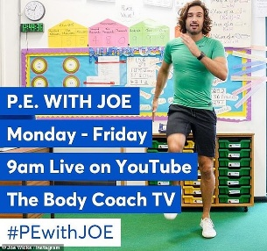
Find Joe on the channel above. There are various kids channels on this channel as well.
Option 3: Change4Life also have some videos that are suitable for children.
Option 4: You could create a dance routine to one of your favourite songs and perform the dance to your family or participate in another form of exercise with your family.
Option 5: New to the school website are 'Dance Videos with Mrs K'. Go to 'School Life' on the school website and you will find the link in there.

Tuesday 02.06.20
Spellings
Complete the look cover write check sheet for your spellings.
Spellings From Home 1.6.20
English
For your Grammar today please complete the following:
Grammar Terms Mixed Up
Maths
Play on TT Rockstars for 10 minutes. Login details are in your journals.
Complete the Beat That Test attached below:
Beat That Test 2
Sweet Shop Ppt
Follow the powerpoint above forhelp in tackling word problems.
Choose the relevant challenge of activity sheets from below (1* is easiest and 3*** is hardest)
Sheet Sweet Shop Activity
Reading
Read a book for 30 minutes. Please keep a log of the pages and the name of the book you read in your reading journals.
There are also some stories you can listen to here: https://www.worldofdavidwalliams.com/elevenses-catch-up/
Geography
Lesson Presentation Coastal Features
Complete the activity sheets below or you could write out the information straight into your books.
Activity Sheet How Beaches Form
Activity Sheet How Bays Form
Activity Sheet Arches And Stacks Form
PE
See Monday for a selection of ideas and links.

Wednesday 03.06.20
Spellings
Complete the look cover write check sheet for your spellings. We usually do a mock test on Weds too so you could ask someone to test you or use the look, cover, write check sheet. Don't forget to record your result.
Spellings From Home 1.6.20
English
Complete the attached comprehension on Coasts. Make sure you choose the relevant level of challenge. The answers are attached for you to check after.
Comprhension Coasts
Maths
Play on TT Rockstars for 10 minutes. Login details are in your journals.
Complete the Beat That Test.
Beat That Test 3
A Puzzling Time Ppt 1
Activity Sheet Puzzling Times
Reading
Read a book for 30 minutes. Please keep a log of the pages and the name of the book you read in your reading journals.
There are also some stories you can listen to here: https://www.worldofdavidwalliams.com/elevenses-catch-up/
Art/DT
Task: sketch Durdle Door and paint it using watercolours (if you have them). Use the picture attached as an example
Durdle Door Art Activity
PE
See Monday for a selection of ideas and links.

Thursday 04.06.20
Spellings
Complete the look cover write check sheet for your spellings.
Spellings From Home 1.6.20
English
WALT plan a scary story based on the Curse of Cogston House. You may wish to read the story first if you are struggling for ideas.
Planning A Scary Story
WARNING: this story is little bit spooky so if you do not like spooky stories then you don’t have to read the whole story but it is here if you want to for ideas. The Curse Of Cogston House Short Story Reading Questions And Discussion Prompts
Maths
Play on TT Rockstars for 10 minutes. Login details are in your journals.
Complete the Beat That Test attached below:
Beat That Test 4

Complete the activity below: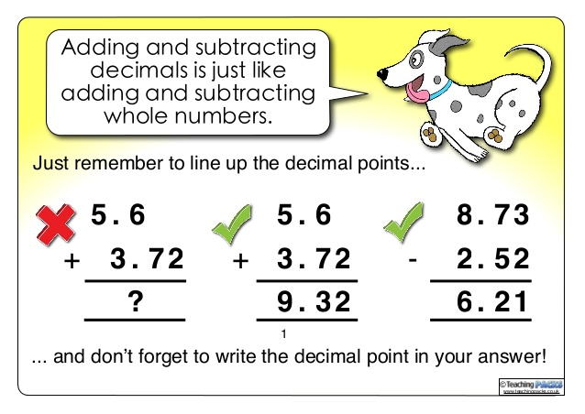
Addition Money Decimals
Reading
Read a book for 30 minutes. Please keep a log of the pages and the name of the book you read in your reading journals.
There are also some stories you can listen to here: https://www.worldofdavidwalliams.com/elevenses-catch-up/
Science
Creative Task:
WALT create a new species of animal and compare it to other animals
Imagine you are a famous naturalist and have discovered a new species of animal in a remote part of the world e.g. the rainforest, desert, Antarctica, under the sea.
- Draw or make a model of the new species
- Give it a name
- Describe its characteristics and life cycle (as you do this compare it to other animals e.g. is milk producing like mammals but it lays eggs so that they grow externally rather than internally (like the spiny anteater and duck-billed platypus).
Powerpoint attached for help/info: Year5LivingthingsYr5Presentation
PE
See Monday for a selection of ideas and links.

Friday 05.06.20
Spellings
Complete the look cover write check sheet for your spellings. It is test day too so if someone can test you- brilliant.
Spellings From Home 1.6.20
English

WALT write a scary story

Last week you planned your scary characters and your scary settings. Yesterday you planned your story.

You should use all of these plans to help your description in your story.

Do not forget to show off your writing skills in your story today.

-use adjectives and adverbs

-short sentences to add suspense

-accurate speech punctuation

-relative clauses, fronted adverbials and subordinate clauses, prepositions, expanded noun phrases etc.
The Curse Of Cogston House Short Story Reading Questions And Discussion Prompts
Maths
Play on TT Rockstars for 10 minutes. Login details are in your journals.
Complete the Beat That Test attached below:
Beat That 5
Subtraction Money Decimals
Reading
Read a book for 30 minutes. Please keep a log of the pages and the name of the book you read in your reading journals.
There are also some stories you can listen to here: https://www.worldofdavidwalliams.com/elevenses-catch-up/
RE

Look through the Christian pilgrimages powerpoint to learn about pilgrimages: 1 Christian Pilgrimages Ppt

Complete the Lourdes comprehension activity- a Christian pilgrimage.

Differentiated Lourdes Reading Comprehension Sheets
Golden Time
PE
See Monday for a selection of ideas and links.

