Year 5 Home Learning Week 2 (23.3.20)
Hello Year 5!
I have attached your Home Learning Work below.
Miss Rooney
:-)
Weekly Task: Read a book of your choice to tick off one of the reading challenges on the Year 5 Reading Challenge which is in the back of your journal. Remember to evidence your read via a photo or activity in your journal.
Monday
Please note: If you need to re-order the day e.g. if you want to do the LIVE PE with Joe at 9am instead of 2.15pm please feel free to do (on a daily basis only).
Spellings:
- Complete the look cover, write, check spelling sheet (spelling sentences are for the English activity).
- Complete your spelling homework book as you normally do on a Monday each week so that you have an up-to-date record in that for future reference.
Spellings From Home 23.3.20
English
- Write spelling sentences to show you understand the meaning of each word on your spelling list. Use a dictionary to find the meaning of any unfamiliar words. Make sure your sentences are clear, coherent and express the meaning of the words clearly in context.
Reading
Read a book for 30 minutes. Please keep a log of the pages and the name of the book you read in your reading journals.
Maths
Play on TT Rockstars for 10 minutes. Login details are in your journals.
Look at the powerpoint presentation if you need reminding on what to do.
Multiplying Fractions Presentation If You Need Reminding
Complete the attached maths activities on multiplying fractions using visual aids. Multiply the whole number and the numerator.
Represent your answer as a fraction and if it is improper then you can convert it into a mixed number too.
Maths Fraction Flower Garden Activity Sheets
Monday Maths Multiplying Fractions Worksheet
*answers are to be looked at after- no peeping!
PE
PE options:
Option 1: You could create a dance routine to one of your favourite songs and perform the dance to your family.
Option 2:
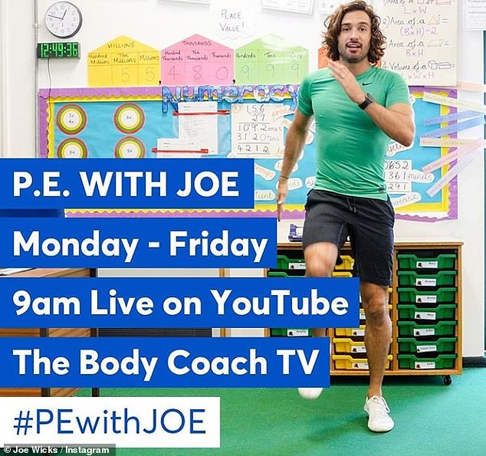
Find Joe on the channel above. There are various kids channels on this channel as well.
Option 3: Change4Life also have some videos that are suitable for children.
Option 4: 'Dance Videos with Mrs K'. Go to 'School Life' on the school website and you will find the link in there.

Music
The Greater Manchester Music Hub has commissioned
local composer, Mike Edwards, to write a song all about
Dippy the Dinosaur.
Find all the song resources here:
http://gmmusichub.co.uk/projects/primary-schools-singing-challenge/
Can you make up your own actions for the chorus?
All children across Greater Manchester will unite in song at 2.15pm on Tuesday 19th May to sing this fantastic song!
http://gmmusichub.co.uk/projects/primary-schools-singing-challenge/

Tuesday
Spellings
Complete the look cover write check sheet for your spellings.
Spellings From Home 23.3.20
English
Revise nouns (there is a quiz you could play too)
https://www.bbc.co.uk/bitesize/topics/z4hrt39/articles/znddqhv
Read through the posters about noun types.
Types Of Nouns Poster
Complete the following activity:
Abstract And Concrete Nouns Activity
Maths
Play on TT Rockstars for 10 minutes. Login details are in your journals.
Complete the Beat That Test attached below:
Beat That Test
Lesson Activities:
Have another look at the presentation below:
Multiplying Fractions Presentation If You Need Reminding
Complete the attached activities. Choose the appropriate level or work through it as it gets progressively harder.
Multiplying Fractions
*answers are to be looked at after- no peeping!
Reading
Read a book for 30 minutes. Please keep a log of the pages and the name of the book you read in your reading journals.
Geography
Research Project:
Biomes
What are biomes?
https://www.bbc.co.uk/bitesize/topics/z849q6f/articles/zvsp92p
Can you find out what a biome is? Please note: biomes are sometimes classified differently according to the site you use. The main biomes are outlined on your map below.
Here is some information which might assist your research on the biomes.
Biomes Information
Task 1: complete the map and colour in using the numbered key.
Biomes Map Outline
Task 2: Research each biome and complete some basic facts for each section as outlined on the worksheet.
Biomes At A Glance
PE
PE options:
Option 1: You could create a dance routine to one of your favourite songs and perform the dance to your family.
Option 2:
Find Joe on the channel above. There are various kids channels on this channel as well.
Option 3: Change4Life also have some videos that are suitable for children.
Option 4: 'Dance Videos with Mrs K'. Go to 'School Life' on the school website and you will find the link in there.

Wednesday
Spellings
Complete the look cover write check sheet for your spellings or ask an adult to complete a mock test like we would normally do on a Wednesday in school. Don't forget to record your results in your spelling homework book.
Spellings From Home 23.3.20
English
Complete the attached comprehension. Choose the relevant level of difficulty. Answers are attached to look at once you have completed.
Reading Comprehension On Our Diverse Planet
Maths
Play on TT Rockstars for 10 minutes. Login details are in your journals.
Complete the Beat That Test.
Beat That Test 2
Complete the activity sheet below on multiplying fractions word problems. Read the word problems and solve the problem. Answer in full sentences.
Wednesday Maths Problems
Weds Maths Answers
Reading
Read a book for 30 minutes. Please keep a log of the pages and the name of the book you read in your reading journals.
Art
Pop Art- Andy Warhol.
Task 1: Make a list of all the colours you see in his famous picture of Marilyn Monroe.
Marilyn Monroe
Task 2: Can you copy this picture of Marilyn Monroe and colour it in the same style?
Tips:
Look carefully at how Andy Warhol has created light and shadow on her face.
Make sure you include this on your picture.
You can add the shadowy areas using your colours (colouring pencils ideally).
You can either create 1 image of her, 2 images of her or all 4 of you are feeling confident.
PE
PE options:
Option 1:
Real PE at home – online learning resources
This includes a programme for children in Key Stage 2, with daily and weekly guidance provided for both programmes (starting from this week) in addition to an option to choose your own themes and activities.
The website address is: home.jasmineactive.com
Usernames and passwords have been emailed via parentmail.
Option 2:
Find Joe on the channel above. There are various kids channels on this channel as well.
Option 3: Change4Life also have some videos that are suitable for children.
Option 4: You could create a dance routine to one of your favourite songs and perform the dance to your family or participate in another form of exercise with your family.
Option 5: 'Dance Videos with Mrs K'. Go to 'School Life' on the school website and you will find the link in there.

Thursday
Spellings
Complete the look cover write check sheet for your spellings.
Spellings From Home 23.3.20
English
Complete the attached writing activities.
Thursday 26th March 2020 Writing Draft Taj Mahal
Maths
Play on TT Rockstars for 10 minutes. Login details are in your journals.
Complete the Beat That Test attached below:
Beat That Test 3
WALT write percentages as a fraction with denominator hundred.
What is a percentage? Follow this link for an introduction:
https://www.bbc.co.uk/bitesize/topics/znjqtfr/articles/z8ws3k7
Connecting FDPs
Complete the activity sheet attached:
Thursday Percentages
Reading
Read a book for 30 minutes. Please keep a log of the pages and the name of the book you read in your reading journals.
Science
Watch the BBC clips about friction (you might need flash player).
https://www.bbc.co.uk/bitesize/topics/zsxxsbk/articles/zxqrdxs
https://www.bbc.co.uk/bitesize/clips/zm9pr82
Task: Further research friction and design a poster which explains about friction including the pros and cons. E.g. When is friction useful? When is friction not useful? You'll need to think about this one.
PE
PE options:
Option 1:
Real PE at home – online learning resources
This includes a programme for children in Key Stage 2, with daily and weekly guidance provided for both programmes (starting from this week) in addition to an option to choose your own themes and activities.
The website address is: home.jasmineactive.com
Usernames and passwords have been emailed via parentmail.
Option 2:
Find Joe on the channel above. There are various kids channels on this channel as well.
Option 3: Change4Life also have some videos that are suitable for children.
Option 4: You could create a dance routine to one of your favourite songs and perform the dance to your family or participate in another form of exercise with your family.
Option 5: 'Dance Videos with Mrs K'. Go to 'School Life' on the school website and you will find the link in there.

Friday
Spellings
Complete the look cover write check sheet for your spellings or ask an adult to test you like we would normally do on a Friday in school.
Spellings From Home 23.3.20
English
This is a follow on activity from Thursday's work:
Friday 27th March Persuasive Techniques
Maths
Play on TT Rockstars for 10 minutes. Login details are in your journals.
Complete the Beat That Test attached below:
Beat That Test 4
Look through the powepoint again as a reminder:
Connecting FDPs
Complete the following activity:
Friday Maths FDP Conversions
If you found that easy, perhaps you could try to challenge yourself and complete this:
Percentages Conversions Friday
Reading
Read a book for 30 minutes. Please keep a log of the pages and the name of the book you read in your reading journals.
RE
Using the following we page, create a leaflet/guide to explain what Easter is. Imagine the person who is reading the leaflet has no clue whatsoever. Make your leaflet bright, attractive and informative.
https://www.bbc.co.uk/bitesize/topics/ztkxpv4/articles/z4t6rj6
PE
PE options:
Option 1:
Real PE at home – online learning resources
This includes a programme for children in Key Stage 2, with daily and weekly guidance provided for both programmes (starting from this week) in addition to an option to choose your own themes and activities.
The website address is: home.jasmineactive.com
Usernames and passwords have been emailed via parentmail.
Option 2:
Find Joe on the channel above. There are various kids channels on this channel as well.
Option 3: Change4Life also have some videos that are suitable for children.
Option 4: You could create a dance routine to one of your favourite songs and perform the dance to your family or participate in another form of exercise with your family.
Option 5: 'Dance Videos with Mrs K'. Go to 'School Life' on the school website and you will find the link in there.

