Week 5 (27.4.20)

Hello Year 5!

I hope you have all had a good week and have enjoyed the lovely weather. Super impressed with some of the work I have seen so far. I have attached your Home Learning Work for the next week below. Try your best and stay safe.

Miss Rooney
:-)

Monday 27.4.20
Weekly Task: Read a book of your choice to tick off one of the reading challenges on the Year 5 Reading Challenge which is in the back of your journal. Remember to evidence your read via a photo or activity in your journal.
Spellings/English
- Complete the look cover, write, check spelling sheet (spelling sentences are for the English activity).
- Complete your spelling homework book as you normally do on a Monday each week so that you have an up-to-date record in that for future reference.
Spellings 27.4.20
Make sure you understand the meaning of each word (most of the words with a c in are the noun form and those with an s are the verb form).
- Write spelling sentences to show you understand the meaning of each word on your spelling list. Use a dictionary to find the meaning of any unfamiliar words. Make sure your sentences are clear, coherent and express the meaning of the words clearly in context (this is attached to your spellings document). Make sure you understand the meaning of each word (most of the words with a c in are the noun form and those with an s are the verb form).
- Spellings quiz on purple mash should be in the 2DO notifications section.
Maths
Play on TT Rockstars for 10 minutes. Login details are in your journals.
Complete the Beat That Test below:
Beat That Test 1
WALT recall the properties of regular and irregular shapes
Complete the attached maths activities below:
*answers are to be looked at after- no peeping!
Task 1: Regular and irregular shapes quiz on purple mash in the 2do notifications.
Task 2: Complete the problems on the worksheet attached below:
Use the final question as a discussion point. Try to find as many as you can looking at tiny shapes and huge shapes... just try to find as many as you can. In class we would discuss how many we can find and show each other where they are.
Reasoning And Ps With Regular And Irregular Shapes
Reading
Read a book for 30 minutes. Please keep a log of the pages and the name of the book you read in your reading journals.
There are also some stories you can listen to here: https://www.worldofdavidwalliams.com/elevenses-catch-up/

Music
Music: Oldham Music Service Activity. Following on from last week…

Task 1: add an extra dimension to your musical instrument e.g., if you have created a “drum kit” why not add cymbals!
Task 2: Choose a suitable song of your own and use your instrument to accompany the piece.
FYI Last week’s activity was: Design and make a musical instrument from junk. You could use empty cereal cartons, plastic bottles, rice, pasta, elastic bands. Make it look fantastic and sound fantastic!
Make A Musical Instrument Activity DESIGN
Design and make a musical instrument from junk. You could use empty cereal cartons, plastic bottles, rice, pasta, elastic bands. Make it look fantastic and sound fantastic!
Think about your instrument’s timbre (sound). Does it tap, shake, scrape, twang, pluck, boom? What is your instrument called?
You could follow this link for more ideas: https://www.bbc.co.uk/teach/bring-the-noise/found-sounds/z7k847h or search “BBC Bring the Noise Found Sounds”. Can you compose a piece of music using your instrument? Tweet us a photo of your instrument!
@Oldhammusic #OMSsoundmaker
PE
PE options:
Option 1:
Real PE at home – online learning resources
This includes a programme for children in Key Stage 2, with daily and weekly guidance provided for both programmes (starting from this week) in addition to an option to choose your own themes and activities.
The website address is: home.jasmineactive.com
Usernames and passwords have been emailed via parentmail.
Option 2:
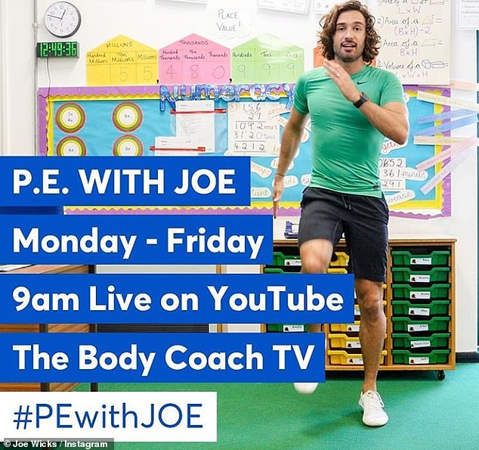
Find Joe on the channel above. There are various kids channels on this channel as well.
Option 3: Change4Life also have some videos that are suitable for children.
Option 4: You could create a dance routine to one of your favourite songs and perform the dance to your family or participate in another form of exercise with your family.
Option 5: New to the school website are 'Dance Videos with Mrs K'. Go to 'School Life' on the school website and you will find the link in there.

Tuesday 28.4.20
Spellings
Complete the look cover write check sheet for your spellings.
Spellings 27.4.20
English
For grammar you are going to complete some revision exercises:
Task 1: Revision of speech punctuation using Purple Mash:
Frank the cleaner- punctuate the direct speech on purple mash should be in the 2do notifications section.
Task 2: Complete the parts of speech activities on Purple Mash
Parts of Speech should be in the 2do notifications section.
Noun- person, place or thing and don’t forget we have concrete (can touch them) and abstract (feelings etc. that we cannot touch) nouns.
Verb- action or doing word
Adjective- describing word
Adverb- describes a verb
Task 3: Complete the attached worksheet which is about parts of speech.
Grammar Printables Y5a Parts Of Speech
Maths
Play on TT Rockstars for 10 minutes. Login details are in your journals.
Complete the Beat That Test attached below:
Beat That Test 2
WALT use the properties of rectangles to deduce related facts and find missing lengths and angles.
Follow the powerpoint to learn about properties of rectangles (oblongs).
Properties Of Rectangles Ppt
You should remember how to calculate area (length x width) and perimeter (l+l+w+w). Using your prior knowledge and what you have learnt about rectangles today, try to calculate the missing lengths. You need to do inverse operations for example, if the area is given and so is one of the sides, do the area divided by the given side to find out the missing side.
Task: Complete the activity sheet below:
Missing Sides Of Rectangles
Missing Sides Of Rectangles Answers
Reading
Read a book for 30 minutes. Please keep a log of the pages and the name of the book you read in your reading journals.
There are also some stories you can listen to here: https://www.worldofdavidwalliams.com/elevenses-catch-up/
Geography
WALT understand how an animal and plant is suited to its biome.
Task: Choose either Savannah, Desert or Tundra (NOT Rainforest as you will do this in Y6) (or all 3 if you wish) and find out about how the plants and animals are suited to survive in the particular biome.
Adaptations
PE
See Monday for a selection of ideas and links.

Wednesday 29.4.20
Spellings
Complete the look cover write check sheet for your spellings. We usually do a mock test on Weds too so you could ask someone to test you or use the look, cover, write check sheet. Don't forget to record your result.
Spellings 27.4.20
English
Complete the attached comprehension on David Attenborough (links in perfectly with our science topic) choosing the relevant level of challenge. The answers are attached for you to check after.
Davidhension
Maths
Play on TT Rockstars for 10 minutes. Login details are in your journals.
Complete the Beat That Test.
Beat That Test 3
Revision of 3D shapes
3d Shapes Warm Up And Revision Powerpoint Powerpoint Quiz
Quiz on purple mash on 3Dshapesin the 2do notifications.
Complete the worksheet below to see how much you have learnt and remembered about 3D shapes.
Posters Of 3d Shapes And Properties
3D Shape Properties Worksheet
Reading
Read a book for 30 minutes. Please keep a log of the pages and the name of the book you read in your reading journals.
There are also some stories you can listen to here: https://www.worldofdavidwalliams.com/elevenses-catch-up/
Art
WALT create increasingly accurate drawings by adding tonal shading.
Tonal Shading Presentation
Try to complete the activities below as accurately as you can:
Tonal Shading Activity Sheet
Extension Activity Tone
PE
See Monday for a selection of ideas and links.

Thursday 30.4.20
Spellings
Complete the look cover write check sheet for your spellings.
Spellings 27.4.20
English
Choral and Performance poetry: Here is the original poem from last week: Gran Can You Rap
WALT plan a performance poem.
Task: Using the same layout for Gran, Can You Rap, use the planning sheet provided to change the poem to create your own version entitled:
Dad, Can You Rap?
Or
Mum, Can You Rap?
Here is my example: Dad Can Rap
- You need to keep to the same rhythm (check your syllables are similar to the original for each line)
- Rhyming pattern
- Makes sense
- Repetition for effect
Dad Mum Can You Rap Plan
Maths
Play on TT Rockstars for 10 minutes. Login details are in your journals.
Complete the Beat That Test attached below:
Beat That Test 4
WALT identify 3D shapes including cubes and cuboids from 2D representations.
Follow the ppts below:
Lesson Presentation Understanding Nets

Match the 2D representations and their shapes by completing the worksheets attached:
WALT Identify 3D Shapes Including Cubes And Cuboids From 2D Representations.
Activity Sheet Shape Nets
Then try to complete some of these questions (they get harder so just try your best).
Horizontal Format Reasoning About 3D Shapes (1)
Answers Reasoning About 3D Shapes (1)
Reading
Read a book for 30 minutes. Please keep a log of the pages and the name of the book you read in your reading journals.
There are also some stories you can listen to here: https://www.worldofdavidwalliams.com/elevenses-catch-up/
Science
WALT understand the advantages and disadvantages of sexual and asexual reproduction in plants
Look at the information in the ppt below. We are looking at reproduction in plants. Some plants are able to reproduce on their own whereas others require another plant. This is a continuation of last week's work.
#Lesson Presentation New Plants 2
Activity Sheet Advantages And Disadvantages
If you are feeling adventurous, you could ask an adult to help you to take a plant cutting and make a new plant.
Activity Sheet Taking Cuttings
PE
See Monday for a selection of ideas and links.

Friday 01.05.20
Spellings
Complete the look cover write check sheet for your spellings. It is test day too so if someone can test you- brilliant.
Spellings 27.4.20
English
WALT write a performance poem.
Task: Using your plan from yesterday, read your performance poem out loud and check that it sounds good.
Does your poem rhyme at the end of each line?
Have you used repetition?
Have you used a similar number of syllables in the lines as the original poem so that it sounds effective when you read it out?
Make any changes that you want now (edit it).
Write your poem out in best.
I would love to see these or even better see or hear you perform it.
Here is the original poem for reference. Use it to make sure you are following the same pattern:
Gran Can You Rap
Maths
Play on TT Rockstars for 10 minutes. Login details are in your journals.
Complete the Beat That Test attached below:
Beat That 5
Task 1: Complete the word problems below (do as many as you can neatly and accurately for 30 minutes) to see how much you have learnt:
Page 103 Describe The Features Of Shapes
Page 104 Describe The Features Of Shapes
Pg 103 And 104 Answers
Task 2: Complete the test attached to see how much you have remembered about shape (approx 20-30mins).
Geometry Test For Properties Of Shape Including Rectangle Facts
Reading
Read a book for 30 minutes. Please keep a log of the pages and the name of the book you read in your reading journals.
There are also some stories you can listen to here: https://www.worldofdavidwalliams.com/elevenses-catch-up/
ICT
WALT create a 3D game
Task: Design a 3D Game on Purple Mash. Click on the 2Do for 2do: 2DIY3D Design, play and share your own 3D games.
You will need your purple mash to login (same as TTRockstars) from your journal.
Follow the video tutorial (top right hand side there is a video play button).
Then design your own game- save it to your work file on Purple Mash at the end.
PE
See Monday for a selection of ideas and links.

