Year 5 Home Learning Week 3 (30.3.20)

Monday 30.3.20
Spellings:
- Complete the look cover, write, check spelling sheet (spelling sentences are for the English activity).
- Complete your spelling homework book as you normally do on a Monday each week so that you have an up-to-date record in that for future reference.
Spellings From Home 30.3.20
English
- Write spelling sentences to show you understand the meaning of each word on your spelling list. Use a dictionary to find the meaning of any unfamiliar words. Make sure your sentences are clear, coherent and express the meaning of the words clearly in context.
Reading
Read a book for 30 minutes. Please keep a log of the pages and the name of the book you read in your reading journals.
Maths
Play on TT Rockstars for 10 minutes. Login details are in your journals.
Complete the Beat That Test below:
Beat That Test 1
Complete the attached maths activities below:
*answers are to be looked at after- no peeping!
Lesson Presentation Percentages
Percentage Colouring Differentiated Activity Sheets

PE
PE options:
Option 1: You could create a dance routine to one of your favourite songs and perform the dance to your family.

Option 2:
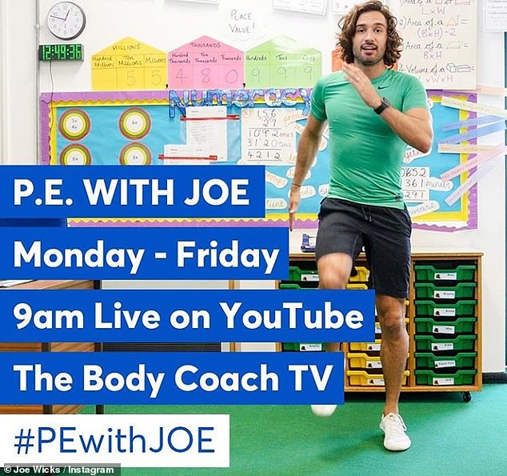
Find Joe on the channel above. There are various kids channels on this channel as well.
Option 3: Change4Life also have some videos that are suitable for children.

Music
Task: Continue to rehearse the song attached below and perfect your performance of it.
The Greater Manchester Music Hub has commissioned
local composer, Mike Edwards, to write a song all about
Dippy the Dinosaur.
Find all the song resources here:
http://gmmusichub.co.uk/projects/primary-schools-singing-challenge/
Can you make up your own actions for the chorus?
All children across Greater Manchester will unite in song at 2.15pm on Tuesday 19th May to sing this fantastic song!
http://gmmusichub.co.uk/projects/primary-schools-singing-challenge/

Tuesday 31.3.20
Spellings
Complete the look cover write check sheet for your spellings.
Spellings From Home 30.3.20
English
Revise verbs:
https://www.bbc.co.uk/bitesize/topics/zwwp8mn/articles/zpxhdxs
Irregular verbs- read the information on the sheet carefully then complete the activities.
T2 E 747 Using The Present Form Of Verbs In Contrast To Past Tense PowerPoint Ver 3 (1)
Regular And Irregular Verbs Task Sheet
Grammar Irregular Verbs

Maths
Play on TT Rockstars for 10 minutes. Login details are in your journals.
Complete the Beat That Test attached below:
Beat That Test 2
Lesson Presentation Comparing Tuesday 31.3.20
Percentage Equivalent Matching Cards Tuesday
Percentage Equivalent Jigsaw Activity Sheets Tuesday
Choose the activities that are a suitable challenge and don't look at the answers until you have had a go.

Reading
Read a book for 30 minutes. Please keep a log of the pages and the name of the book you read in your reading journals.

Geography
Research Project:
Biomes
Task 1: Using an atlas or ICT, label the map with the world's deserts.
Deserts World Map
Task 2: Pick one of the deserts and create your own poster about it. Be as creative and informative as you can be.
Don't forget- you can email photos of your work to school and you might appear on the website! :-)

PE
PE options:
Option 1: You could create a dance routine to one of your favourite songs and perform the dance to your family.
Option 2:
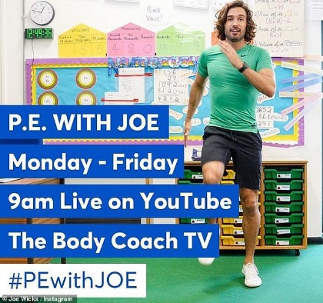
Find Joe on the channel above. There are various kids channels on this channel as well.
Option 3: Change4Life also have some videos that are suitable for children.

Wednesday 1.4.20
Spellings
Complete the look cover write check sheet for your spellings or ask an adult to complete a mock test like we would normally do on a Wednesday in school. Don't forget to record your results in your spelling homework book.
Spellings From Home 30.3.20
English
Complete the attached comprehension. Choose the relevant level of difficulty. Answers are attached to look at once you have completed.
Hotel Adverts
Maths
Play on TT Rockstars for 10 minutes. Login details are in your journals.
Complete the Beat That Test.
Beat That Test 3
Main activity work:
Visual Representations For Fdp

Reading
Read a book for 30 minutes. Please keep a log of the pages and the name of the book you read in your reading journals.

Art
Pop Art- Andy Warhol.
Task: Using the same colours and same style as Andy Warhol, create your own self portrait like the one of Marilyn Monroe.
Marilyn Monroe
Tips:
Look carefully at how Andy Warhol has created light and shadow on her face and add the same to your own.
You can add the shadowy areas using your colours (colouring pencils ideally).
You can either create 1 image of yourself, 2 images or all 4 of you are feeling confident.
SUPPORT: If you are struggling, you could trace over a photograph to get the outline of your self portrait.

PE
PE options:
Option 1:
Real PE at home – online learning resources
This includes a programme for children in Key Stage 2, with daily and weekly guidance provided for both programmes (starting from this week) in addition to an option to choose your own themes and activities.
The website address is: home.jasmineactive.com
Usernames and passwords have been emailed via parentmail.
Option 2:
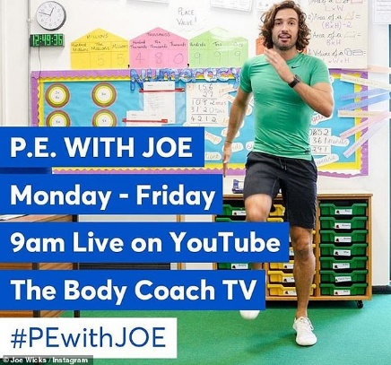
Find Joe on the channel above. There are various kids channels on this channel as well.
Option 3: Change4Life also have some videos that are suitable for children.
Option 4: You could create a dance routine to one of your favourite songs and perform the dance to your family or participate in another form of exercise with your family.

Thursday 2.4.20
Spellings
Complete the look cover write check sheet for your spellings.
Spellings From Home 30.3.20

English
Complete the attached writing activity. Be as creative as you can! Use the comprehension that you completed yesterday to help you with your persuasive techniques.
Task 1 Advertise Your Town

Maths
Play on TT Rockstars for 10 minutes. Login details are in your journals.
Complete the Beat That Test attached below:
Beat That Test 4
Maths Activities:
Matching Fdp
Converting Fdp

Reading
Read a book for 30 minutes. Please keep a log of the pages and the name of the book you read in your reading journals.

Science
Look at the PowerPoint presentation attached and complete the activity sheet.
Levers Pulleys And Gears Task Setter Powerpoint
Task 1: complete the activity sheet below:
Lever, Gear Or Pulley Sheet
Task 2: Design a mechanism which uses a gear, lever or pulley. At home, you could be creative and make something (I'd love to see pictures of these). If you cannot make your mechanism, you could draw and label a picture of it instead explaining how it works.

PE
PE options:
Option 1:
Real PE at home – online learning resources
This includes a programme for children in Key Stage 2, with daily and weekly guidance provided for both programmes (starting from this week) in addition to an option to choose your own themes and activities.
The website address is: home.jasmineactive.com
Usernames and passwords have been emailed via parentmail.
Option 2:
Find Joe on the channel above. There are various kids channels on this channel as well.
Option 3: Change4Life also have some videos that are suitable for children.
Option 4: You could create a dance routine to one of your favourite songs and perform the dance to your family or participate in another form of exercise with your family.
Option 5: New to the school website are 'Dance Videos with Mrs K'. Go to 'School Life' on the school website and you will find the link in there.

Friday 3.4.20
Spellings
Complete the look cover write check sheet for your spellings or ask an adult to test you like we would normally do on a Friday in school.
Spellings From Home 30.3.20

English
Writing Task Introduction Task Setter

Maths
Play on TT Rockstars for 10 minutes. Login details are in your journals.
Complete the Beat That Test attached below:
Beat That 5
See if you can use your arithmetic skills in answering the test paper below.
Y5 Arithmetic Full Test 5

Reading
Read a book for 30 minutes. Please keep a log of the pages and the name of the book you read in your reading journals.

RE
How can we help others?
As this is a very strange time for everyone, it is more important than ever to help each other. For your RE this week, I thought it would be nice if you came up with an idea for how to cheer others up. Here are some ideas that I have thought of but feel free to do something completely different:
- Write your own song lyrics to a cheerful song or make up a dance routine and perform it. E.g. Happy by Pharrell Williams or you could use the Dippy soundtrack from Monday's music lesson.
- Create a painting with an inspirational/uplifting quote on it. You could put it in your window to cheer people up when they see it on their walk.
- Help your parents whilst you are at home.
- Create a charity money box. You could use the purple mash 2design kit that we have been using in our ICT or you could make it out of something else you have at home.
- Anything else you or your family can think of (knitting, sewing, baking- always be safe and ask an adult to help you).
- You could complete this kindness diary
Power Of Kindness Calendar My Kind Acts
You could do more than one if you wish!
I would love to see your ideas- don't forget to email any pictures to school. :-)
PE
PE options:
Option 1:
Real PE at home – online learning resources
This includes a programme for children in Key Stage 2, with daily and weekly guidance provided for both programmes (starting from this week) in addition to an option to choose your own themes and activities.
The website address is: home.jasmineactive.com
Usernames and passwords have been emailed via parentmail.
Option 2:
Find Joe on the channel above. There are various kids channels on this channel as well.
Option 3: Change4Life also have some videos that are suitable for children.
Option 4: You could create a dance routine to one of your favourite songs and perform the dance to your family or participate in another form of exercise with your family.
Option 5: New to the school website are 'Dance Videos with Mrs K'. Go to 'School Life' on the school website and you will find the link in there.

