Year 5 Home Learning Week 6 (04.05.20)

Hello Year 5!

I hope you are all okay :-) I love seeing your posts and updates on Tapestry. I have attached work for week 6 below and there is no work for Friday because it is a bank holiday- YAY :-) Have a good week.

Miss Rooney
:-)

Monday 04.05.20
Weekly Task: Read a book of your choice to tick off one of the reading challenges on the Year 5 Reading Challenge which is in the back of your journal. Remember to evidence your read via a photo or activity in your journal.
Spellings/English
- Complete the look cover, write, check spelling sheet (spelling sentences are for the English activity).
- Complete your spelling homework book as you normally do on a Monday each week so that you have an up-to-date record in that for future reference.
Spellings 4.5.20
Make sure you understand the meaning of each word.
- Write spelling sentences to show you understand the meaning of each word on your spelling list. Use a dictionary to find the meaning of any unfamiliar words. Make sure your sentences are clear, coherent and express the meaning of the words clearly in context (this is attached to your spellings document).
- Spelling revision of prefixes activities are on Purple Mash in the 2Do section followed by the activity sheet below: "George misbehaves" and a "shopping trip"
- Grammar Printables Y5c Verb Prefixes
Maths
Play on TT Rockstars for 10 minutes. Login details are in your journals.
Complete the Beat That Test below:
Beat That Test 1
Revision of arithmetic: Y5 Arithmetic Full Test 6
WALT use coordinates in the first quadrant.
Lesson Presentation Coordinates
Cafe Coordinates Activity Sheet 1
Reading
Read a book for 30 minutes. Please keep a log of the pages and the name of the book you read in your reading journals.
There are also some stories you can listen to here: https://www.worldofdavidwalliams.com/elevenses-catch-up/
Music
Mrs Cermack has planned your music lessons using Charanga:
Please try this address www.gmmusiconline.co.uk or simply type ‘gym music online’ into your search engine and it should pop up at the top of your page. An email has been/will be sent out with login details for Charanga and login details will also be on Tapestry. Please do not change your password. The lesson is below but the music is on there to listen to.
Dinosaurs Lesson 1
*Listen to “Fossils” and try to find the pulse of the music
*Cut up a piece of paper in to 6 pieces
*On each piece of paper, write the name of a dinosaur (you may need to use the web to help with the pronunciations).
*Next to, or underneath the names of the dinosaurs write a number between 2-8
*Put the papers into any order
*This will now form your piece of dino music, try and clap the names of the dinosaurs as many times as the number tells you to.
*Can you clap your dino pattern along with the music?
Alternatively, you could try the BBC music lesson on the following link:
https://www.bbc.co.uk/bitesize/articles/z4skd6f
PE
PE options:
Option 1:
Real PE at home – online learning resources
This includes a programme for children in Key Stage 2, with daily and weekly guidance provided for both programmes (starting from this week) in addition to an option to choose your own themes and activities.
The website address is: home.jasmineactive.com
Usernames and passwords have been emailed via parentmail.
Option 2:
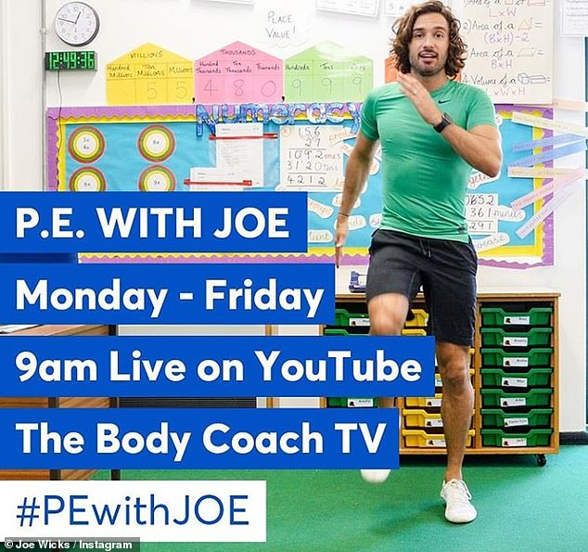
Find Joe on the channel above. There are various kids channels on this channel as well.
Option 3: Change4Life also have some videos that are suitable for children.
Option 4: You could create a dance routine to one of your favourite songs and perform the dance to your family or participate in another form of exercise with your family.
Option 5: New to the school website are 'Dance Videos with Mrs K'. Go to 'School Life' on the school website and you will find the link in there.

Tuesday 05.05.20
Spellings
Complete the look cover write check sheet for your spellings.
Spellings 4.5.20
English
Task 1: Following on from yesterday's work there is a spag.com on prefixes and suffixes. Your login details are in your reading journals.
Task 2: parenthesis using brackets, dashes and commas (there is a booklet on the website too and I have attached it below. There are lots of activities in it- you can do as few or as many as you wish). Grammar Activities Booklet
https://www.bbc.co.uk/bitesize/articles/zn8c47h
Task 3: commas
https://www.bbc.co.uk/bitesize/topics/zvwwxnb/articles/zc773k7
Maths
Play on TT Rockstars for 10 minutes. Login details are in your journals.
Complete the Beat That Test attached below:
Beat That Test 2
Complete the activities below following on from yesterday's work.
Pirate Map Coordinates 3
Missing Coordinates Activity
Reading
Read a book for 30 minutes. Please keep a log of the pages and the name of the book you read in your reading journals.
There are also some stories you can listen to here: https://www.worldofdavidwalliams.com/elevenses-catch-up/
Geography
Read the information in the ppt. I have attached a world map below in case you do not have access to an atlas. Look at the coloured maps to find out the climate zones and biomes found in different countries. Then complete a postcard of your favourite one making sure you make reference to the climate (temperature and weather), plants and animals.
T3 G 93 World Biomes And Climate Zones Powerpoint Ver 1 (1)
Map To Go With Postcard Biomes And Climates
Biomes And Climates In Countries Postcard
PE
See Monday for a selection of ideas and links.

Wednesday 06.05.20
Spellings
Complete the look cover write check sheet for your spellings. We usually do a mock test on Weds too so you could ask someone to test you or use the look, cover, write check sheet. Don't forget to record your result.
Spellings 4.5.20
Complete the attached comprehension choosing the relevant level of challenge. The answers are attached for you to check after.
Comprehension Alice In Wonderland
Maths
Play on TT Rockstars for 10 minutes. Login details are in your journals.
Complete the Beat That Test.
Beat That Test 3
Lesson Presentation Reflected Shapes
Activity Sheet Drawing Reflected Shapes
Reading
Read a book for 30 minutes. Please keep a log of the pages and the name of the book you read in your reading journals.
There are also some stories you can listen to here: https://www.worldofdavidwalliams.com/elevenses-catch-up/
Art
WALT create increasingly accurate drawings by adding tonal shading and colour..
Art Lesson Andy Warhol Cans
PE
See Monday for a selection of ideas and links.

Thursday 07.05.20
Spellings
Complete the look cover write check sheet for your spellings.
Spellings 4.5.20
English
Choral and Performance poetry: Look at the powerpoint carefully and plan a poem using the structure given.
Performance Poem Changes
Poetry Features Plan
Change Poetry
Maths
Play on TT Rockstars for 10 minutes. Login details are in your journals.
Complete the Beat That Test attached below:
Beat That Test 4
Lesson Presentation Reflecting With Coordinates
Activity Sheet Identifying Reflected Shapes BW
Reading
Read a book for 30 minutes. Please keep a log of the pages and the name of the book you read in your reading journals.
There are also some stories you can listen to here: https://www.worldofdavidwalliams.com/elevenses-catch-up/
Science
Lesson Presentation Mammals 2020
Look at the ppt above.
Task: Think about a rabbit, a kangaroo and a platypus (Placentals, Marsupials and Monotremes) and answer the following questions.
How are the life cycles similar? How are they different?
Create a poster/video/powerpoint/puppet show etc. to compare the similarities and differences in mammals. Use the website link here to find out more information (it has games and videos too):
https://www.theschoolrun.com/homework-help/mammals
PE
See Monday for a selection of ideas and links.

Friday 08.05.20
BANK HOLIDAY

