Lindisfarne Priory

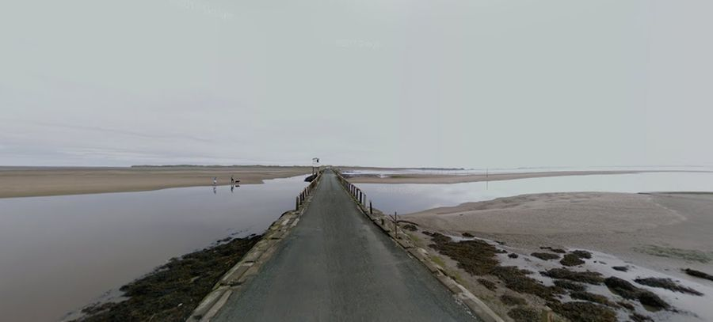
Where is Lindisfarne?
Lindisfarne is a tiny island off the coast of the North East of England. When the tide is out, there is a causeway so you can drive or walk to the island. When the tide is in, the causeway is underwater and you can only get to the island by boat.

Who Founded the Priory?
The Priory on Lindisfarne was founded in AD 635 by an Irish monk called St Aiden who was living in the Abbey on Iona. The King of Northumbria, Oswald summoned him to be the bishop of his kingdom and then gave him the island of Lindisfarne to build his monastery. The monastery became very wealthy and successful.

Who lived at the Priory?
The most famous monk that lived at the priory was called St Cuthbert. He arrived on the island in the 670s and became the leader of the monks at Lindisfarne. He decided to change the way the monks lived and the monks did not like this so Cuthbert decided to move away and live alone.
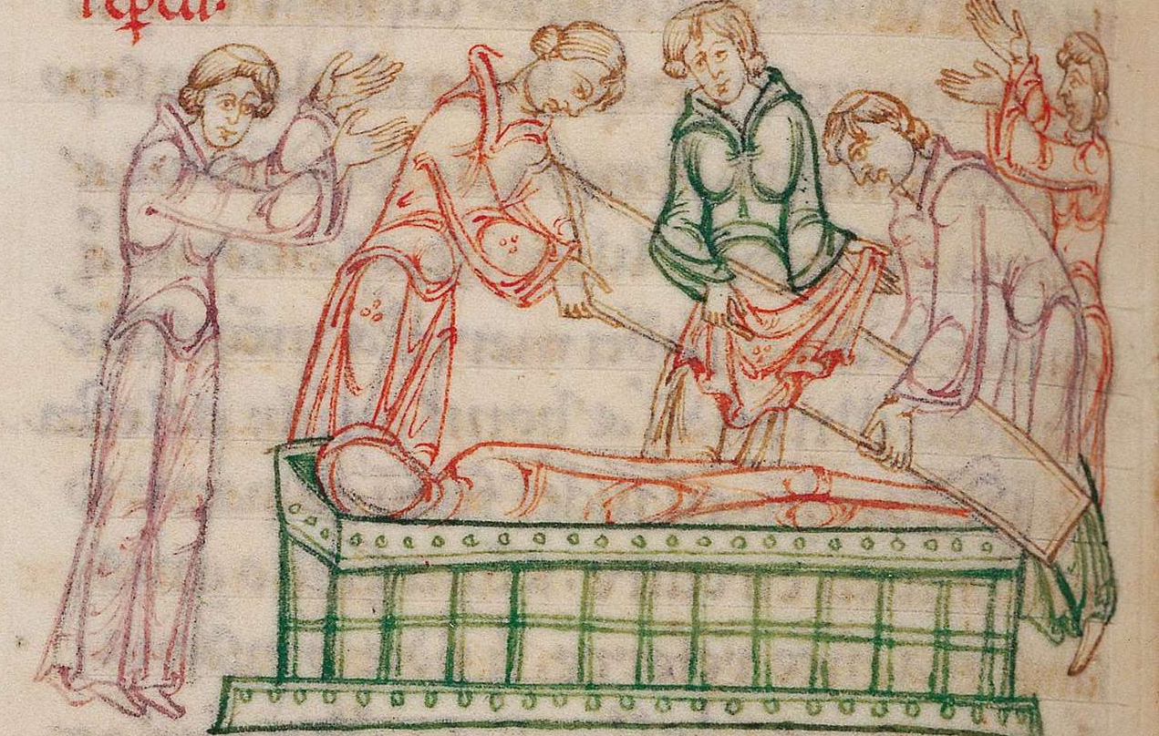
Eleven years after Cuthbert died some of the monks discovered that his body had not decayed at all. They decided that this was a miracle and was a sure sign that Cuthbert was extremely holy. Cuthbert’s remains were put into a shrine and suddenly lots of pilgrims began flocking to Lindisfarne. This brought lots of money to the Priory.

Why is Lindisfarne Famous?
In AD 793, the Vikings invaded Lindisfarne. They were attracted there by all the wealth the monks had collected over the years. (I’m not going to tell you any more about the Viking raid because you’ll learn all about it in Year 5).

