Lines of Symmetry
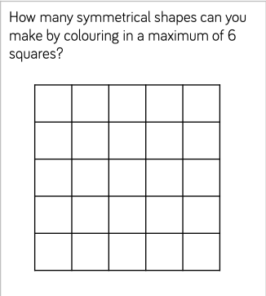

Copy the grid into your book for each new shape you colour in.

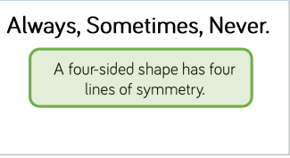
Draw some quadrilaterals or have a look back at the PowerPoint on quadrilaterals if you’re stuck.

