Number Puzzles
Cut out and stick the questions into your maths book then work out the answer. Once you’ve worked it out, check the answer with the QR code scanner.
Put a tick or a cross next to the question to show whether you got it correct or not. If you didn’t, then have a go at getting the right answer BUT do not rub out what you have already done.
- The library contains 3000 books when it is full. If one third of the books were on loan, how many books would be in the library?
Answer: | 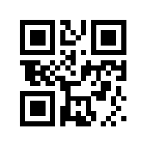

- If you have an overdue book from the library, the fine is 26p per day. How much will your fine be if your book is 1 week overdue?
Answer: | 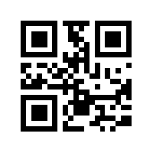

- Oldham library has 2500 books. Shaw Library only has 1 fifth as many. How many books are in Shaw Library?
Answer: | 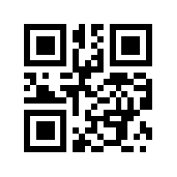

- 67 books fit onto one shelf in the library. How many books would fit onto five shelves?
Answer: | 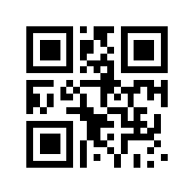

- The library is selling off some of its old books. A paperback costs 23p and a hardback costs 55p. Jodie bought 2 paperbacks and 4 hardbacks. How much change did she get from £5?
Answer: | 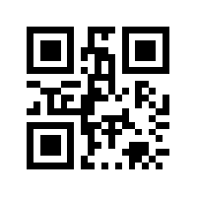

- One copy of The Oxford English Dictionary weighs 2.5kg. How much would 3 copies weigh?

Answer:

- Connor borrows 3 books from the library each month. How many will he borrow in 3 years?
