WALT: gather ideas for our character description

What is his personality like?

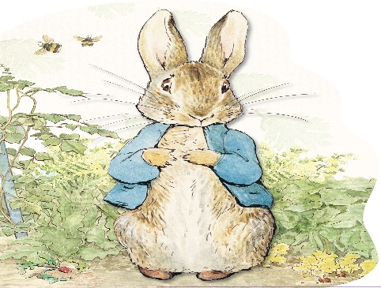

What does Peter Rabbit look like?

What does Peter Rabbit get up to in the story?

What two questions would you like to ask Peter Rabbit?

What do you think of Peter Rabbit and why?