Pirate Descriptosaurus

Choose precise nouns, verbs and adjectives.

Choose descriptive phrases.

Improve your vocabulary.

Create amazing character descriptions!

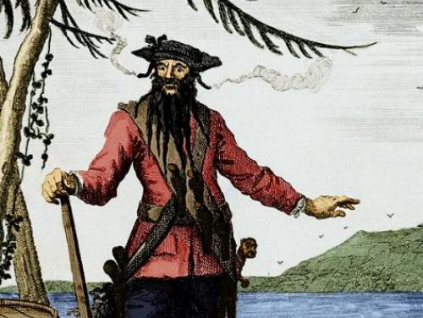

Eyes/Eyebrows

Adjectives: blue, grey, green, brown, black, slate, charcoal, bloodshot, deep, icy, steely, flinty, piercing, dangerous, watchful, dark, heavy, bushy, arched, straight, wicked, ferocious.

Verbs: watched, stared, glinted, burned, pierced.

Phrases: as black as coal, flinty grey, slate grey, steely blue, cold and dangerous, piercing grey, eyes like a hawk, razor sharp eyes, fierce staring eyes, dark pools of evil.

Mouth/Teeth

Adjectives: brown, yellow, stained, chipped, crooked, jagged, rotting, toothless, crumbling.

Phrases: toothless grin, two jagged rows of rotting teeth, stained and chipped teeth, mouth full of yellow teeth.

Hands/Fingers

Nouns: nails, knuckles, veins, spots, dirt, grime.

Adjectives: bony, wrinkled, swollen, lumpy, black, sharp, dirty.

Verbs: held, covered, blackened, chipped, burnt, twisted, grabbed, grasped, clutched.

Phrases: his fingers were twisted claws, veins like rivers on a map, nails like claws, skeleton hands, filthy with dirt and grime, stretched out a battle scarred hand.

Hair/Beard

Nouns: hair, beard, moustache, whiskers, black, ginger, grey, red.
Adjectives: long, curly, thick, bushy, shaggy, twisted, knotted, tangled, matted, enormous, heavy, dark, black, scruffy.

Verbs: tied, held, fastened, gathered, fell, cascaded, grew, sprouted, spread, covered.

Phrases: heavy rope of black hair, like great twisted roots, twisted out in all directions, fell from his chin, covered his face.

Skin

Nouns: scar, wounds, veins, bruise, blisters, scabs, patches.

Adjectives: leathery, horrible, scarred, blistered, hideous.

Phrases: black eye, purple bruise, angry sores around his lips, ugly wide scar around his left eyebrow, had a battle-scarred face, pulled his eye into a curious squint.

Clothes and Weapons

Nouns: eye patch, tricorn hat, bandanna, waistcoat, breeches, boots, belt, gold jewellery, peg-leg, parrot, cutlass, sword, pistol, dagger, boarding axe, fuses.

Adjectives: red, blue, purple, loose, mismatched, blood-stained.

Phrases: rich red, deep purple, royal blue coat, eye patch hiding his ugly scar, falling apart at the seams, glinting menacingly in the sun, held threateningly in his right hand.

Voice

Adjectives: loud, strong, booming, thunderous, deafening, dry, rough, hoarse, threatening.

Verbs: shouted, snarled, barked, growled, yelled, boomed, thundered, bellowed, spat.

Phrases: a low, cold voice full of evil, a voice like a growling bear, hissed angrily, snarled like a vicious dog.

Smell

Nouns: smell, stink, stench, odour.

Adjectives: foul, strong, sickening.

Verbs: smelt, stank, reeked, wafted.

Phrases: foul smelling, stank of rotten fish, reeked of rum and tobacco

