Buckstones C.P. School
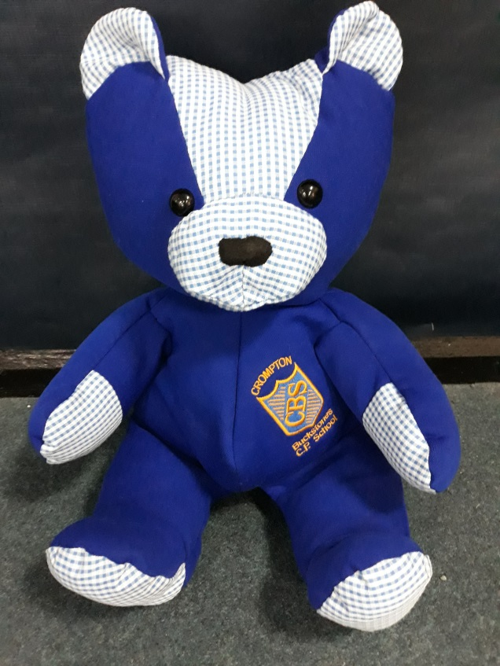

Parental Handbook
Reception

Website: buckstones.oldham.sch.uk
Telephone: 0161 770 5850

Welcome to the Reception class at Buckstones Primary School!

This booklet has been produced to give you and your child some helpful information about what to expect when starting full time school. Please don’t hesitate to contact a member of the Reception staff if you have any other questions or concerns.

The staff in Reception are:
Mrs A. Pearson Class teacher
Mrs C. Hall Full time Teaching Assistant

+ Mrs K. Kulczycki PPA cover (Wednesday afternoons only)

Our Topics
Each half term our learning will be covered under a fun and engaging topic.
Autumn 1 | Autumn 2 | Spring 1 | Spring 2 | Summer 1 | Summer 2
All About Me | Let’s celebrate! | Superheroes | Under the Sea | Minibeast Magic | Amazing Animals
Tapestry
In Reception we use an online observation tool called Tapestry. Tapestry enables us to not only observe, make notes and take photographs of your child for our own use in school but also we are able to share the observations with you electronically so that you can really feel part of your child’s learning journey. All you need to do is download the Tapestry app to your device and use the personal log in details that we will send to you in due course.
Reading
Reading and phonics are so important in Reception. We teach the children each of the letter sounds in our daily phonics session in a multisensory way; using songs, actions and rhymes as well as the letter sound and shape. Here at Buckstones we use both the ‘Jolly Phonics’ and the ‘Letters and Sounds’ phonics schemes.
In school we read with each child individually twice a week (usually Tuesdays and Thursdays). This can be with either a member of the Reception staff or with one of our parent helpers.

Writing
In Reception we will initially be focussing on letter formation (see letter formation hand out) and linking each letter to the sound that it makes.
We have many activities which promote independent writing around the classroom and encourage the children to write at every opportunity.
We will also be helping the children to improve their fine motor skills in preparation for writing through creative activities such as cutting, sticking and play-doh.
Throughout the infants we mainly write in pencil, it would be useful therefore if the children practise using this medium at home also.

Maths
Maths is embedded throughout our provision. The children will be encouraged to use mathematical language (such as bigger, smaller, underneath, next to etc.) and they will use maths throughout the day in the choices they make for play.
To begin, the main focus of our maths learning in Reception will be on becoming really confident with numbers to 10: being able to recognise, write and count each number. To support our maths learning we use a range of maths resources such as number lines, Numicon and other practical items.
Assessment and Reporting
Throughout Reception your child will be assessed by means of the Foundation Stage Profile. These informal, short assessments take place during normal class activities and are often just observations of behaviour/learning, without the child even being aware that they are happening. Assessments are made in the seven Early Years Foundation Stage (EYFS) areas of learning:
Personal, Social and Emotional Development
Communication and Language
Physical Development
Literacy
Mathematics
Understanding the World
Expressive Arts and Design

This system enables us to have a very informed understanding about the next stages of learning for each child.

Parent’s Evenings
There will be two ‘traditional’ parent’s evenings during the school year; one just before the October half term and the other just before the Easter holidays. These evenings give you the opportunity to meet with Mrs Pearson to discuss your child’s progress in more detail.

P.E.
In Reception the children have two regular sessions of P.E. every week:
Wednesday afternoon: Dance (covered by Mrs Kulczycki)
Friday morning: P.E.
All children will need an indoor P.E. kit (yellow or white T-shirt, black shorts, and black pumps) for these sessions. No jewellery is allowed for health and safety reasons. The P.E. kits will remain in school and will be sent home at the end of every half term to be washed. Please ensure that all items in the P.E. kits are labelled with the child’s name!
Reception children also have regular outdoor physical development opportunities throughout the week where they are encouraged to become more adventurous with the larger play equipment outside. It is essential therefore, that children come with a waterproof coat and wear sensible footwear to school every day.

Forest School
Every Friday we have our Forest School session. This is where we take the children into our forest area and take part in outdoor learning. This will happen for each child in a three-weekly cycle as we take the children in groups of ten. We will be out in all weathers so it is vital that your child has appropriate clothing (please make sure everything is labelled!): Wellies, waterproofs (separate trousers are much easier for the children than all-in-ones) and in the Winter; hat, scarves and gloves.

Homework
In Reception the children won’t be given any ‘homework’ as such. Instead our home learning focus is solely on reading. Each child will bring home a book from school, along with their reading record. Please let us know that you have read with your child by either initialling or commenting in their reading record. If your child has already read their book from school please feel free to choose a book from home and add it into their reading record too. Children will be rewarded for their home reading. For each day that the child has read at home the children will get a stamp in their book and after completing a set number of home reads the child will be awarded a certificate in assembly and be able to choose a new book to take home and keep.
In addition to their reading book the children will begin to bring home a set of ‘key words’ to practise reading. These are the high frequency words that children of Reception age are expected to be able to read by the end of the year.

To promote general reading at home (separate to the school books that we send home) we also have a whole school ‘Buckstones reading challenge’. This is a fun activity for you to complete with your child at home over each term. We will create a display of the photographs that you send in to us of your child completing the activities for this challenge.

Whole School Celebration Assemblies
After the initial settling in period the Reception children will begin to join the rest of the school in the assemblies in the hall. Every Friday a child from each year group is chosen by their class teacher (for outstanding effort, behaviour or work) to go up in assembly to receive a special certificate from Miss Healey. A photograph of these children is also taken and published on the school website after each assembly (unless you have asked us NOT to use photographs on the internet): www.buckstones.oldham.sch.uk
You will also find useful dates, general information and a ‘Reception’ page on the school website too.

Snacks
Each day the children will be able to choose if they would like to have a drink of milk and a snack. The snack options are always fruit or vegetables, but vary from day to day. It is therefore vital that you inform us of any dietary requirements, particularly allergies, that your child has.
Buckstones has a ‘Healthy Schools’ award. Part of this means that we do not allow sweets/sugary treats to be brought into school to celebrate birthdays etc. If you wish your child to bring something in to give to the other children on their birthday (and there is certainly no expectation to do so), we would encourage something other than sweets – such as pencils or rubbers - or you could even do something like donate a book to the whole class on behalf of your child!

If you have any questions or concerns, please do not hesitate to contact one of the Reception team members.

We look forward to welcoming your child to Buckstones

