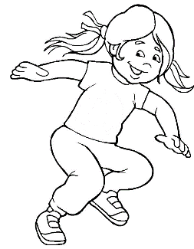

All about me!

This is me

|  |
| --- |
| Please fix a photograph here |

My name is ___________________________

I was born on _________________________

Can you draw a picture of yourself?

Can you write your name?

_____________________________

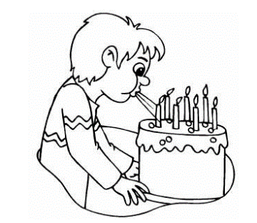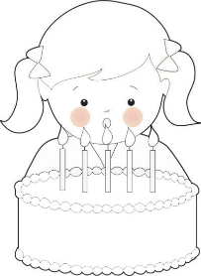

Draw candles on the birthday cake.



I am ..............................years old

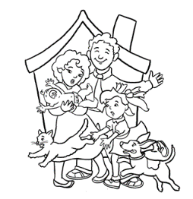

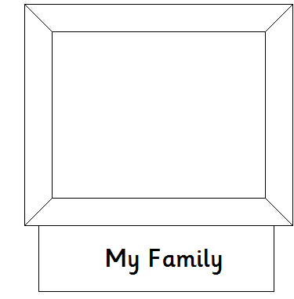Draw or stick a photo of your family.

I have .......................brother/s

I have ..........................sister/s

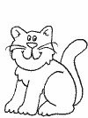[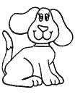](http://www.coloring.ws/t.asp?b=m&t=http://www.coloring.ws/animals/dogs/dog22.gif)

Draw or stick a picture of your family pet/s if you have one.

My pets name/s ...............................

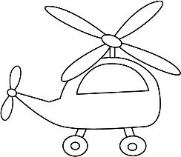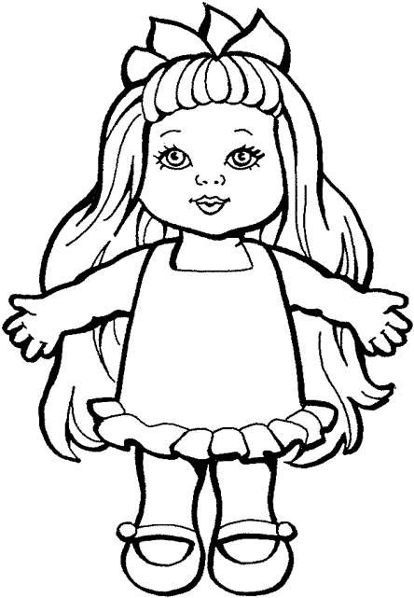

What do you like to play with?



What activities do you enjoy?

Is there anything you don’t like or that makes you upset?

Is there anything that you will need help with in school?

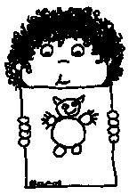

Draw a picture using your favourite colour.

Have you been to a pre-school or nursery? Please provide details below if so.

Thank you so much for filling in this booklet, we can’t wait to

meet you!

