**Week Beginning 1.6.20 Reception Home Learning**

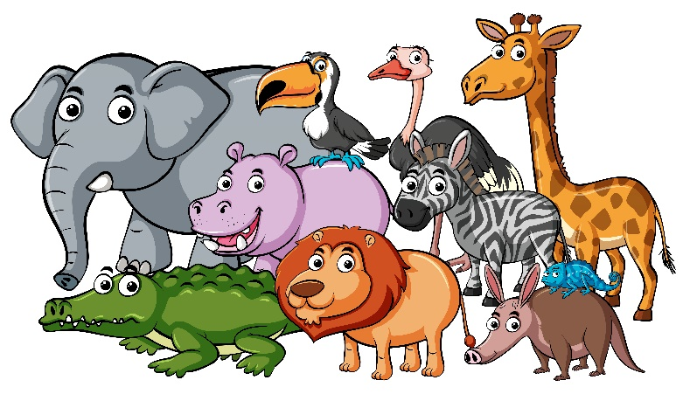It's the start of a brand new half term and a brand new topic. Our topic this time is **Amazing Animals!** We are going to be looking at different animals from all over the world and learning about the different places that they live. It's going to be lots of fun!

**Monday**

**English**

Watch this [Dear Zoo](https://www.youtube.com/watch?v=UywEnHKTMXk) video by Rod Campbell. Discuss the story, is one that you know already?

Next we are going to practise our handwriting as we need to make sure that we are forming our letters correctly. First look at the [Letter Formation Posters](https://www.buckstones.oldham.sch.uk/wp-content/uploads/2020/05/Letter-formation-posters.pdf) (no need to print these out). They just explain the groups that letters can be put into based upon how we write them. Each week we will focus on one group, this week it's the curly caterpillars! Use the [Curly Caterpillars](https://www.buckstones.oldham.sch.uk/wp-content/uploads/2020/05/curly-caterpillars.pdf) sheet or just use plain paper (lined if possible) to practise this group of letters. Please make sure that your child is starting each letter in the correct place - and practise any that they struggle with at the end.

**Phonics**

We're going to revise Phase 2 sounds today. Start by reading the sounds along [Scrap's Phonics](https://central.espresso.co.uk/espresso/primary_uk/subject/module/frontscreen/item61932/gradef/index.html) path on espresso. Check that your child is reading each sound confidently and click on any of the sounds that they are not so confident with to watch that video. Afterwards Click on Scraps Tricky Words at the end of the path to watch that video and then choose from any of Scraps phase 2 games to play.

**Maths**

Start with our [numbers to 20](https://www.youtube.com/watch?v=0VLxWIHRD4E)song. This week we are going to re-cap numbers to 20, to make sure we are really confident with reading, writing and ordering them. Today we are going to focus on ordering numbers 11-20, using the [Animal Cut And Stick 11 20 sheet.](https://www.buckstones.oldham.sch.uk/wp-content/uploads/2020/05/Animal-cut-and-stick-11-20.pdf) (page 2 only). First cut out the number cards, read each one and put in the right order. Once you're happy that the order is correct you can stick them down.

**Topic**

Watch the [Pets Video](https://central.espresso.co.uk/espresso/primary_uk/subject/news/video/item307180/gradef/index.html?source=search-all-F-all-all&source-keywords=pets) on espresso. Discuss what a pet is and talk about any pets that you have (or have had in the past). Draw/paint a picture of any pets that you have at your house. If you don't have any pets of your own you could draw a pet belonging to a family member or even a pet that you would like to have one day!

**Tuesday**

**English**

Watch/read [Dear Zoo](https://youtu.be/rudDGRQ9QGA) by Rod Campbell.  Use careful colouring to colour all the animals on the [Dear Zoo Colouring Sheet](https://www.buckstones.oldham.sch.uk/wp-content/uploads/2020/05/Dear-Zoo-colouring-sheet.pdf)  (draw the animals if you don't have access to a printer). Discuss which animal is your favourite!

**Phonics**

First watch the [Phase 2 tricky words video](https://www.bbc.co.uk/bitesize/topics/zf2yf4j/articles/zdrd8xs). Then we're going to use our phase 2 phonics knowledge to practise using the sounds to blend and read. Click on the [Phonics Play Comics](https://phonicsplaycomics.co.uk/comics.html) link and select the last phase 2 comic: 'A bug'. This is a comic strip which allows the child to practise their phase 2 phonics - you could take it in turns to read a caption each.  If they enjoy this one try any of the other phase 2 comic strips, it's great reading practise!

**Maths**

Start with a [numbers to 20](https://youtu.be/eHbByA0fQnQ) song. Today we are going to focus on counting accurately, making sure we count each item once (pointing to/touching each item is really important for this). Use the [Zoo Animals Count And Colour](https://www.buckstones.oldham.sch.uk/wp-content/uploads/2020/05/Zoo-animals-count-and-colour.pdf) sheet, or just create your own.

**Topic**

Tuesday afternoon is our computing afternoon. Go to the [Elephant activity](https://www.purplemash.com/#app/pap/animals/elephant) on Purple Mash (Art, Animals, Elephant). And create your own amazing elephant! Don't forget to save your picture in our Reception folder.

**Wednesday**

**English**

Re-read/watch this version of  [Dear Zoo](https://youtu.be/phBt7CLp1UI) by Rod Campbell (this one shows the actual book, with the flaps to lift on each page).  Today we are going to pretend that the author of the book wants a new page in the middle adding and he wants us to write it for him! Use the [Dear Zoo New Page!](https://www.buckstones.oldham.sch.uk/wp-content/uploads/2020/05/Dear-Zoo-new-page.docx) or simply create your own. Think of a new animal that would be fun new page in the book. Write the name of the animal, draw the animal and think of a reason why the animal might not be a good idea to keep as a pet. If you like you could even add a flap of paper to cover your picture so that it looks like a page in the real book!

**Phonics**

For the rest of this week we're going to focus on phase 3 phonics. First watch and join in with the [Phase 3 sounds video](https://uk.video.search.yahoo.com/search/video;_ylt=AwrJS9Yz1dBeCF8APm4M34lQ;_ylu=X3oDMTB0ZTgxN3Q0BGNvbG8DaXIyBHBvcwMxBHZ0aWQDBHNlYwNwaXZz?p=phase+3+phonics+bbc&fr2=piv-web&fr=mcafee#id=2&vid=0d3448ae48e2419bcae6a29649bf0e4e&action=view). Then read along the sounds on [Polly's Phase 3 phonics](https://central.espresso.co.uk/espresso/primary_uk/subject/module/frontscreen/item62767/gradef/index.html) path on espresso, stopping to click on and watch the videos for any sounds your child is not yet confident with. Afterwards play any of Polly's Phase 3 games.

**Maths**

Start with our [numbers to 20](https://www.youtube.com/watch?v=0VLxWIHRD4E)song. Then explain that today we are focusing on **writing** numbers correctly. First watch the [Writing numbers](https://central.espresso.co.uk/espresso/modules/ey_writing_to_20/videos/video_writing_20.html) video on espresso. Then practise writing the numbers 1 - 10, using the [Number Formation 1 10](https://www.buckstones.oldham.sch.uk/wp-content/uploads/2020/05/Number-formation-1-10.pdf) sheet, or simply on a piece of paper (lined if possible). Please make sure that every number starts at the top and practise any that they find tricky again at the end.

**Topic**

First play the [What Pet Am I? Powerpoint game](https://www.buckstones.oldham.sch.uk/wp-content/uploads/2020/05/What-Pet-am-I-Powerpoint-1.pptx) together (remember to click on 'slide show' and 'from beginning' first). Then we are going to do a sorting activity. Which animals are commonly kept as pets and which ones are definitely not? Use the [Pets Or Wild Animals](https://www.buckstones.oldham.sch.uk/wp-content/uploads/2020/05/Pets-or-Wild-Animals.docx) sheets, or just create your own.

**Thursday**

**English**

Re-read/watch yesterday's version of  [Dear Zoo](https://youtu.be/phBt7CLp1UI) by Rod Campbell. Today we're going to create our own **last page** of the story, a page for a **perfect** pet! Think of animal that you think would be a perfect pet and create your own new page for it, using either the [Dear Zoo New Last Page!](https://www.buckstones.oldham.sch.uk/wp-content/uploads/2020/05/Dear-Zoo-new-last-page.docx) or create your own. Remember to add a flap if you like!

**Phonics**

Try the Phase 3 sounds again by watching the [Phase 3 sounds video](https://uk.video.search.yahoo.com/search/video;_ylt=AwrJS9Yz1dBeCF8APm4M34lQ;_ylu=X3oDMTB0ZTgxN3Q0BGNvbG8DaXIyBHBvcwMxBHZ0aWQDBHNlYwNwaXZz?p=phase+3+phonics+bbc&fr2=piv-web&fr=mcafee#id=2&vid=0d3448ae48e2419bcae6a29649bf0e4e&action=view). Then Play the [Picnic on Pluto](https://new.phonicsplay.co.uk/resources/phase/3/picnic-on-pluto) game (Phase 3 option) on Phonics Play, choosing whichever sounds group you feel your child needs to practise the most.

**Maths**

Start with a [numbers to 20](https://youtu.be/eHbByA0fQnQ) song. Today we are carrying on with our work on **writing** numbers correctly. First watch the [Writing numbers](https://central.espresso.co.uk/espresso/modules/ey_writing_to_20/videos/video_writing_20.html) video on espresso. Then practise writing the numbers 1 1-20, using the [Number Formation 11 20](https://www.buckstones.oldham.sch.uk/wp-content/uploads/2020/05/Number-formation-11-20.pdf) sheet, or simply on a piece of paper (lined if possible). Please make sure that every number starts at the top and practise any that they find tricky again at the end.

**Topic**

Listen to the [Dear Zoo song](https://youtu.be/KsHXDPxozTk), then it's creative time! Make one of the animals from the Dear Zoo story out of anything you can find around your house - paper, boxes, play-doh etc. Be as creative as you like! Here are some ideas to get you started:

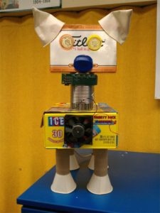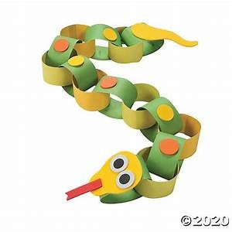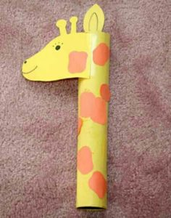

**Friday**

**P.E.**

Start by playing our [Dear Zoo song](https://youtu.be/KsHXDPxozTk), have a dance to warm up as it plays!  Then we're going to do some [Dear Zoo yoga.](https://uk.video.search.yahoo.com/search/video?fr=mcafee&p=cosmic+kids+dear+zoo#id=3&vid=52d58bb232e00b2e618c94ec54da32f6&action=click)

**Phonics**

Try the Phase 3 sounds again by watching the [Phase 3 sounds video](https://uk.video.search.yahoo.com/search/video;_ylt=AwrJS9Yz1dBeCF8APm4M34lQ;_ylu=X3oDMTB0ZTgxN3Q0BGNvbG8DaXIyBHBvcwMxBHZ0aWQDBHNlYwNwaXZz?p=phase+3+phonics+bbc&fr2=piv-web&fr=mcafee#id=2&vid=0d3448ae48e2419bcae6a29649bf0e4e&action=view). Then Read the [Pet Vet](https://phonicsplaycomics.co.uk/comic_ph3_pet_vet.html) comic on Phonics Play Comics, taking it in turns to read a caption as you go.

**Forest School**

Use your walk time to do a bit of animal spotting! Go for a walk and make a list (written or pictorial) of any animals you see in your local area. Maybe it will be birds or minibeasts, maybe it will be farm animals or other people's pets... I wonder if any of you will see a lion or a crocodile?! Please send us a photograph of your lists so we can see the kinds of animals you've seen on your walk.

**Topic**

Friday afternoon is as always, our finishing off/ intervention time. Go over any activities that your child needs to complete or has found tricky this week. Remember number and letter formation is always a priority – especially **writing their own name**perfectly!

Have a lovely weekend! :)