Week Beginning 15.6.20 Reception Home Learning

Woodland Animals!
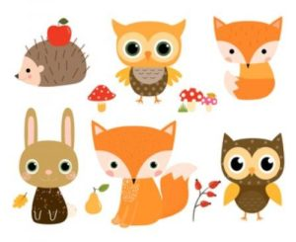

Monday

English
Read or watch Owl Babies by Martin Waddell. Do you know this story already? What do you like about it?
We are going to leave our handwriting practise until later in the week and use today's time to prepare for Father's Day (which isn't until Sunday, but we need to do them in school today as we have to leave them for at least 72 hours before the children can take them home😥). If you would like to make a father's day card for your dad, or maybe even a special uncle or grandad, you can use any ideas you have - just make something you think they'd like! In school we are going to use this idea:
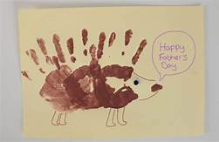
Here are some links you can use if you'd like some other ideas: Father's Day Certificates Father's Day Football Card Father's Day I Love You This Much! Make sure you write a nice message inside in your neatest writing!

Phonics
Start by watching the Phase 3 tricky words video. This week we're going to re-cap those trickier sounds at the end of phase 3, to make sure we're really confident with them all. Go to Polly's Phonics path on espresso. Read along all the sounds, click on any that you are unsure of along the way. Afterwards play the Blending air, er, ture game on espresso.

Maths
Start with our numbers to 20 song. Then we're going to practise finding numbers to 20 by playing the Blast Off! game on Top Marks that we tried last week. There are different options for this game. Please choose: Find a Number, Direct and then 10-20.

Topic
First watch the owl video on espresso. Monday afternoon is our computing afternoon! Go to the Owl Babies activity on Purple Mash (Art, Animals, Owl Babies). Can you add your own owl babies to the branch? Don't forget to save your picture in our Reception folder.
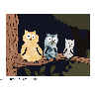

Tuesday

English
Re-read or watch Owl Babies by Martin Waddell. Then we're going to learn a new word this afternoon: nocturnal. Nocturnal means to sleep all day and be awake at night-time. Lots of forest animals are nocturnal - like owls, hedgehogs and foxes. Watch the Nocturnal Animals video and then complete the Nocturnal Animals Labelling Sheet, colouring the animals in when you've finished.

Phonics
Start by watching the Phase 3 tricky words video again. Go to Polly's Phonics path on espresso. Read along all the sounds, click on any that you are unsure of along the way. Afterwards play the Reading (air, er, ture) game on espresso.

Maths
Start with our numbers to 20 song. Then we are going to think about time for the rest of the week, starting by looking at day and night. First look through the Night and Day photo book on espresso. Then use the Day And Night Sorting Activity Posters (or just two pages of paper, labelled day and night) and see if you can draw at least 3 things that happen during the day and at least 3 things that happen during the night.

Topic
We're going to learn a new word this afternoon: Nocturnal. Nocturnal means to sleep all day and be awake at night-time. Lots of forest animals are nocturnal - like owls, hedgehogs and foxes. Watch the Nocturnal Animals video. Then have a go at creating your own nocturnal animal picture - using paint, crayons, chalk or any other art resources you might have.

Wednesday

English
Read or watch Don't Wake The Bear, Hare! by Steve Smallman. Then we're going to learn another big word: Hibernate. Hibernate means to sleep all Winter whilst it's cold and there's not much food around and then wake up again in the Spring time - like the bear does in the story. Watch the hibernation song. Then today is our handwriting day. First look at the Letter Formation Posters again (no need to print these out). They just explain the groups that letters can be put into based upon how we write them. Each week we are focussing on one group, this week it's the One Armed Robot Letters! Use the One Armed Robot Letter Formation sheets or just use plain paper (lined if possible) to practise this group of letters. Please make sure that your child is starting each letter in the correct place - and practise any that they struggle with at the end.

Phonics
First start by doing the Flash Cards activity on Phonics Play. Select Phases 2 and 3 (if you want to do it separately, as a phase 2 game and then a phase 3 game that is fine). As your child reads each sound please click on either 'correct' or 'incorrect' - this is really useful as at the end it will then give you a list of sounds that your child didn't know - and then these are the sounds that your child needs to practise for the rest of the session.

Maths
As we are learning about animals who hibernate all Winter, the next time topic that we're going to look at is seasons. Watch the seasons video and look at the seasons activity on espresso then complete the seasons sheet (or just draw your own little picture for each of the four seasons).

Topic
First watch the Woodland animals video together, then introduce the new word: Habitat. Habitat is just the name for a place where an animal lives. This week we're learning about animals whose habitat is the woodland. Try the Woodland And Ocean Sorting Activity focussing not only on thinking about animals which animals live in woodlands, but also our colouring and cutting skills too.

Thursday

English
Re-read or watch Don't Wake The Bear, Hare! by Steve Smallman. Then we're going to write a woodland animal riddle! First think of a woodland animal and then write a set of clues for it, using the Woodland Creature Riddle sheet (or just on a blank piece of paper). When you've written your clues you can draw a picture of your animal in the box and cover it up with a flap of paper... See if your family members can guess what your animal is from reading your clues! Send them in to Tapestry and we'll see if we can guess them too!

Phonics
Start by doing the Flash Cards activity on Phonics Play again. Select Phases 2 and 3 and again make a note of any sounds your child is not yet confident with to practise on throughout the day. Then play the Segmenting (air, er, ture) game on espresso.

Maths
Today we're going to think about time using a clock. We're going to introduce 'o clock. First watch the Telling The Time Powerpoint together. All we need to know is that when it's 'o clock the big hand always points to the 12 and it is the little hand that tells us the important bit! After working through the powerpoint the children can make their own clock using the Clock template.

Topic
First watch the Woodland Animal Habitats Powerpoint. This afternoon we are going to get creative and make our own woodland animals out of anything we like! You can use whatever materials you already have at home - junk, paint, construction toys - whatever your child will enjoy the most!
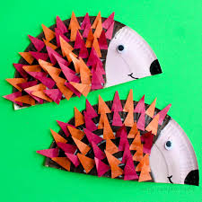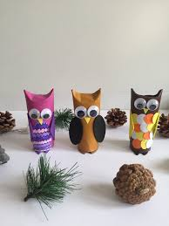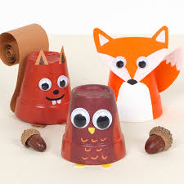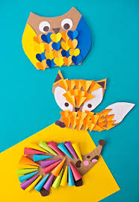

Friday

P.E.
It's time for Cosmic Yoga - this time it's Tallulah the Owl!

Phonics
Start by doing the Flash Cards activity on Phonics Play again. Select Phases 2 and 3 and again make a note of any sounds your child is not yet confident with to practise on throughout the day. Finish by reading the The haircut comic strip (phase 3) on Phonics Play Comics.

Forest Fun
Use our forest fun time to collect some natural resources to make your own woodland creatures from. Here are some lovely examples to give you some ideas:
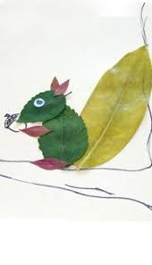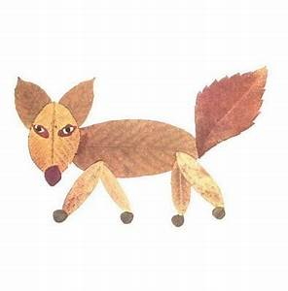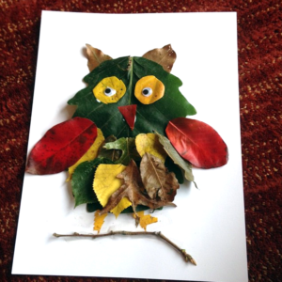

Topic
Friday afternoon is our finishing off/ intervention time (handwriting and number formation are always our focus in school). However, don't forget that this weekend is Father's Day. If you haven't had chance to make a Father's card yet this might be a good chance... but remember to keep them a surprise until Sunday! 😉😉😉

Have a lovely weekend :)

