Week Beginning 22.6.20 Reception Home Learning

Cold climate Animals!

Monday

English
Watch or Read The Penguin Who Wanted to Fly by Catherine Vase. Have you ever heard this story before?
Today is our handwriting day. First look at the Letter Formation Posters again (no need to print these out). They just explain the groups that letters can be put into based upon how we write them. Each week we are focussing on one group, this week it's the Zigzag monster Letters! Use the Zigzag Monster Letter Formation sheet or just use plain paper (lined if possible) to practise this group of letters. Please make sure that your child is starting each letter in the correct place - and practise any that they struggle with at the end.

Phonics
Start by watching the Phase 3 tricky words video again. Go to Polly's Phonics path on espresso. Read along all the sounds, click on any that you are unsure of along the way. Afterwards play the Reading (air, er, ture) game on espresso.

Maths
We're going to start by playing two songs that re-cap the work we did on time last week: The clock song and The O'clock song. Remind children that as long as the big hand is pointing up to the 12 then it is 'o clock!
This week we are going to have a 2D shape focus in our maths lessons (2D shapes are basically flat shapes). First go through the 2D Shape Introduction then choose one of the 2D Shape Colouring pages to colour in carefully.
Topic
We're going to start the afternoon by watching a Penguin Song. Monday afternoon is our computing afternoon. Go to the Penguin activity on Purple Mash (Art, Animals, Penguin). Can you create your own little penguin? Don't forget to save your picture in our Reception folder.
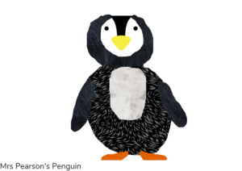

Tuesday

English
Re-read or watch The Penguin Who Wanted to Fly by Catherine Vase. Flip Flop was desperate to be able to fly. Is there anything you really really wish you could do but can't? Use The Penguin Who Wanted To Fly sheet (or create your own version) to write a sentence and then draw a picture of you doing something you really wish you could do!

Phonics
Start by doing the Flash Cards activity on Phonics Play (the link might work, if not it's just because you need to log in to Phonics Play first). Select Phases 2 and 3 and again make a note of any sounds your child is not yet confident with to practise on throughout the day. Then play the Segmenting (air, er, ture) game on espresso.

Maths
Start by watching the 2D shape song and then look through the 2D Shape Powerpoint. Then you're going to do a shape search around your home (and/or garden if you prefer!). Fill in the 2D Shape Hunt sheet (or just create your own on a blank piece of paper). Please just remind the children that rectangles can also be called oblongs - they are the same thing!

Topic
In very cold countries, it is like being in Winter all the time. Watch the It's Freezing! video on espresso. What kind of clothes do we wear in Winter to keep us warm? Design your own Winter clothes using the Cold Clothes Design sheet or just draw your own on a blank piece of paper.

Wednesday

English
Read or watch Big Bear Little Bear by David Bedford and Jane Chapman. Is this a story you know already? What is your favourite part of the story? Draw a picture of your favourite part of the story and explain to a family member why that is your favourite part.

Phonics
Start by watching the Phase 2 tricky words video. Then play the Phase 2 Tricky Word Trucks game on Phonics Play (the link might work, if not it's just because you need to log in to Phonics Play first). They should hopefully be quite confident with these words now - if so, try the 'Phase 2 All HFW' (High Frequency words) option for more challenge.

Maths
First watch the Shape song. then we're going to practise making patterns out of 2D shapes. Use the 2D Shape Patterns sheet or just create your own patterns using 2D shapes for your child to continue.

Topic
Start by watching the Polar Bear Song. There are lots of animals that live in cold climates. Think about if you were going to travel to a cold climate, it would be a very different kind of holiday to a beach in a hot climate! You don't have fur or a thick layer of blubber to keep you warm like lots of the animals in cold climates do. What would you need to pack to take with you to keep you warm? Can you colour and sort the items into the two suitcases on the Pack A Suitcase Activity (if you don't have access to a printer just draw the outline of 2 suitcases and ask your child to draw things they would need for a cold holiday and things they would need for a hot holiday).

Thursday

English
Re-read or watch Big Bear Little Bear by David Bedford and Jane Chapman. Then we're going to think about both of our stories from this week. If you could choose to be either a penguin or a polar bear, which one would you be? Use the Penguin Or Polar Bear sheet or just use a blank piece of paper to write your answer and why you would choose that animal!

Phonics
Start by watching the Phase 3 tricky words video. Then play the Phase 3 Tricky Word Trucks game on Phonics Play (the link might work, if not it's just because you need to log in to Phonics Play first). Repeat to become more confident and try to beat your previous score!

Maths
First watch the Shape song again and then we're going to cut out some shapes to make our own 2D shape penguins! As you cut each shape out can you say what the shape is? Use the Shape Penguin Activity Sheets and see if you can make your own little penguin!

Topic
Start with a penguin dance! Then it's our creative afternoon - we're going to make a penguin model out of anything we have at home: junk, plasticine, Lego - whatever you have and you will enjoy using! Here are some ideas to get you started:
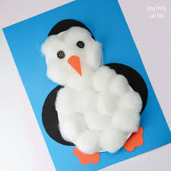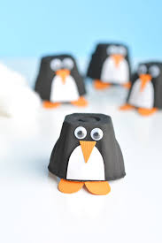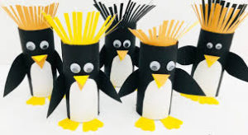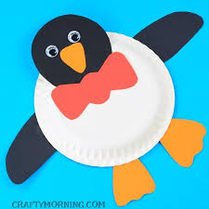

Friday

P.E.
We've got a penguin themed session this week! First start with our penguin dance. Then we're going to do a Cosmic yoga session called Pedro the Penguin!

Phonics
Start by doing the Flash Cards activity on Phonics Play again (the link might work, if not it's just because you need to log in to Phonics Play first). Select Phases 2 and 3 and again make a note of any sounds your child is not yet confident with to practise on throughout the day. Then play any of the Phase 3 games on Phonics Play to finish.

Forest Fun
The weather is forecast to be more 'Summery' this week so we're going to use our forest fun time to get out and look for signs of Summer! What can you see around you that tells you it's Summer time? Have a look at all the leaves on the trees and all the different plants and flowers. Use the Summer Flowers Hunt sheet to see how many of the different flowers and plants you can spot whilst you're outside.

Topic
Friday is always our finishing off/catch up/intervention time. If there is anything your child has not managed to do yet or you feel would benefit from going over again, please use this time to do so. Also, please make sure that they are forming all of the letters in their name correctly!
Have a lovely weekend 😊

