Week Beginning 8.6.20 Reception Home Learning

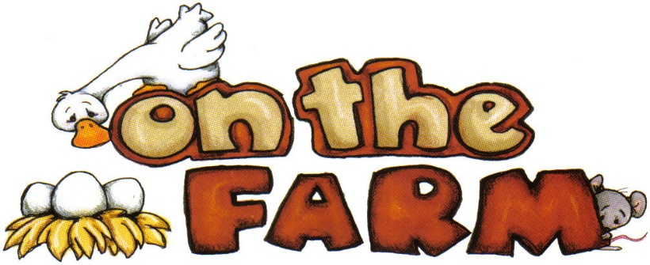Monday

English
Watch or read Farmyard Hullabaloo by Giles Andreae. Discuss the different farm animals together, which farm animal is your favourite?
Next we are going to practise our handwriting as we need to make sure that we are forming our letters correctly. First look at the Letter Formation Posters again (no need to print these out). They just explain the groups that letters can be put into based upon how we write them. Each week we will focus on one group, this week it's the Ladder Letters! Use the Ladder Letters sheet or just use plain paper (lined if possible) to practise this group of letters. Please make sure that your child is starting each letter in the correct place - and practise any that they struggle with at the end.

Phonics
Start by watching and singing along to the Phase 2 tricky words video. Then we are going to focus on some of the 'trickier' phase 3 sounds this week (the ones near the end of Polly's phonics path) to make sure we're really confident with them. Today we're going to focus on the ear sound. Click on this sound on Polly's Phonics path on espresso. Watch the video and then play the ear Phoneme Roll And Read Game, reading each word carefully and crossing it off after you've read it correctly.

Maths
Start with our numbers to 20 song. Then we're going to practise finding numbers to 20 by playing the Blast Off! game on Top Marks. There are different options for this game. Please choose: Find a Number, Direct and then 10-20.

Topic
First watch and join in with the Old Mac Donald song together. Then... computing afternoon is changing to a Monday from now on!
Go to the Farm Activity on Purple Mash (Art, Animals, Farm). Add a farm animal (or animals) of your choice to the farm scene. Don't forget to save your picture in our Reception folder.
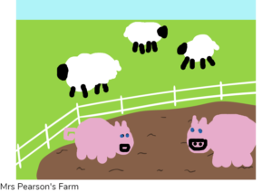

Tuesday

English
Read or watch Farmyard Hullabaloo by Giles Andreae. Use careful colouring to colour all the animals on the Farmyard Hullabaloo Colouring Sheets - there are two sheets to choose from, one is fine! (draw the animals if you don't have access to a printer). Discuss which animal is your favourite!

Phonics
Start by watching and singing along to the Phase 2 tricky words video again, we're getting really good with these words now! Today we're going to focus on the air sound. Click on this sound on Polly's Phonics path on espresso. Watch the video and then play the Find the air words game on espresso.

Maths
Start with a numbers to 20 song. Then for our activity we are going to see if we can find missing numbers! Play the Missing Numbers 0-20 activity on espresso (if this is too hard for your child try the 0-10 version first).

Topic
Watch the Animals On The Farm powerpoint (remember to click on 'slide show' and 'from beginning'). Then try and match the baby animals to their mothers by using the Mothers And Their Young Matching Activity (or just draw the mothers and baby animals if you don't have access to a printer). Discuss the different animal baby names as you go.

Wednesday

English
Today we're going to read a new farmyard story. This one is called Cock-A-Moo-Moo! and it is by Juliette Dallas-Conte. Did you like this story? Next play the Which Farm Animal Am I? powerpoint game, listening carefully to the clues. Afterwards your task is a speaking and listening activity: With a partner give them clues that describe a farm animal, without telling them what that animal is. Can they guess the correct animal? Swap over and see if you can guess their animal!

Phonics
Start by watching the Phase 3 tricky words video. Then today we're going to focus on the er sound. Click on this sound on Polly's Phonics path on espresso. Then play the er Phoneme Roll And Read Game reading each word carefully and crossing it off after you've read it correctly.

Maths
Start by watching a numbers to 20 song, then we're going to be number detectives! We're going to see if we can solve the farm animal problems - some of the numbers have been taken away and mixed up - your job is to put the right numbers back in the right place. Use the Farm Animals Missing Numbers sheet or just create some a similar activitiy on paper.

Topic
Watch and join in with the Old Mac Donald song again. Then this afternoon we're going to create our own farms! For this you can use whatever you think your child will enjoy most - you could paint a farm picture, use toy animals to create a farm scene, make a junk-model farm or you can use the farm picture templates listed below to cut out, colour and stick:
My Farm Cut Outs Black And White
My Farm Poster Black And White 2xA4
My Farm Poster Black And White A3

Thursday

English
Re-read Cock-A-Moo-Moo! by Juliette Dallas-Conte. Afterwards use the Farm Animals List template (or just a blank piece of paper if you don't have access to a printer) to make a list of different farm animals that you can remember. Use your phonics skills to carefully sound each animal name out and write it down. You can add a little picture to go with each animal afterwards if you like!

Phonics
Watch the Phase 3 tricky words video again. Today we're going to focus on the ture sound. Click on this sound on Polly's Phonics path on espresso. Watch the video and then play the Find the ture words game on espresso.

Maths
Start with our numbers to 20 song. Then we're going to practise our number formation, to make sure that we're getting them all the right way round! Use the Number Formation 11 - 20 sheet or just practise on a piece of paper.
Top tips: All the numbers start at the top and the only one you take your pencil off the paper for is the number 4!

Topic
This afternoon we're going to look closely at one particular farm animal, the chicken! 🐣 A hen is the name for a mummy chicken. First watch the Hen Life Cycle PowerPoint (remember to click on 'slide show' and 'from beginning'). Then create your own chicken life cycle, using either the Hen Life Cycle Worksheets or the Hen Life Cycle Wheel activity, or any other way you'd prefer! Here are some other ideas:
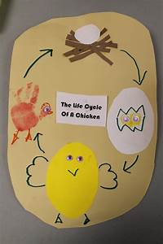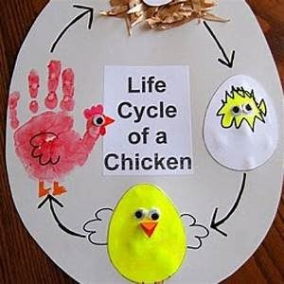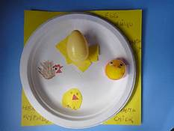

Friday

P.E.
Farmyard yoga time! Start by performing the Old Mac Donald song. Then use the following link to go to today's Cosmic Yoga session: Farm Cosmic Yoga

Phonics
Start by watching our Phase 3 tricky words video again. Watch the video and then then use your phonics skills to carefully read each farm animal name and match it to the right animal picture on the Farm Animals Word Match sheet.

Forest School
We're going to think about our little chicks today. Can you collect some interesting leaves and make your own chick (or family of chicks) with them? You could draw the legs and faces on with a felt-tip, or you could even use little twigs! Please send pictures of your chicks in so that we can see them ☺🐣🐥
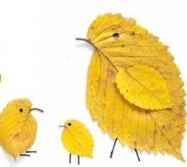

Topic
Friday afternoon is as always, our finishing off/ intervention time. Go over any activities that your child needs to complete or has found tricky this week. Remember number and letter formation is always a priority – especially writing their own name perfectly!

Have a lovely weekend! :)

