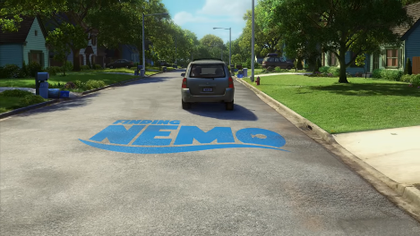 | 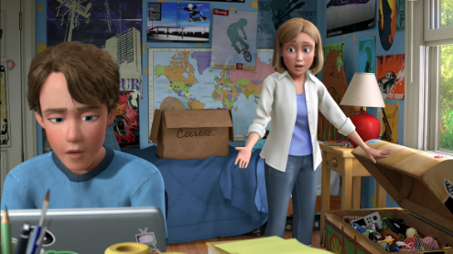 | 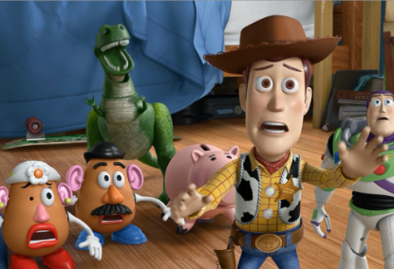 | 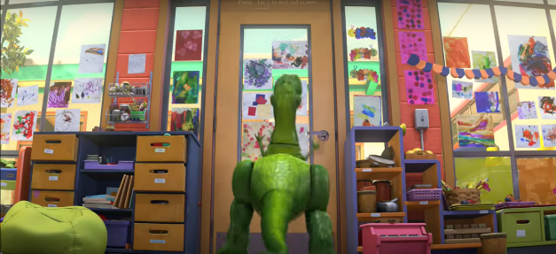
From the creators of Finding Nemo, Up and Wall E. | Andy’s Mum asks him what he’s going to do with his old toys now he’s going to college. | The toys are worried about what will happen to them. | The gang have ended up in Daycare – Rex is excited about being played with again.
 | 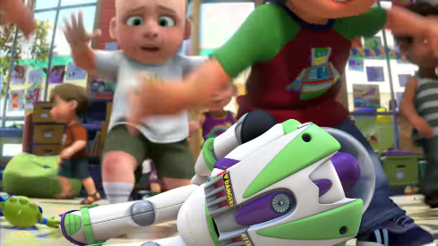 | 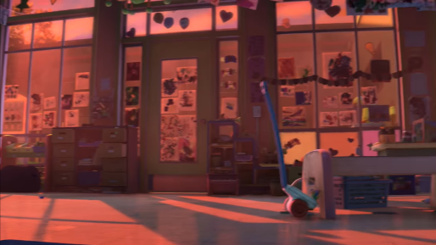 | 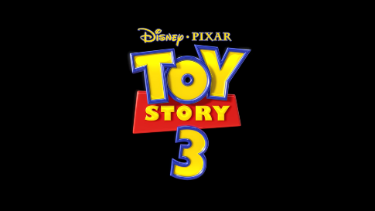
 | Shot where the little children come in and are really rough with the toys. | Woody tells the other toys they have to escape. Shot where Jessie catapults Buzz into the air
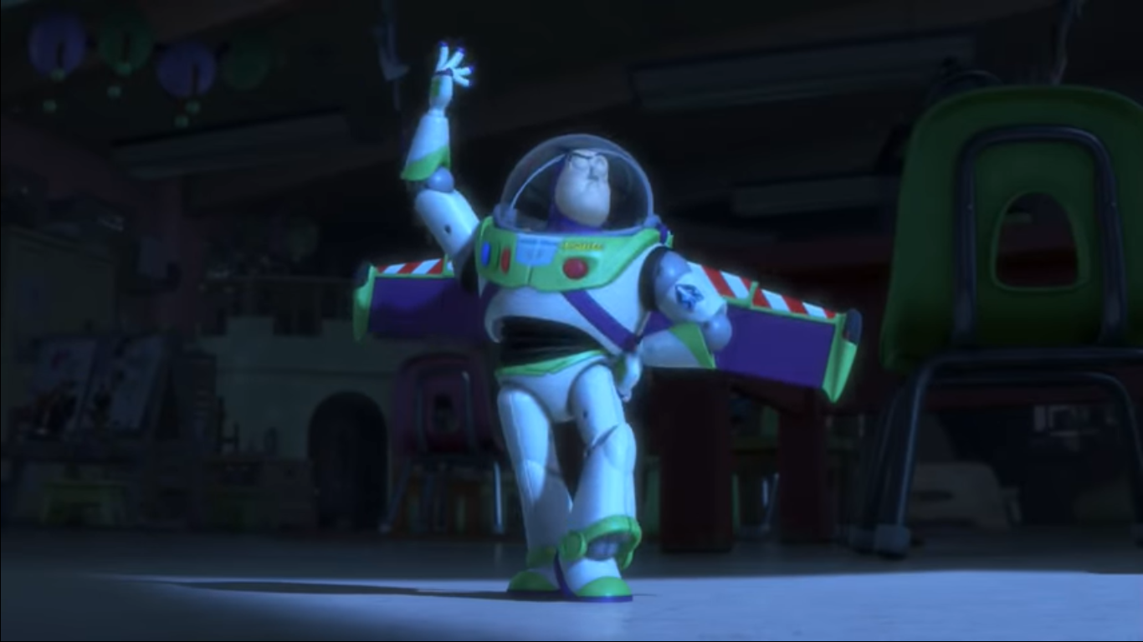
Shows the toys resetting Buzz so he becomes Spanish Buzz.

